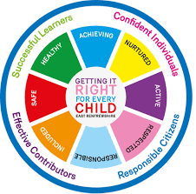
St. Ninian’s High School
PSHE Newsletter
Week beginning 20th May 2019

Focus:

- 5 steps to wellbeing video – Please show all classes

- Health and Wellbeing Committee Needs You!!!

- Sports & Family Fun Day: Wednesday 5th June, 3pm

- School Show: 18-21st June. Tickets available at the school office.

Daily Prayers

Mental Strength and Wellbeing
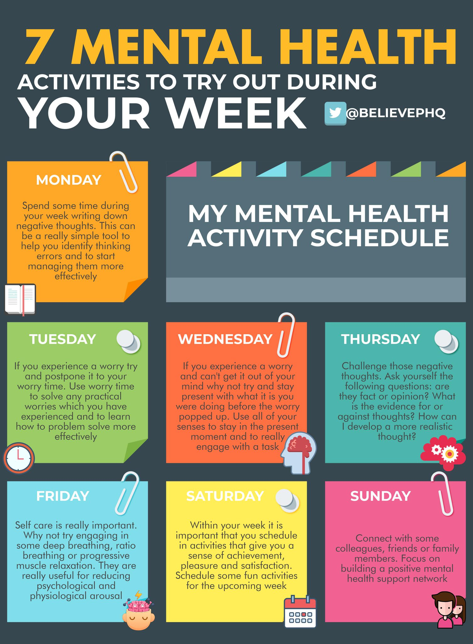

S1
Please complete the Full Report Section in PSHE booklets with all pupils. Pupils should set targets in relation to discussion from parent’s night

Substance Misuse 2

Substance Misuse 1

Alcohol Part 2

Alcohol Part 1

PSHE Evaluation

S2
Drugs Scenario

Drugs Introduction

Self-Harm

Self Esteem

Friends and Friendship

Stressed Out

Getting the Lowdown

S3
SDS Workshops
- Monday 20th May Period 6 3a9 and 3a10
Mrs Sheppard will visit both classes during the period visiting 3a9 for the first half and 3a10 for the second half
Healthy Eating/Unbalanced Diets

Understanding Prejudice

Alcohol lessons Click view- ‘Kick it, Binge Drinking’

Alcohol lesson

PSHE Evaluation

T. Low

