St Ninian’s High School
PSHE Newsletter
Week Beginning 18th November 2019

Focus:

Daily Prayers

• Catholic Education Week - Article by Monsignor Monaghan on his experience of catholic education in our school

- November: Month of The Holy Souls

- Standards and Expectations – Please reiterate and cover with all classes

- Lost Property – Please highlight procedures to all pupils

- Emergency Evacuation Procedure

- Christmas Market Friday 29th November
Tickets: Children £1 and Adults £3

Notices for R.E.

- November Service of Light, 12.20pm on Thursday 21 November
Mental Strength
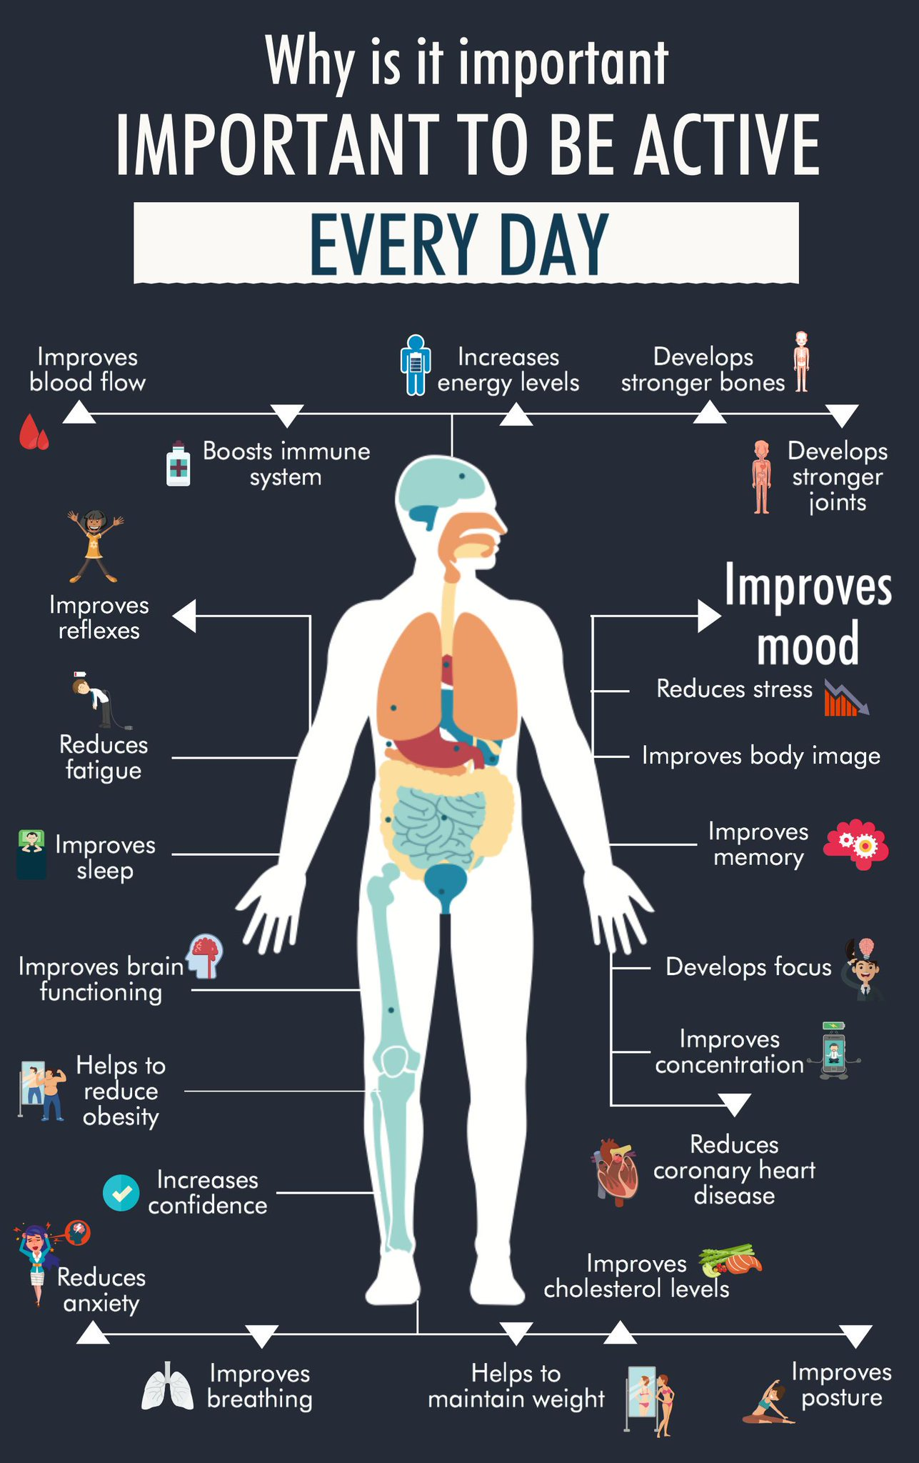

S1

Talented Athlete programme – Please highlight to pupils and ask those that meet the criteria to speak with Miss Briggs in P.E.

Ski Trip – Pleaes promote to S1 pupils

S1 Pupil Council Minutest – Please cover with class

Road Safety Week 18th to 24th November

Anti – Bullying Week 11th to 15th November

Children Focussed video on rise of Nazis and how it affects a Jewish family – Please watch video with all classes

S1 Road Safety Talks
1a8 – Wednesday 22nd November
1a5 - Friday 23rd November
Please collect speaker from the school office

S1 First aid visits
1a9 – Wednesday 4th December

S2

Anti – Bullying Week 11th to 15th November
Teachers Notes

Children Focussed video on rise of Nazis and how it affects a Jewish family – Please watch video with all classes

YPI Lessons for S2 PSHE – Please complete with class

Hunting the Cyber Bullies - Clickview -Panorama February 2012. Watch video and use Powerpoint with class
S3

Anti Social Behaviour

S3 pupil forum minutes – please cover with all classes

Anti – Bullying Week 11th to 15th November
Teachers Notes

Strathclyde’s Engineering the Future for Girls – Please advertise to girls in S3 classes

Children Focussed video on rise of Nazis and how it affects a Jewish family – Please watch video with all classes

Talk in Lecture theatre with PC J. Waters (Campus Police Officer) regarding:
• Teenage drinking
• Unacceptable use of social media
• Sexting and online bullying

Monday 18/11/19 – 3a9 and 3a10
Tuesday 19/11/19 – 3a4 and 3a5

STUC Talks
Monday 2nd December at 1.50pm to 2.40pm – Classes 3a9 and 3a10
Tuesday 3rd December at 1.50pm to 2.40pm – Classes 3a4 and 3a5
Please register pupils and take them to the lecture theatre. The speaker will also need to be collected from the school office

Please regisgter classes and take to the lecture theatre. Please also collect
PC Waters from the school office.

S4

S4 Routes and Pathways Talks:
- Wednesday the 20th of November P3 4a9 and 4a10
- Friday the 22nd of November P5 4a9 and 4a10

Tracking Extercise to be completd in class

Road Safety Week 18 – 24 November

Prelim Study
All S4 pupils will receive study packs throughout this week. If you are absent when they are issued, please see Mrs Miller
Make the most of all the resources, along with accessing the helpful webpages to help you with studying for your prelims

RAMH Talks
Wednesday 20th November – 4a9
Friday 22nd November – 4a4
Please collect speaker from school office

Children Focussed video on rise of Nazis and how it affects a Jewish family – Please watch video with all classes

Work Experience Recap lesson – Please cover the attached lesson via the hyperlink on pupils work experience placement and complete their booklets

Study Timetable Template – Please Highlight to pupils and print off if pupils would like a copy.

Focus group minutes for S4 – Please go over minutes with classes in PSHE

S5

RAMH Talks
5a9 – Tuesday 19th November – Please collect speaker from the school office

My WOW – Please ensure that pupils are registered

Road Safety Week 18 – 24 November

Please speak with pupils regarding the Pupil Engagement and Tracking process

S5 Tracking QR Code – Pleaes ask S5 pupils to complete in class

Anti – Bullying week – Slides and link to discussion – Please ensure that all classes provide a return on the Microsoft Forms using the QR Code reader or via the school website

Children Focussed video on rise of Nazis and how it affects a Jewish family – Please watch video with all classes

Interim Report – Please complete Page 71 in PSHE Booklets – Pupils are to complete full page along with identifying Targets that they wish to achieve and how they will achieve this

Every Action has consequences Lessson 1

Study Timetable Template – Please Highlight to pupils and print off if pupils would like a copy.

Wider Involvemnent – complete pages 36 – 40 in PSHE booklets

Prepare a Study Plan – What do top students do?
Watch the video and look to see how you can create an effective study plan for yourself

S6

Road Safety Week 18 – 24 November

Healthy Eating on a budget for 6a7– Register classes and go to Home Economics

Stewart Ivory Money Talks visit Thursday 5th December – 6a6 – Pleaese collect speaker from the school office

S6 Tracking QR Code – Pleaes ask S6 pupils to complete in class

Anti – Bullying week – Slides and link to discussion – Please ensure that all classes provide a return on the Microsoft Forms using the QR Code reader or via the school website

Children Focussed video on rise of Nazis and how it affects a Jewish family – Please watch video with all classes

Please cover hyperlink slides from Mr McArthur with class:
UCAS – All pupils who are looking at applying through the UCAS process are to log on and fill in basic details including:

1. Personal Details
2. Additional information
3. Student Finance
4. Choices (If Pupils are aware of what Course they are applying for).
5. Education
6. Employment

Pupils should also be looking to complete drafts of Personal Statements for feedback from Pastoral Teacher. Highlight the links below which are on the school website.

6a9 Stewart Ivory Financial education talk. Please collect speaker from the school office

Healthy Eating on a budget for 6a6– Register classes and go to Home Economics

Application evening for S6 pupils

Pupils should log on to the school websit to see the advice available on how to complete their Personal Statement – See Below Hyperlinks

Link to school website and advice on completing Personal Statement

Link 1 – Advice on completing Personal Statement

Link 2 – How to structure Personal Statement

Caritas Award

GIRFEC Booklet – Work through SHANARRI Indicators and complete with class

All about me – Complete with class

T. Low

