St. Ninian’s High School
PSHE Newsletter
Week beginning 18th March 2019

Focus:

- 5 steps to wellbeing video – Please show all classes

- Lent 3: For use with your pupils and for personal use.

- SCIAF staff vs pupil quiz, 20th March, lunch time, Lecture Theatre.
- Dance & Gymnastics Show: Wednesday 20th March, 7pm
- Art Exhibition and Fashion Show: Thursday 21st March, 7-9pm
- No Child Taken Quiz Night, Friday 22nd March, 7-9pm.
- Afternoon Tea for Life: Saturday 23rd March, 1pm-4pm.
- SCIAF 24 Hour Sponsored Fast, 27th of March.
- Spring Concert, 28th March, 7pm.
- Millport Trip, 2nd April. Details from Josef Fuchs.
- Easter School: Programme available from Year Heads and Pastoral Teachers. Many thanks to colleagues able to support the programme
- Estimate Grades: Please discuss with your pupils the grade you are submitting to SQA

Outstanding Library materials – please ask pupils to return books etc.

Daily Prayers

Mental Strength HWB
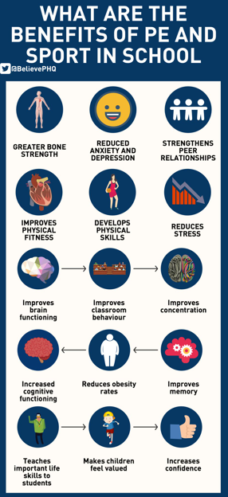

S1
Friends and Friendship

Planning for Choices

PSHE Evaluation

Complete Inspiring Purpose booklet

S2
Full Assembly for S2 at 10.40am – Fire Service talk on Anti-Social behaviour

Healthy Lifestyle

Campus Police Officer PC Trainer – Drug Awareness Talk
Thursday 21st March – 2a3 at 2.40pm

Scottish Youth Parliament elections open – Please encourage pupils to vote in the street area where the S6 tables are

Mental Health Awareness

PSHE Evaluation

S3
Please ask pupils who would be interested in a career in medicine and pass names to Mrs Wilson

Scottish SPCA Visit
18th March – 3a9 and 3a10
19th March – 3a5
Please collect speaker from the school office and take them to classroom

W/B 25 March My WOW Ambassador presentation for all classes – Class ambassadors will present to their own classes

Parents Evening Reflection – Complete Page 44 regarding Parents Evening Reflection and plan to improve Areas of Development

Social media use & internet safety

PSHE Evaluation

Transferable Skills

S4
PSHE Evaluation

Positive Mental Attitudes – How does it feel?

Knife Violence & Gang Culture‐ Knife City (Clickview)

Online Etiquette

Social Media

EMA – Education Maintenance Allowance – Go over with pupils

S5
S5 in to S6 Options mop up

Click view - Drug Education for Teens – (Pastoral Staff to choose video topic to be shown to class)

Positive Mental Attitudes - Stigma

Work Experience Survey – Please ask pupils to follow the link via the QR code and fill in any work experience they have done

PSHE Evaluation

Anti-Smoking – Clickview – Smoking Our deadliest Habit – Click on link and use glow details to log in

Ensure that PSHE booklets are up to date including:

- Full report reflection for S5
- Career education standards
- Wellbeing web
- SHANARRI task

Internet Use & Social Network Sites - Clickview- Internet Ethics & Young People

EMA – Education Maintenance Allowance

S6
Pupils should log on to the S6 School Website page and click on the “S6 Diploma 2019” link and add their Diploma comments to the Microsoft forms document

PSHE Evaluation

Diploma Completion for S6 pupils – See the below instructions

- Pupils go on to “Pupil Shared Area”
- Click on “PSHE”
- Pupils go on to “Diploma 2019”
- Pupils click on their own respective Alpha
- Click on the “S6 Diploma” and immediately save in the folder using their name.
- Pupils are to complete each section of the Diploma by writing in to the text box at the bottom of each section
- This will be a working document and pupils should save their work as they go
- It is important that when pupils are writing information in to the text box that they do not hit the return key as this will not work with the software when transferring on to the Diploma

Link to examples of previous diplomas

Link to Lesson for “Responsible Citizen”
Link to Lesson for “Confident Individual”
Link to Lesson for “Successful Learner”
Link to Lesson for “Effective Contributor”

Interview Preparation - 10 step guide on how to prepare for an interview

EMA – Education Maintenance Allowance

Interview Techniques – Watch the clip on “Interview Techniques” and discuss with class
T. Low

