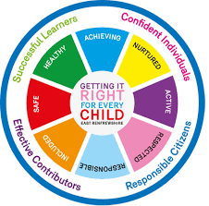

St Ninian’s High School
PSHE Newsletter
Week Beginning 17thSeptember 2018

Focus:

Daily Prayers

- Responding to bullying - What are my options?
- Bullying - A guide for parents and carers
- Anti-bullying Policy through to practice – Getting it right
- Discussion of Interim report for S2 and S4
Teachers should discuss the Negotiated Target and On Track to Achieve Grades with pupils explaining how the grades have been decided. Pastoral staff and Year Head will review the Reports and discuss the action required by pupils, support required from parents, & areas for action through support

P.E. Reminder
Pupils are reminded that pupils are not allowed to use Aerosol/Spray deodorants in the changing rooms. If pupils are found to have these types of deodarants they will be confiscated by staff.

Extra-Curricular programme booklet

Mental Health Awarenss

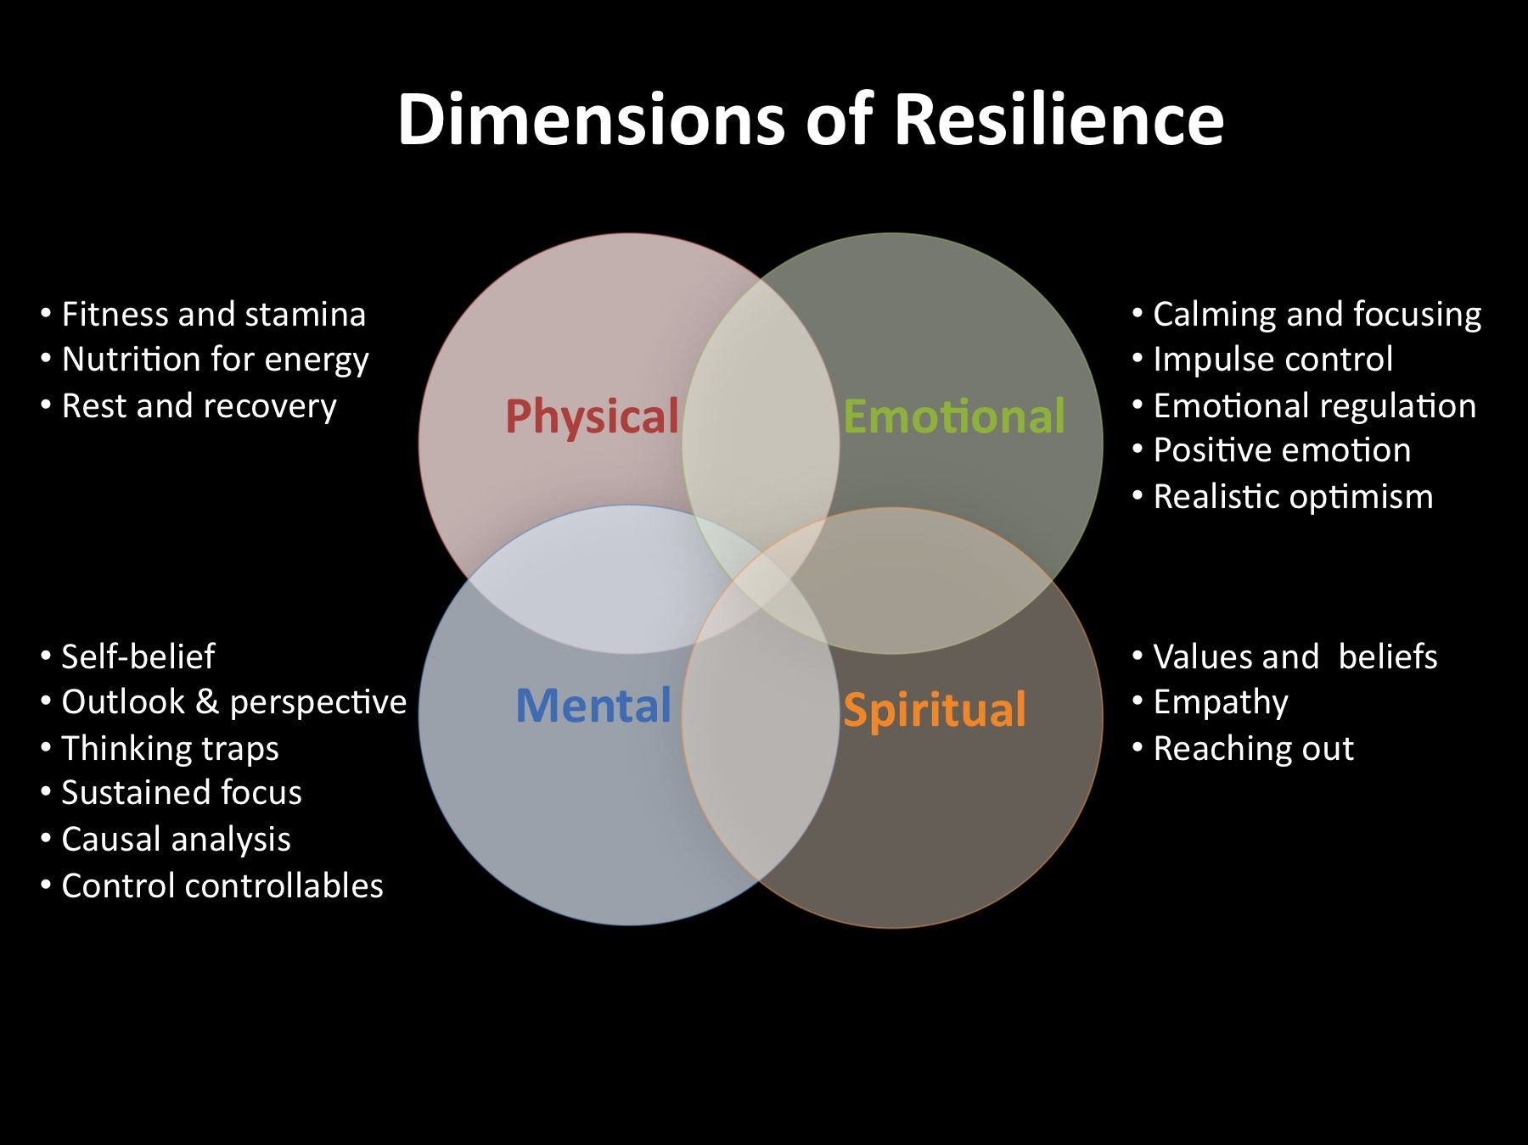

Mental Health Awareness

How can we be more resilient?

We all need to take steps to look after our wellbeing. Being able to deal with pressure and reducing the impact that stress has on our lives is essential to having a positive mindset. But how do we become emotionally resilient?

Practise being straightforward and assertive in communicating with others. If people are making unreasonable or unrealistic demands on you, be prepared to tell them how you feel and say no.

Use relaxation techniques. You may already know what helps you relax, like having a bath, listening to music or taking your dog for a walk. If you know that a certain activity helps you feel more relaxed, make sure you set aside time to do it.

Develop your interests and hobbies. Finding an activity that's completely different from the things causing you stress is a great way to get away from everyday pressures.

Make time for your friends. When you've got a lot on this might seem hard, but it can help you feel more positive and less isolated. Chatting to friends about the things you find difficult can help you keep things in perspective – and you can do the same for them.

Find balance in your life. You may find that one part of your life, such as your job or taking care of young children, is taking up almost all of your time and energy. Try making a decision to focus some of your energy on other parts of your life, like family, friends or hobbies. It's not easy, but this can help spread the weight of pressures in your life, and make everything feel lighter.

Look after your physical health

- Get enough sleep.

- Be active.

- Eat healthily.
S1

First Aid Class for 1a10 – Wednesday 19 September 11.30am
Please collect guest from the reception prior to start of the lesson

Internet Safety
Pupils must use their notes page to answer the questions on this document here

Watch the following clips:
- Chat Rooms
- Downloading files
- Instatnt Messaging
- Online Gaming
- Social Networking

Now answer the questions in your PSHE Booklet Notes section

Healthy Eating

Film Club

GIRFEC Booklet – Work through SHANARRI Indicators and complete with class

Body Image

Pupil Council Nominations to be completed ASAP. Please forward names to year head.

S2

Child Protection

Internet Safety

Film Club

GIRFEC Booklet – Work through SHANARRI Indicators and complete with class

Study Skills for year ahead

Pupil Council Nominations to be completed ASAP. Please forward names to year head.

S3

Arnold Clark Apprenticeship experience – if any pupils are interested please pass their names to Mrs Kennedy

Sound Sleep

Mental Health and Wellbeing
The attached slides cover how pupils, parents and staff can access support for a range of Mental Health issues. The information here can also be accessed on the main school website.

Study Skills

GIRFEC Booklet – Work through SHANARRI Indicators and complete with class

Balanced Diet

Exercise Health and Fitness

S4

Arnold Clark Apprenticeship experience – if any pupils are interested please pass their names to Mrs Kennedy

Work Experience Check – pupils who have yet to hand in a green form should log on to WorkIT and request placements. Usernames and Passwords can be obtained from Mrs Kennedy

Mental Health and Wellbeing
The attached slides cover how pupils, parents and staff can access support for a range of Mental Health issues. The information here can also be accessed on the main school website.

PSHE Booklet – complete skills learned in each subject

GIRFEC Booklet – Work through SHANARRI Indicators and complete with class

PSHE Booklet – Health and Wellbeing Pages 10, 11, 12 & 13.
Complete Term 1 Sections

Work Experience – Please go over with your respective classes

Pupil Council Nominations to be completed ASAP. Please forward names to year head.

S5

Arnold Clark Apprenticeship experience – if any pupils are interested please pass their names to Mrs Kennedy

Prepare a Study Plan – What do top students do?
Watch the video and look to see how you can create an effective study plan for yourself

Complete S5 achievements profile on Pages 36, 37, 38 and 39. Also complete Academic transferable skills and Attributes Page 40.

Mental Health and Wellbeing
The attached slides cover how pupils, parents and staff can access support for a range of Mental Health issues. The information here can also be accessed on the main school website.

Importance of Sleep

GIRFEC Booklet – Work through SHANARRI Indicators and complete with class

Study Skills – in booklets, highlight the different types of approach to studying. Use ‘Notes’ page for this activity

Study Tips – Inside the mind of a Procrastinator

Induction Slides

Urdu Class for Nat 5 and Higher begins Friday 25th August. Please make those concerned aware of this.

Pupil Council Nominations to be completed ASAP. Please forward names to year head.

S6

Arnold Clark Apprenticeship experience – if any pupils are interested please pass their names to Mrs Kennedy

Pupils should log on to the school websit to see the advice available on how to complete their Personal Statement – See Below Hyperlinks

Link to school website and advice on completing Personal Statement

Link 1 – Advice on completing Personal Statement

Link 2 – How to structure Personal Statement

Fast Track applicants should hand first draft of personal statement to teacher for feedback. Also, log on to UCAS using phones or computers to ensure all information is up to date.

Mental Health and Wellbeing
The attached slides cover how pupils, parents and staff can access support for a range of Mental Health issues. The information here can also be accessed on the main school website.

Caritas Award

GIRFEC Booklet – Work through SHANARRI Indicators and complete with class

Stuart Ivory "Money Talks" sessions 6a8 – Thursday 20 September 1.00pm. Please collect guest from the reception prior to the start of the lesson

First Aid Class for 6a6 – Thursday 20 September 1.00pm
Please collect guest from the reception prior to the start of the lesson

Study Tips – Inside the mind of a Procrastinator

All about me – Complete with class

Induction Slides

Pupil Council Nominations to be completed ASAP. Please forward names to year head.

T. Low

