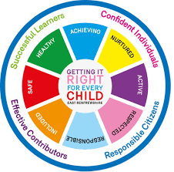
St. Ninian’s High School
PSHE Newsletter
Week beginning 15th April 2019

Focus:

- 5 steps to wellbeing video – Please show all classes

• Holy Week: Thank you to Fr. Stephen, Fr. Patten, Monsignor Monaghan, staff, pupils and parents for your support for our Lenten Programme.

• Finalising preparation for the SQA Exams: Timetable of exams / Revision programme / Letter to Pupils and their Parents

• Wishing pupils and staff a very happy Easter and enjoyable weekend.

- Lent 5: For use with your pupils and for personal use.

- Credit Union – Please promote to all year groups and staff

- Health and Wellbeing Committee Needs You!!!

Outstanding Library materials – please ask pupils to return books etc.

Daily Prayers

Mental Strength HWB
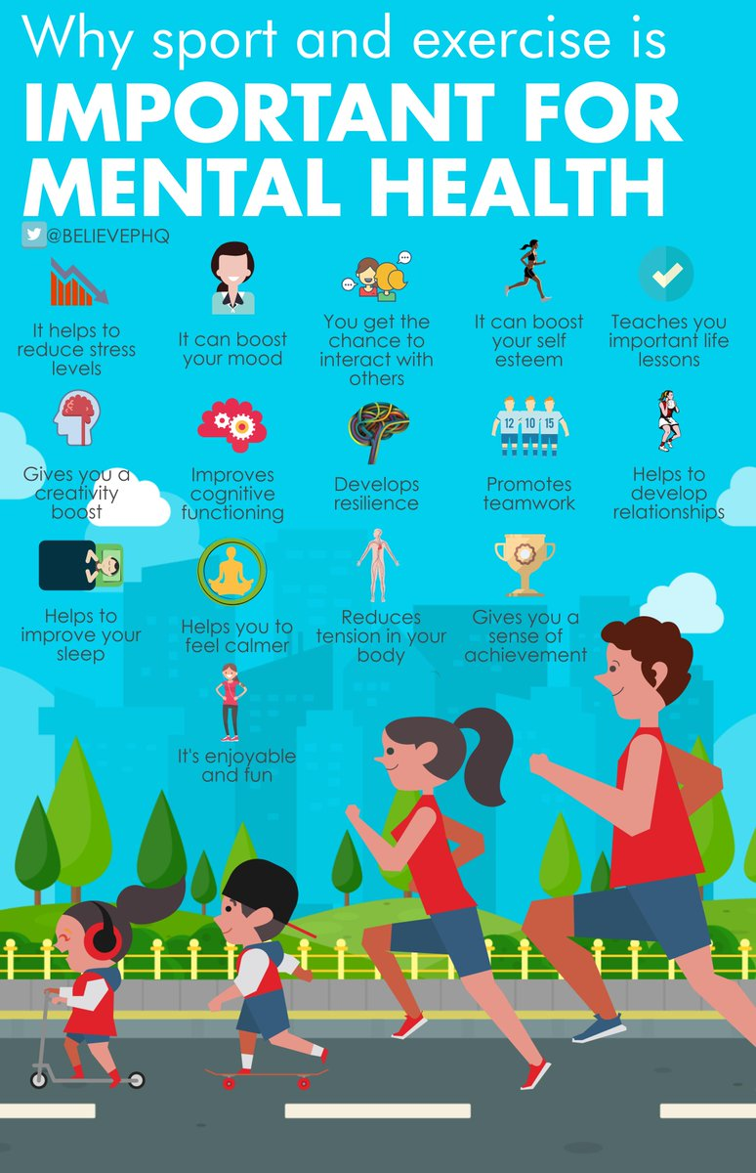

S1
Stressed Out

Friends and Friendship

Planning for Choices

PSHE Evaluation

Complete Inspiring Purpose booklet

S2
Getting the Lowdown

Healthy Lifestyle

Mental Health Awareness

PSHE Evaluation

S3
SDS Workshops
- Monday 15th April Period 6 3a6
- Tuesday 16th April Period 6 3a1

Alcohol lesson

Social media use & internet safety

PSHE Evaluation

Transferable Skills

S4
Preparing for Study Leave

School Holidays – Balancing time

PSHE Evaluation

Positive Mental Attitudes – How does it feel?

Knife Violence & Gang Culture‐ Knife City (Clickview)

EMA – Education Maintenance Allowance – Go over with pupils

S5
Preparing for Study Leave

Police Scotland are currently offering 1 place per school on the week long, work experience programme which is designed for young people who have an interest in joining the police. The week of the programme is Monday 10th until Friday 14th June 2019. The minimum age for the young people to get a place on the programme is 16 years old (at the time of the programme starting). Deadline for the application is Wednesday 17th April 2019. Please see your Pastoral teacher if interested in this opportunity.

School Holidays – Balancing time

Click view - Drug Education for Teens – (Pastoral Staff to choose video topic to be shown to class)

Positive Mental Attitudes - Stigma

Work Experience Survey – Please ask pupils to follow the link via the QR code and fill in any work experience they have done

PSHE Evaluation

Anti-Smoking – Clickview – Smoking Our deadliest Habit – Click on link and use glow details to log in

Ensure that PSHE booklets are up to date including:

- Full report reflection for S5
- Career education standards
- Wellbeing web
- SHANARRI task

S6
Pupils should log on to the S6 School Website page and click on the “S6 Diploma 2019” link and add their Diploma comments to the Microsoft forms document

PSHE Evaluation

Diploma Completion for S6 pupils – See the below instructions

- Pupils go on to “Pupil Shared Area”
- Click on “PSHE”
- Pupils go on to “Diploma 2019”
- Pupils click on their own respective Alpha
- Click on the “S6 Diploma” and immediately save in the folder using their name.
- Pupils are to complete each section of the Diploma by writing in to the text box at the bottom of each section
- This will be a working document and pupils should save their work as they go
- It is important that when pupils are writing information in to the text box that they do not hit the return key as this will not work with the software when transferring on to the Diploma

Link to examples of previous diplomas

Link to Lesson for “Responsible Citizen”
Link to Lesson for “Confident Individual”
Link to Lesson for “Successful Learner”
Link to Lesson for “Effective Contributor”

T. Low

