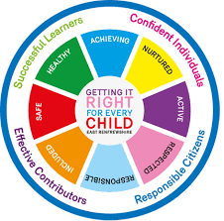
St Ninian’s High School
PSHE Newsletter
Week beginning 15th January 2018

Focus for the week:

• S4 Prelims: Timetable/Accommodation/Cover/ASN Arrangements

• Virtues for living and learning: Intentional & Prophetic

Intentional

Intentional and Prophetic Behaviour

Prophetic

Poster for classrooms

Daily Prayers

S1

Inspiring Purpose
Part 1 – Inspiring Purpose Booklets required

Peer Awards

Young Carers

S2

Mindfulness – Breathing Space

Peer Awards

Factors Affecting Food Choice

Pupil PSHE Booklet completion – Complete profile on skills and attributes

S3

Young Carers

Study Skills - Recap on how to study for class/block tests

S4

Getting the Lowdown – Stress and Anxiety – PPt
Use the below link for the application for class

Getting the Lowdown App for S4

S5

Young Carers

Study Skills
- Preparing for Exams
- Study Plan

S6

The Interview – Clickview is need for this PowerPoint along with PSHE booklets

Interview Skills – Search Clickview for “Interview Skills”.

T. Low

