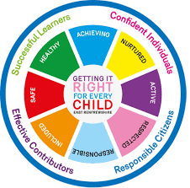
St. Ninian’s High School
PSHE Newsletter
Week beginning 14th January 2019

Focus:

- Courtesy Counts & Kindness

- S4 prelims 14th January-25th January. Timetable / Revision Advice.

- The Holy Hour for Vocations will take place at 7.00pm in the Oratory on Tuesday 22 January 2019 and will be led by Fr Matthew Carlin. This is a great opportunity to put aside some time to pray for vocations especially to the priesthood. All pupils, staff and families are invited.

- 5 steps to wellbeing video – Please show all classes

Daily Prayers

HWB Mental Strength

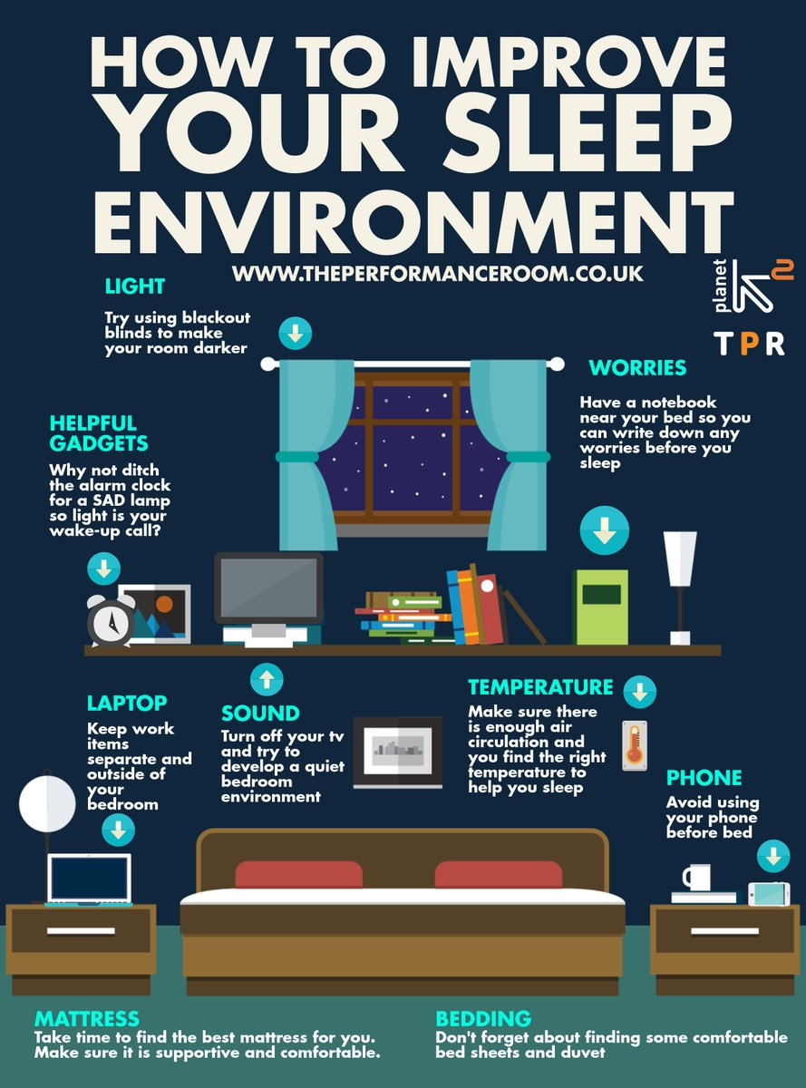

S1

1a4 First Aid Visit Friday 18th January – please collect speaker from the school office

S1 Peer Awards – Please pick up slips from Pastoral base for nominations.

Young Carers

S2

S2 Peer Awards – Please pick up slips from Pastoral base for nominations.

Factors Affecting Food Choice

Pupil PSHE Booklet completion – Complete profile on skills and attributes

S3

Study Techniques – Pupils will learn a variety of methods that can be used when they are studying

Study Skills - Recap on how to study for class/block tests

S4

Please complete Page 63 with all pupils following Work Experience

EMA – Education Maintenance Allowance – Go over with pupils

Stress and Anxiety – Dealing with Exam stress

STUC Talks
Wednesday 16th January Period 3 for classes 4a6 and 4a7. Please register pupils and take them to the lecture theatre. Please collect the lecture theatre key and collect speaker from the school office

RAMH Visits
Wednesday 16th January, 4a10 Period 3 – Talk to take place in classroom

Friday 18th January, 4a5 Period 5 - Talk to take place in classroom
Please ensure to collect the speaker from the school office.

Creating a study plan

S5

EMA – Education Maintenance Allowance

Young Carers

Scottish Space School Opportunity

Please complete Page 23 in PSHE booklets

RAMH Visits
Monday 14th January, 5a2 & 5a5 Period 5

Tuesday 15th January, 5a7 Period 6

Classes should be registered and then taken to the Lecture theatre for their respective talks. Please ensure to collect the lecture theatre keys and speaker from the school office.

S6

EMA – Education Maintenance Allowance

Interview Techniques – Watch the clip on “Interview Techniques” and discuss with class

- Pupils go on to “Pupil Shared Area”
- Click on “PSHE”
- Pupils go on to “Diploma 2019”
- Pupils click on their own respective Alpha
- Click on the “S6 Diploma” and immediately save in the folder using their name.
- Pupils are to complete each section of the Diploma by writing in to the text box at the bottom of each section
- This will be a working document and pupils should save their work as they go
- It is important that when pupils are writing information in to the text box that they do not hit the return key as this will not work with the software when transferring on to the Diploma

Link to examples of previous diplomas

Link to Lesson for “Responsible Citizen”
Link to Lesson for “Confident Individual”
Link to Lesson for “Successful Learner”
Link to Lesson for “Effective Contributor”

Link to school website to be added for Diploma

Presentation Slides for BARCLAYS Money Survival

T. Low

