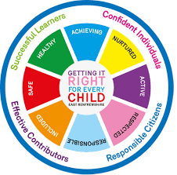
St. Ninian’s High School
PSHE Newsletter
Week beginning 13th May 2019

Focus:

- 5 steps to wellbeing video – Please show all classes

- Health and Wellbeing Committee Needs You!!!

- Parents and Friends Retreat: Friday 17th May. Details issued

- Sports & Family Fun Day: Wednesday 5th June, 3pm

- School Show: 18-21st June. Tickets available at the school office.

Daily Prayers

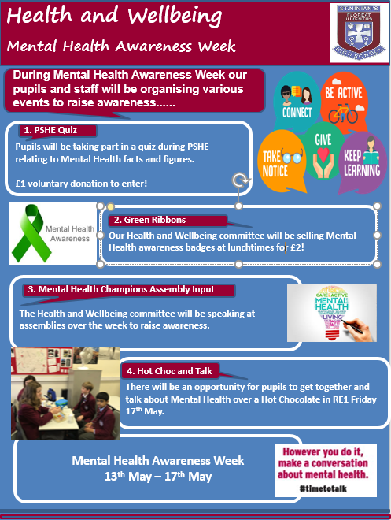
Mental Health Awareness Week 13/05/19 to 17/05/19

S1
Mental Health Awareness Week 13 May to 19 May

Please complete the Full Report Section in PSHE booklets with all pupils. Pupils should set targets in relation to discussion from parent’s night

1a5 First Aid Lesson 17/05/19 at 10.40am – Please collect speaker from the school office

Substance Misuse 1

Alcohol Part 2

Alcohol Part 1

PSHE Evaluation

S2
Mental Health Awareness Week 13 May to 19 May

Drugs Introduction

Self-Harm

Self Esteem

Friends and Friendship

Stressed Out

Getting the Lowdown

S3
Mental Health Awareness Week 13 May to 19 May

SDS Workshops
- Monday 13th May Period 6 3a8
- Tuesday 14th May Period 6 3a5

Understanding Prejudice

Alcohol lessons Click view- ‘Kick it, Binge Drinking’

Alcohol lesson

PSHE Evaluation

T. Low

