St. Ninian’s High School
PSHE Newsletter
Week beginning 11th March 2019

Focus:

- 5 steps to wellbeing video – Please show all classes

- Lent 2: For use with your pupils and for personal use.
- SCIAF staff vs pupil quiz, 20th March, lunch time, Lecture Theatre.
- Dance & Gymnastics Show: Wednesday 20th March, 7pm
- Art Exhibition and Fashion Show: Thursday 21st March, 7-9pm
- No Child Taken Quiz Night, Friday 22nd March, 7-9pm.
- Afternoon Tea for Life: Saturday 23rd March, 1pm-4pm.
- SCIAF 24 Hour Sponsored Fast, 27th of March.
- Spring Concert, 28th March, 7pm.
- Millport Trip, 2nd April. Details from Josef Fuchs.

Outstanding Library materials – please ask pupils to return books etc.

Daily Prayers

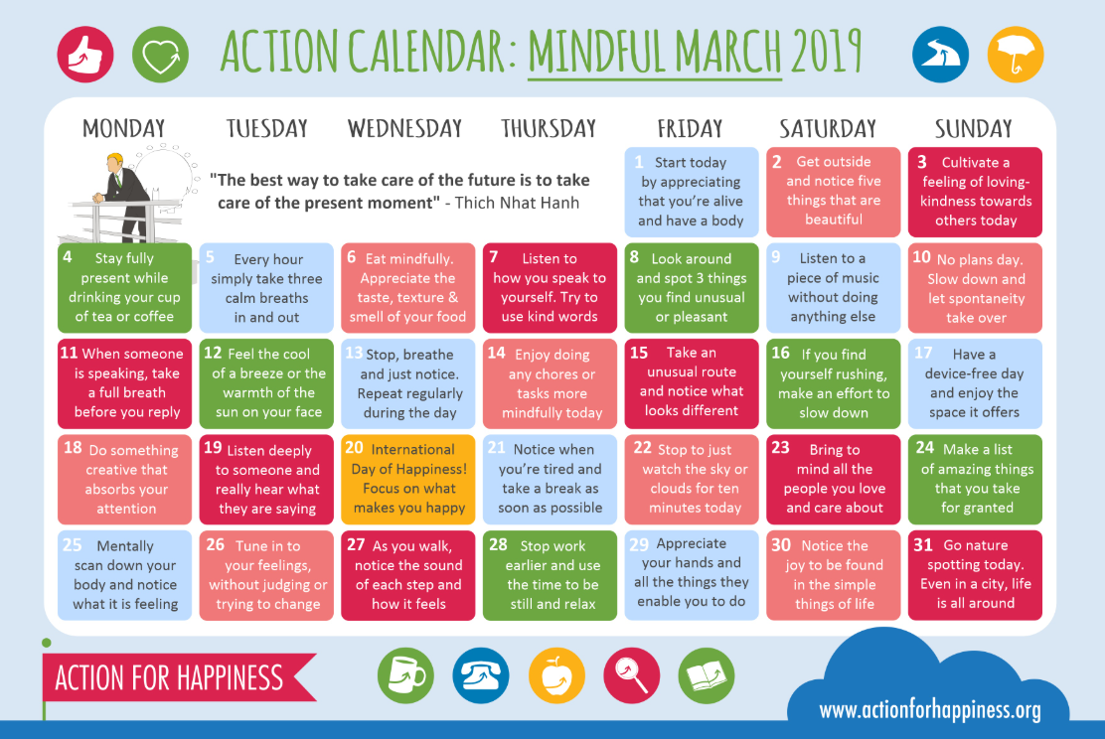
Mindful March

S1
Subject Choice Group Work
1a6 – 1a10 Wednesday 13th March
1a1 – 1a5 Friday 15th March
Classes will be visited by SDS

Planning for Choices

PSHE Evaluation

Complete Inspiring Purpose booklet

S2
Campus Police Officer PC Trainer – Drug Awareness Talk
Thursday 14th March – 2a2 at 2.40pm

Scottish Youth Parliament Talks – Please collect speakers from the school office for the following classes:

10.40am – 2a8 & 2a9
2.40pm – 2a3 & 2a4

Please complete the survey by typing in the exact web address - https://teenagecancertrust.onlinesurveys.ac.uk/schools-programme-student-evaluation-20182019

S2 Healthy Relationships

Online Etiquette

Mental Health Awareness

PSHE Evaluation
S3
Parents Evening Reflection – Complete Page 44 regarding Parents Evening Reflection and plan to improve Areas of Development

Keeping Myself Safe using Technology: Clickview: Becky’s Story

Tracking Exercise – Please click on link and show pupils the survey that they are to complete at home. The sheet they were given on Friday has the instructions of how this should be completed

Social media use & internet safety

PSHE Evaluation

Transferable Skills

Study Techniques 2 – Follow up on last week’s lesson

Study Techniques – Pupils will learn a variety of methods that can be used when they are studying

S4
Positive Mental Attitudes – How does it feel?

Knife Violence & Gang Culture‐ Knife City (Clickview)

PSHE Evaluation

Online Etiquette

Social Media

EMA – Education Maintenance Allowance – Go over with pupils

Stress and Anxiety – Dealing with Exam stress
S5
S5 in to S6 Options to be completed

Click view - Drug Education for Teens – (Pastoral Staff to choose video topic to be shown to class)

Positive Mental Attitudes - Stigma

Work Experience Survey – Please ask pupils to follow the link via the QR code and fill in any work experience they have done

PSHE Evaluation

Anti-Smoking – Clickview – Smoking Our deadliest Habit – Click on link and use glow details to log in

Ensure that PSHE booklets are up to date including:

- Full report reflection for S5
- Career education standards
- Wellbeing web
- SHANARRI task

Internet Use & Social Network Sites - Clickview- Internet Ethics & Young People

EMA – Education Maintenance Allowance

S6
Assembly for 6a6, 6a7, 6a8, 6a9 & 6a10 on Thursday 14th March – Please register pupils and take them to the Lecture Theatre

Work Experience Survey – Please ask pupils to follow the link via the QR code and fill in any work experience they have done

PSHE Evaluation

Diploma Completion for S6 pupils – See the below instructions

- Pupils go on to “Pupil Shared Area”
- Click on “PSHE”
- Pupils go on to “Diploma 2019”
- Pupils click on their own respective Alpha
- Click on the “S6 Diploma” and immediately save in the folder using their name.
- Pupils are to complete each section of the Diploma by writing in to the text box at the bottom of each section
- This will be a working document and pupils should save their work as they go
- It is important that when pupils are writing information in to the text box that they do not hit the return key as this will not work with the software when transferring on to the Diploma

Link to examples of previous diplomas

Link to Lesson for “Responsible Citizen”
Link to Lesson for “Confident Individual”
Link to Lesson for “Successful Learner”
Link to Lesson for “Effective Contributor”

Interview Preparation - 10 step guide on how to prepare for an interview

EMA – Education Maintenance Allowance

Interview Techniques – Watch the clip on “Interview Techniques” and discuss with class

T. Low

