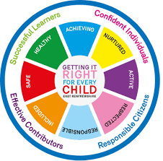
St. Ninian’s High School
PSHE Newsletter
Week beginning 10th June 2019

Focus:

- Rosary and Eucharistic Adoration, 12.25-1pm, (Friday 12pm-1pm).

- Pentecost

- Sports & Family Fun Day: Rescheduled for Wednesday 19th June – Opening Ceremony at 3.00pm

- School Show: 18-21st June. Tickets available at the school office

- Blackpool Trip Wednesday 26th June – Please see Miss Finnigan if you have yet to hand in your consent form and pay for the trip

- Silverburn Teenage Market – Please advertise to pupils

Daily Prayers

Mental Strength and Wellbeing

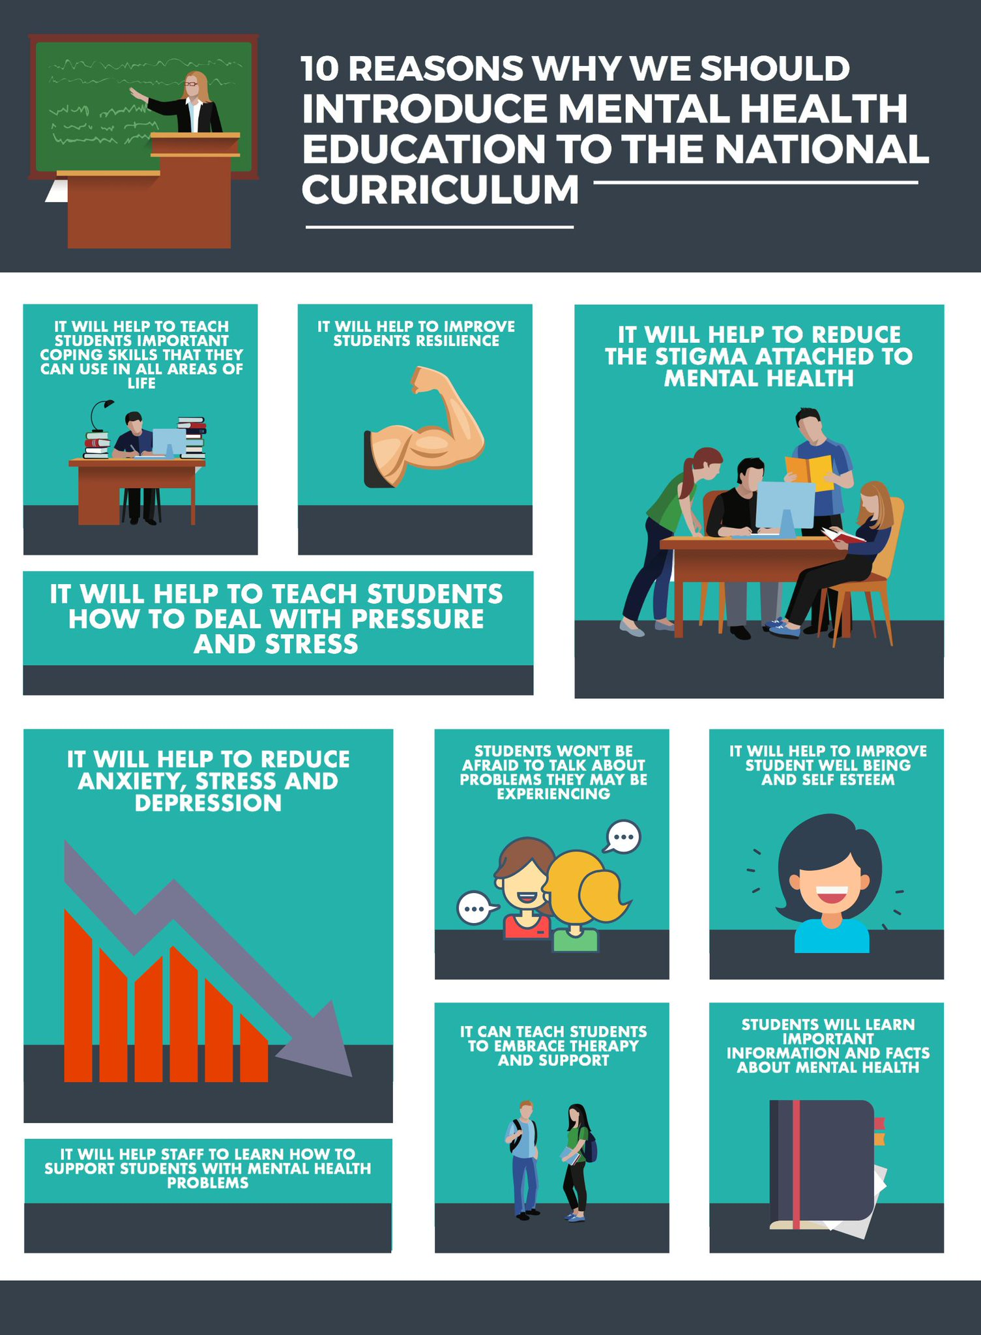

S2

PSHE Booklet completion – Please ensure that all sections of the booklet are completed including:

- GIRFEC section
- Wellbeing wheel (3rd term)
- Post 2 for all subjects
- Literacy, Numeracy, Health and Wellbeing page

Standards and Expectations – June Induction

PSHE Evaluation – Please ask pupils to complete using there GLOW username and password

Please complete the Full Report Section in PSHE booklets with all pupils. Pupils should set targets in relation to discussion from parent’s night

Substance Misuse 2

Substance Misuse 1

Alcohol Part 2

Alcohol Part 1

S3

PSHE Booklet completion – Please ensure that all sections of the booklet are completed including:

- GIRFEC section
- Wellbeing wheel (3rd term)
- Post 2 for all subjects
- Literacy, Numeracy, Health and Wellbeing page

Standards and Expectations – June Induction

All Pupils attending Ardeche trip 2019:
EHIC cards, Passports and Pocket Money is due ASAP.

Achieving a Healthy Lifestyle

Drugs Scenario

Drugs Introduction

Stressed Out

S4

PSHE Booklet completion – Please ensure that all sections of the booklet are completed including:

- GIRFEC section
- Wellbeing wheel (3rd term)
- Post 2 for all subjects
- Literacy, Numeracy, Health and Wellbeing page

Standards and Expectations – June Induction

Eating Disorders

Healthy Eating/Unbalanced Diets

Understanding Prejudice

PSHE Evaluation

S5

PSHE Evaluation

Standards and Expectations – June Induction

S6

St. Ninian’s First Aid Course – Please go over details with pupils. Any interested pupils should give their details to their Pastoral teacher

Diploma Completion for S6 pupils – See the below instructions

- Pupils go on to “Pupil Shared Area”
- Click on “PSHE”
- Pupils go on to “Diploma 2020”
- Pupils click on their own respective Alpha
- Click on the “S6 Diploma” and immediately save in the folder using their name.
- Pupils are to complete each section of the Diploma by writing in to the text box at the bottom of each section
- This will be a working document and pupils should save their work as they go
- It is important that when pupils are writing information in to the text box that they do not hit the return key as this will not work with the software when transferring on to the Diploma

Link to examples of previous diplomas

Link to Lesson for “Responsible Citizen”
Link to Lesson for “Confident Individual”
Link to Lesson for “Successful Learner”
Link to Lesson for “Effective Contributor”

Career Opportunities

S6 Service slides

S6 Service spread sheet uptake

Standards and Expectations – June Induction

T. Low

