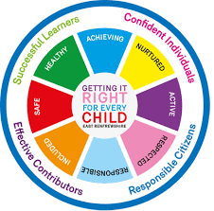
St. Ninian’s High School
PSHE Newsletter
Week beginning 08th May 2019

Focus:

- 5 steps to wellbeing video – Please show all classes

- May: the month dedicated to Mary. Among the names given to Our Lady is “Queen of Peace.” Pope Francis has asked us to “Make use of the prayer of the Holy Rosary, that it may bring peace to our heart, to our family, to the Church and the world”. Each Friday we pray the rosary for our school community

- S1 Parents’ Evening; Newsletter and advice for interviewing teachers

- Health and Wellbeing Committee Needs You!!!

- S1 Parents’ Evening: Thank you to teachers for your preparation

- Parents and Friends Retreat: Friday 17th May. Details issued

- Sports & Family Fun Day: Wednesday 5th June, 3pm

Daily Prayers

Mental Strength HWB
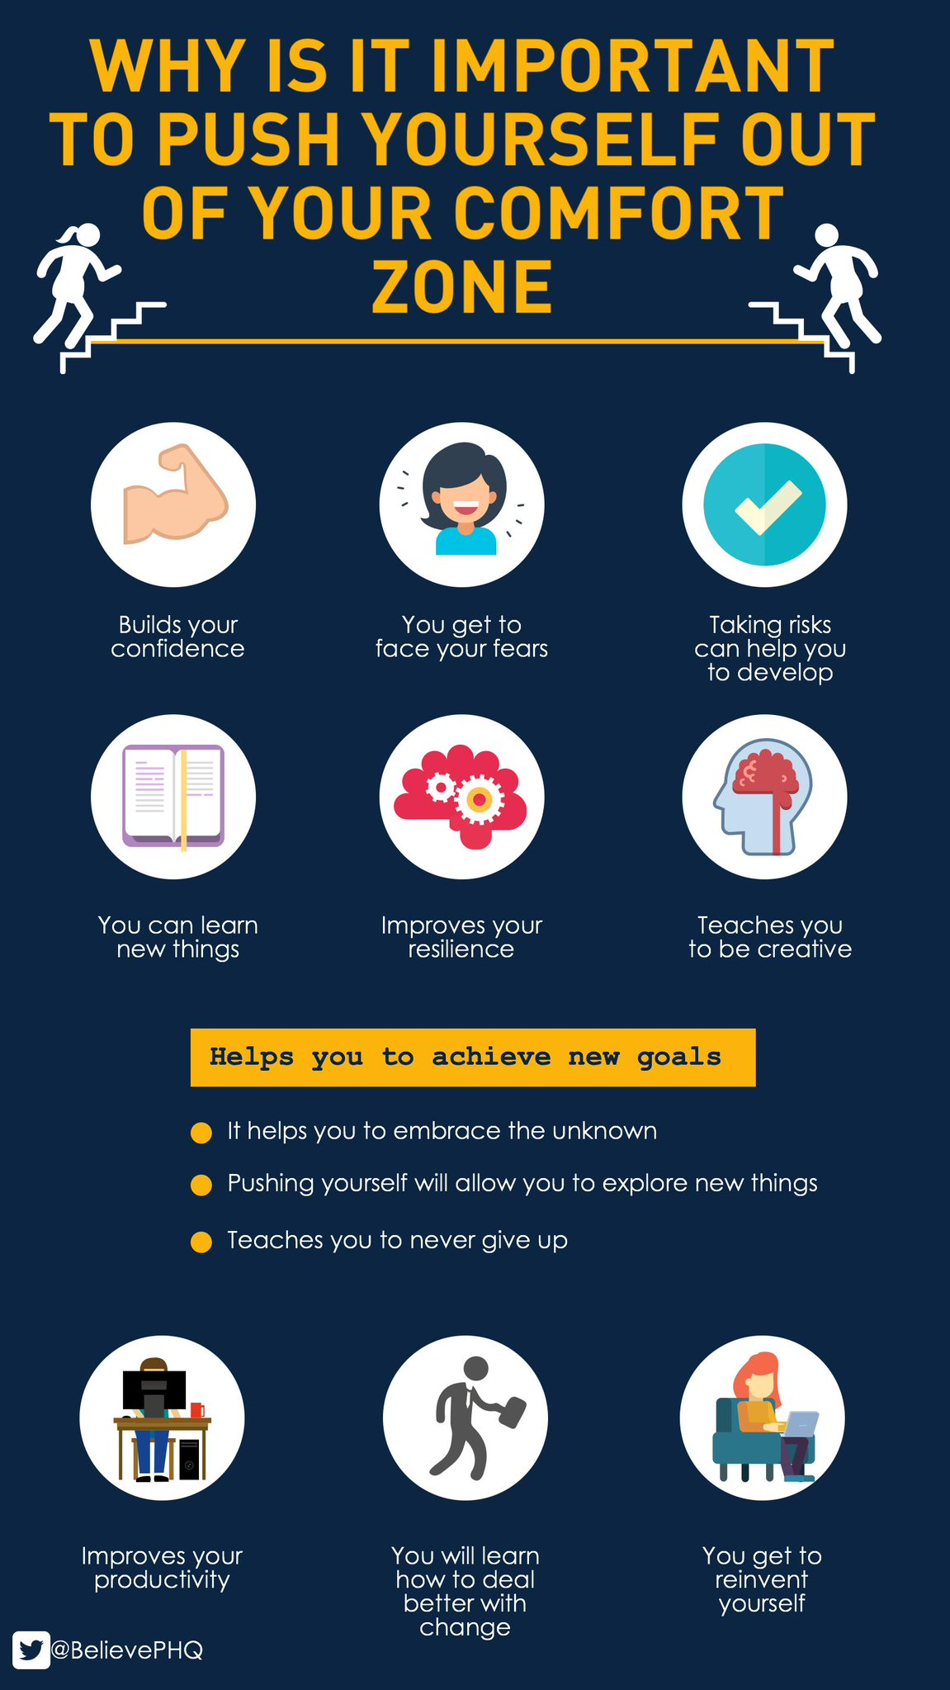

S1
Homework task for pupils to complete engagement form

Substance Misuse 1

Alcohol Part 2

Alcohol Part 1

Stressed Out

PSHE Evaluation

S2
Self Esteem

Friends and Friendship

Stressed Out

Getting the Lowdown

T. Low

