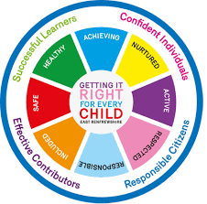
St Ninian’s High School
PSHE Newsletter
Week beginning 8th January 2018

Focus:

- Focus for the week – Apostleship Prayer

• S4 Prelims: Timetable / Exam Preparation / Revision / Study Support.

• The Pope’s Prayer

EMA Meals and Clothing Grant – Must be promoted to all pupils

Food bank Collection

Congratulations and well done to all pupils and staff who brought in food

for the ER Foodbank. The total weight of food collected was 238kg.

It is estimated that this will help to feed 10 large families for three days or 23 single people for the same period of time. Thank you to Miss Murphy and

The Sports Council for the excellent work they carried out for this cause.

Daily Prayers

S1

Peer Awards

Young Carers

S2

Peer Awards

Factors Affecting Food Choice

Pupil PSHE Booklet completion – Complete profile on skills and attributes

S3

Study Skills - Recap on how to study for class/block tests

S4

RAMH Talks – Dealing with stress

4a6, 4a7, 4a8, 4a9 and 4a10 – Go to forum once registered with bags.

4a1,4a2, 4a3, 4a4 and 4a5 – Go to forum once registered with bags.
Creating a study plan

S5

Study Skills
- Preparing for Exams
- Study Plan

S6

Blood Collection Drive – All day. Pupils involved should attend agreed time for blood donation.

Barclays Money Skills workshop
6a8 and 6a6 – Respective teachers will have representatives from Barclays attend class to complete workshop with pupils.

Presentation Slides for BARCLAYS Money Survival

Interview Skills – Search Clickview for “Interview Skills”.

T. Low

