St Ninian’s High School
PSHE Newsletter
Week Beginning 7th October 2019

Focus:

Daily Prayers

- A safe & restful holiday to pupils and staff. Thank you for your great support and hard work this term.

- Pupils in S1-3 are NOT allowed to go to shops/toll. They should remain on the school grounds. S3 pupils are allowed to go to Eastwood Café during lunchtime only.

- Show Racism the Red Card – Please cover with all classes

- The Dangers of mobile phone/tablet use for young people – “Dear Student” film. Please show to all classes

- Optomistic October Calendar – Please promote to all pupils

Mental Health

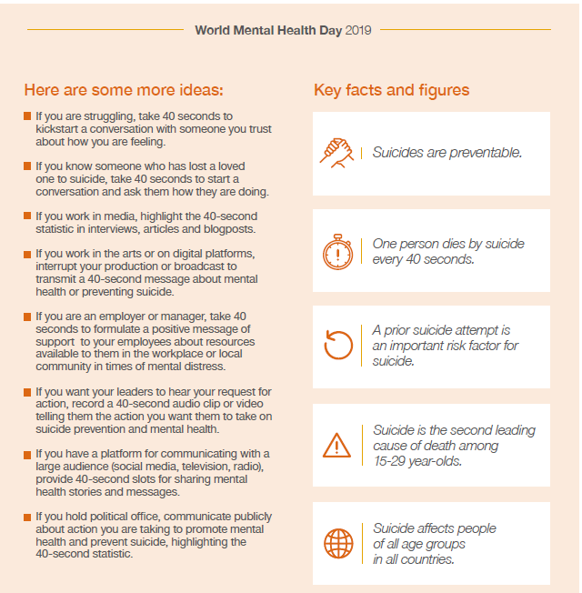

S1

S1 interim tracking report sheet – Please get pupils to complete in class

Marvel Movie Night – Please ask pupils to complete QR code questionnaire

Collate Pupil Council Names and send to year head

S1 First aid visits
1a9 – Wednesday 4th December

S1 Tracking Exercise

Homework Diary Check – Pleaese check and sign pupils Diaries

What is Bullying

Internet Safety
Pupils must use their notes page to answer the questions on this document here

Watch the following clips:
- Chat Rooms
- Downloading files
- Instatnt Messaging
- Online Gaming
- Social Networking

Now answer the questions in your PSHE Booklet Notes section

Healthy Eating

Film Club

GIRFEC Booklet – Work through SHANARRI Indicators and complete with class

Body Image

S2

Tracking for S2 – Please complete with class today!

Marvel Movie Night – Please ask pupils to complete QR code questionnaire

The Science of Character – please show video to all classes and discuss the questions in the powerpoint slide

Hunting the Cyber Bullies - Clickview -Panorama February 2012. Watch video and use Powerpoint with class

The Impact of Bullying

Child Protection

Internet Safety

GIRFEC Booklet – Work through SHANARRI Indicators and complete with class

Study Skills for year ahead

Pupil Council Nominations to be completed ASAP. Please forward names to year head.

S3

Marvel Movie Night – Please ask pupils to complete QR code questionnaire

Collate Pupil Council Names and send to year head

Talk in Lecture theatre with PC J. Waters (Campus Police Officer) regarding:
• Teenage drinking
• Unacceptable use of social media
• Sexting and online bullying

Monday 07/10/19 – 3a6, 3a7 & 3a8
Tuesday 08/10/19 – 3a1, 3a2 & 33

Please regisgter classes and take to the lecture theatre. Please also collect
PC Waters from the school office.

Homework Diary Check – Pleaese check and sign pupils Diaries

S3 Tracking – Please cover with classes

PSHE Booklet Page 39 – CV Writing. Please complete Personal statement and Skills section with pupils. The hyperlink will also provide some usefule information for CV Writing.

Body Image

Sound Sleep

Mental Health and Wellbeing
The attached slides cover how pupils, parents and staff can access support for a range of Mental Health issues. The information here can also be accessed on the main school website.

Study Skills

GIRFEC Booklet – Work through SHANARRI Indicators and complete with class

Balanced Diet
S4

Marvel Movie Night – Please ask pupils to complete QR code questionnaire

Collate Pupil Council Names and send to year head

RAMH Visit
4A8 Wednesday 9th October
4a2 Friday 11th October
Please collect speaker from the school office

Homework Diary Check – Pleaese check and sign pupils Diaries

Study Timetable Template – Please Highlight to pupils and print off if pupils would like a copy.

Anti Smoking – Clickview - Introducing Tobacco

Focus group minutes for S4 – Please go over minutes with classes in PSHE

CV Writing

Mental Health and Wellbeing
The attached slides cover how pupils, parents and staff can access support for a range of Mental Health issues. The information here can also be accessed on the main school website.

PSHE Booklet – complete skills learned in each subject

GIRFEC Booklet – Work through SHANARRI Indicators and complete with class

PSHE Booklet – Health and Wellbeing Pages 10, 11, 12 & 13.
Complete Term 1 Sections

Work Experience – Please go over with your respective classes

S5

Marvel Movie Night – Please ask pupils to complete QR code questionnaire

Collate Pupil Council Names and send to year head

RAMH Talks
5a2 – Monday 28th October
5a8 – Tuesday 22nd October

Homework Diary Check – Pleaese check and sign pupils Diaries

Study Timetable Template – Please Highlight to pupils and print off if pupils would like a copy.

Wider Involvemnent – complete pages 36 – 40 in PSHE booklets

Sound Sleep

Prepare a Study Plan – What do top students do?
Watch the video and look to see how you can create an effective study plan for yourself

Complete S5 achievements profile on Pages 36, 37, 38 and 39. Also complete Academic transferable skills and Attributes Page 40.

Mental Health and Wellbeing
The attached slides cover how pupils, parents and staff can access support for a range of Mental Health issues. The information here can also be accessed on the main school website.

Importance of Sleep

GIRFEC Booklet – Work through SHANARRI Indicators and complete with class

Study Skills – in booklets, highlight the different types of approach to studying. Use ‘Notes’ page for this activity

S6

Marvel Movie Night – Please ask pupils to complete QR code questionnaire

Collate Pupil Council Names and send to year head

6a7 Stewart Ivory Financial education talk. Please collect speaker from the school office

Homework Diary Check – Pleaese check and sign pupils Diaries

Study Timetable Template – Please Highlight to pupils and print off if pupils would like a copy.

Healthy Eating on a budget for 6a1 and ½ 6a2 – Register classes and go to Home Economics

Application evening for S6 pupils

Date | Event | Time
29th October | Application for early years and teaching | 7-9pm
5th November | Application for Business & Accounting | 7-9pm
5th November | Application for Engineering & Computing | 7-9pm
11th November | Application for Law and Social Sciences | 7-9pm
11th November | Interview evening for Medics/Dentists | 7-9pm

Pupil Focus Group meeting for S6

Volunteers required for S1 information evening. Please give your name to your Pastoral Teacher if you wish to help on the evening (4 October).

Arnold Clark Apprenticeship experience – if any pupils are interested please pass their names to Mrs Kennedy

Pupils should log on to the school websit to see the advice available on how to complete their Personal Statement – See Below Hyperlinks

Link to school website and advice on completing Personal Statement

Link 1 – Advice on completing Personal Statement

Link 2 – How to structure Personal Statement

Fast Track applicants should hand first draft of personal statement to teacher for feedback. Also, log on to UCAS using phones or computers to ensure all information is up to date.

Mental Health and Wellbeing
The attached slides cover how pupils, parents and staff can access support for a range of Mental Health issues. The information here can also be accessed on the main school website.

Caritas Award

GIRFEC Booklet – Work through SHANARRI Indicators and complete with class

Study Tips – Inside the mind of a Procrastinator

All about me – Complete with class

Induction Slides

Pupil Council Nominations to be completed ASAP. Please forward names to year head.

T. Low

