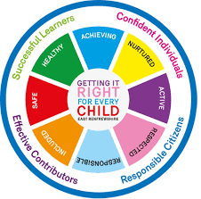
St. Ninian’s High School
PSHE Newsletter
Week beginning 7th January 2019

Focus:

Welcome back

- Courtesy Counts & Kindness

- S4 prelims 14th January-25th January. Timetable / Revision Advice.
- DYW – Working in Science and Technology

- DYW – Working in Education

Daily Prayers

HWB Mental Strength

January challenge:

Whether it’s running 5k, or walking to school a new way, a morning swim or taking your bike out for a spin - join the thousands of people around the UK kick-starting their 2019 in the most positive way.

Start the year off by setting yourself a fitness challenge every day in January:

- Walk a mile

- Jog a mile

- Take part in Monday Spin class in the gym

- Try a new sport or activity at one of our extra-curricular clubs

- Walk to and from school

These are just some of the things you could to help improve your fitness and mental wellbeing in January.

Alternatively, take a picture of the below fitness challenge and try this at home.

You only have to do 2 sets of this 4 times per week.

Join in with the January Challenge!

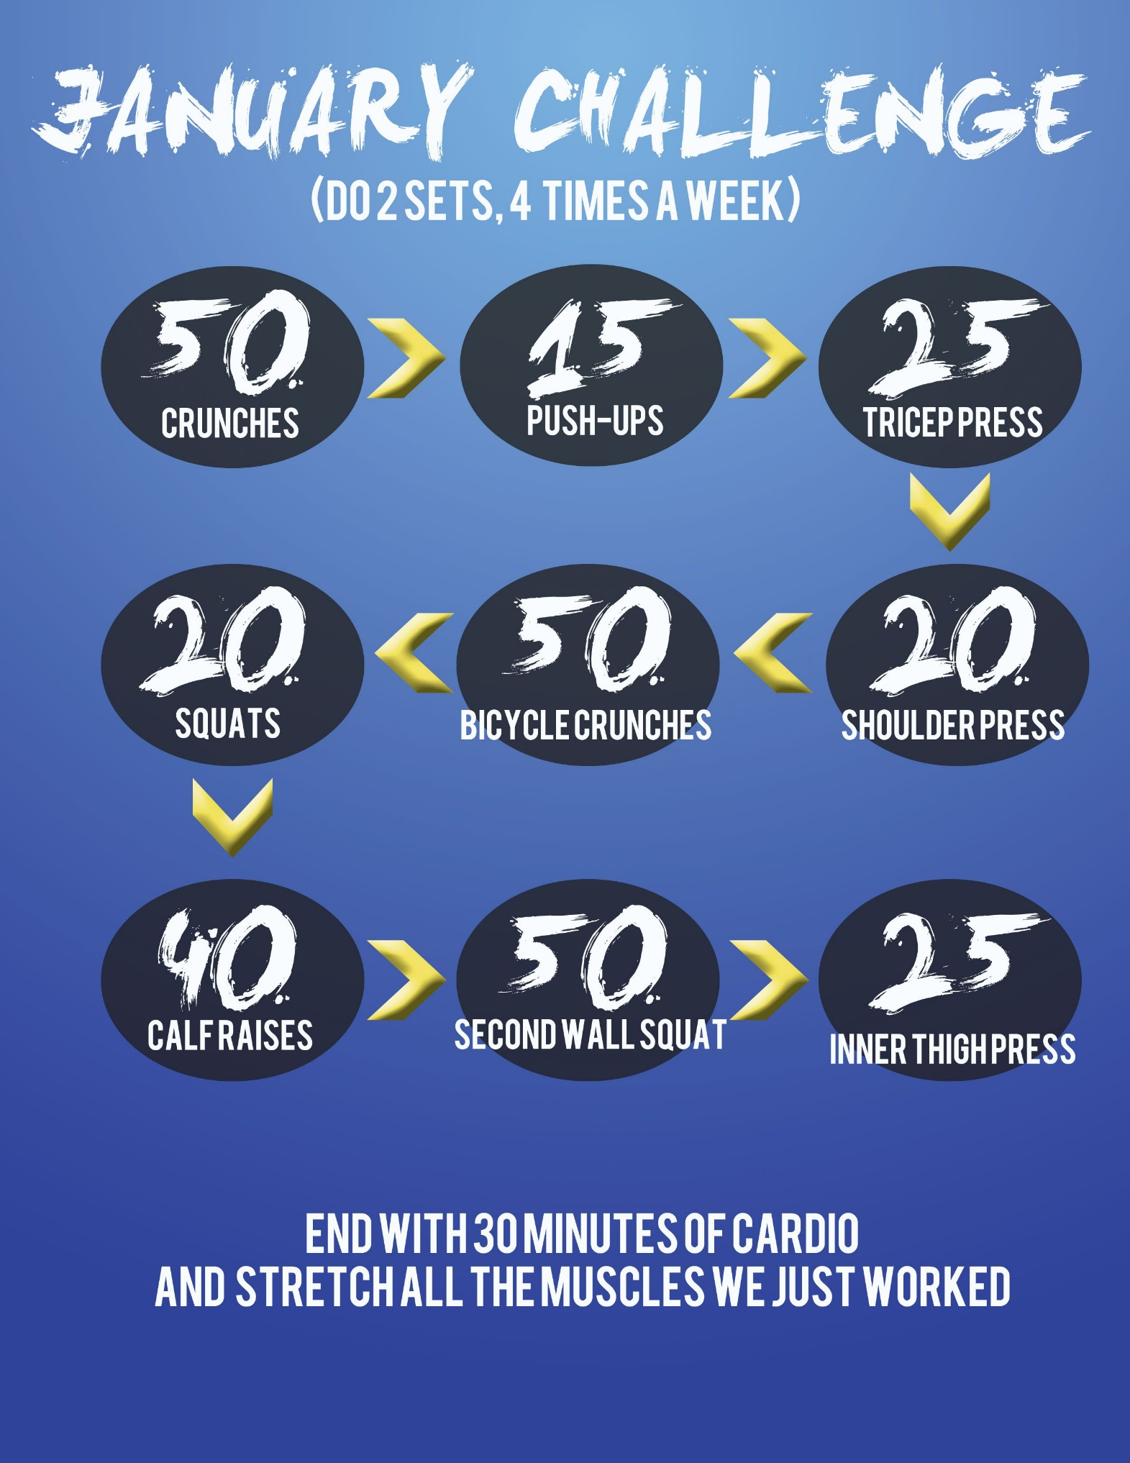

S1

S1 Road Safety Lesson for 1a4 Friday 11th January – Please collect speaker from school office Transport Options – please collect speaker from school office.

Young Carers

Peer Awards

S2

Factors Affecting Food Choice

Peer Awards

Pupil PSHE Booklet completion – Complete profile on skills and attributes

S3

Study Skills - Recap on how to study for class/block tests

S4

RAMH Visits
Wednesday 9th January, 4a8 & 4a9 Period 3

Friday 11th January, 4a3 & 4a4 Period 5

Classes should be registered and then taken to the Lecture theatre for their respective talks. Please ensure to collect the lecture theatre keys and speaker from the school office.

Creating a study plan

S5

RAMH Visits
Monday 7th January, 5a3 & 5a4 Period 5

Tuesday 8th January, 5a6 & 5a9 Period 6

Classes should be registered and then taken to the Lecture theatre for their respective talks. Please ensure to collect the lecture theatre keys and speaker from the school office.

Study Skills
- Preparing for Exams
- Study Plan

S6

Blood Collection Drive – Assembly on Thursday 10th January. Please register pupils in class and escort them to the forum.

Blood collection day Monday 14th January All day. Pupils involved should attend agreed time for blood donation.

- Pupils go on to “Pupil Shared Area”
- Click on “PSHE”
- Pupils go on to “Diploma 2019”
- Pupils click on their own respective Alpha
- Click on the “S6 Diploma” and immediately save in the folder using their name.
- Pupils are to complete each section of the Diploma by writing in to the text box at the bottom of each section
- This will be a working document and pupils should save their work as they go
- It is important that when pupils are writing information in to the text box that they do not hit the return key as this will not work with the software when transferring on to the Diploma

Link to examples of previous diplomas

Link to Lesson for “Responsible Citizen”
Link to Lesson for “Confident Individual”
Link to Lesson for “Successful Learner”
Link to Lesson for “Effective Contributor”

Link to school website to be added for Diploma

Presentation Slides for BARCLAYS Money Survival

T. Low

