St Ninian’s High School
PSHE Newsletter
Week Beginning 5th November 2018

Focus:

Daily Prayers

- Eco Committee are now looking for new members – Please cover the attached poster will pupils from S1 – S6

- Digital Leaders Opportunity for pupils from S1 – S6 – Please cover with all PSHE classes

- Details for November Focus available at: S:\All Staff\Focus For The Week

- Movember

- Rememberance Sunday - Please remember to take time to discuss with your classes the purpose of Remembrance Sunday

- Ring Binders for use – Please promote to all pupils

Extra-Curricular programme booklet

HWB Mental Strength
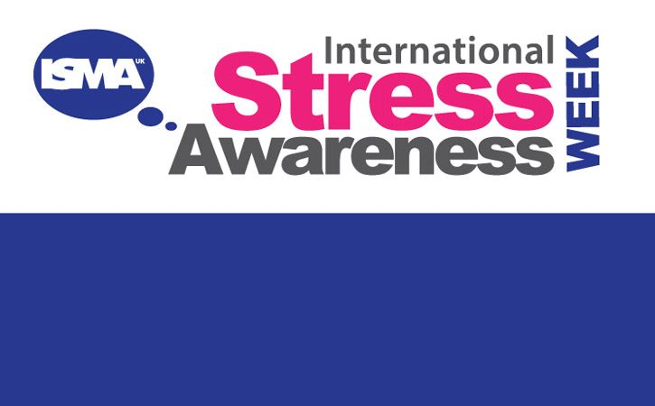

Click here to see how you can identify if you are stressed

Click here for the top 10 Stress Busting Tips

S1

S1 Road Safety lesson

S1 Road Safety Lesson for 1a7 Wednesday 7th November and 1a3 Friday 9 November – Please collect speaker from school office

First Aid Talk for 1a4 9th November – Please collect speaker from school office

Transport Options

GIRFEC Booklet – Work through SHANARRI Indicators and complete with class

S2

YPI Lessons for S2 PSHE – Please complete with class

S2 Pupil Focus Group Minutes – Please go over with class.

Tracking for S2 – Please complete with class. Chromebooks are in R.E. corridor during P3 and P7. Candidate numbers can be found HERE

S3

Anti Byllying lesson 2

Anti Bullying – Please cover with class

STUC Presentation for 3a6, 3a7 and 3a8 Monday 29th October and Tuessday 30th October 3a1, 3a2 and 3a3 – Please register classes and take them to the lecture – Click here for Presentation for STUC speaker

PSHE Booklet Page 39 – CV Writing. Please complete Personal statement and Skills section with pupils. The hyperlink will also provide some usefule information for CV Writing.

S4

Work Experience Prep – Please distribute to class and cover the attached lesson via the hyperlink

Study Timetable Template – Please Highlight to pupils and print off if pupils would like a copy.

Focus group minutes for S4 – Please go over minutes with classes in PSHE

CV Writing

GIRFEC Booklet – Work through SHANARRI Indicators and complete with class PSHE Booklet – Health and Wellbeing Pages 10, 11, 12 & 13.
Complete Term 1 Sections

S5

Interim Report – Please complete Page 71 in PSHE Booklets – Pupils are to complete full page along with identifying Targets that they wish to achieve and how they will achieve this

Every Action has consequences Lessson 1

Alcohol Lesson

Keeping myself safe – Safety at parties and nights out – Staff should log in to Clickview through ‘Glow’ and show video of Jo’s Story

Study Timetable Template – Please Highlight to pupils and print off if pupils would like a copy.

Complete S5 achievements profile on Pages 36, 37, 38 and 39. Also complete Academic transferable skills and Attributes Page 40.
GIRFEC Booklet – Work through SHANARRI Indicators and complete with class

Study Skills – in booklets, highlight the different types of approach to studying. Use ‘Notes’ page for this activity

S6

Award in Volunteering Skills SCQF Level 3 – Please promote to pupils

Healthy Eating on a budget for 6a3 and ½ 6a9 – Register classes and go to Home Economics

First Aid Talk for 6a1 Thursday 8th November – Please collect speaker from the reception

Stuart Ivory Money Talks Presentation for 6a1 and 6a2. Double up class in ICT2. Please collect speaker from School office and take to classroom

UCAS – All pupils who are looking at applying through the UCAS process are to log on and fill in basic details including:

1. Personal Details
2. Additional information
3. Student Finance
4. Choices (If Pupils are aware of what Course they are applying for).
5. Education
6. Employment

Pupils should also be looking to complete drafts of Personal Statements for feedback from Pastoral Teacher. Highlight the links below which are on the school website.

Pupils should log on to the school website to see the advice available on how to complete their Personal Statement – See Below Hyperlinks

Link to school website and advice on completing Personal Statement

Link 1 – Advice on completing Personal Statement

Link 2 – How to structure Personal Statement

GIRFEC Booklet – Work through SHANARRI Indicators and complete with class

T. Low

