St Ninian’s High School
PSHE Newsletter
Week Beginning 4th November 2019

Focus:

Daily Prayers

- November: Month of The Holy Souls

- 5 Habits of an Effective Learner

- Emergency Evacuation Procedure

- Rememberance Sunday - Please remember to take time to discuss with your classes the purpose of Remembrance Sunday

- S5 Tracking QR Code – Pleaes ask S5 pupils to complete in class

- S6 Tracking QR Code – Pleaes ask S6 pupils to complete in class

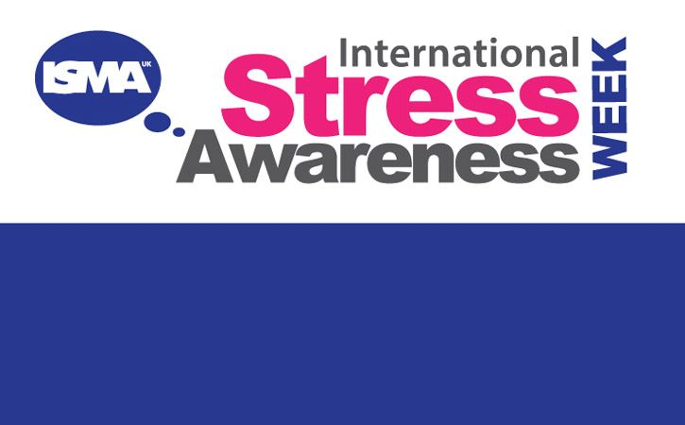
Mental Strength

Click here to see how you can identify if you are stressed
Click here for the top 10 Stress Busting Tips
S1

S1 Pupil council meeting, Period 5 on Friday 8th November in ICT 1 – Please remind those involved to register and go to ICT 1

Children Focussed video on rise of Nazis and how it affects a Jewish family – Please watch video with all classes

S1 Road Safety lesson

S1 interim tracking report sheet – Please get pupils to complete in class

S1 Road Safety Talks
1a7 – Wednesday 6th November
1a3 - Friday 8th November
Please collect speaker from the school office

S1 First aid visits
1a9 – Wednesday 4th December

S1 Tracking Exercise

What is Bullying

S2

Children Focussed video on rise of Nazis and how it affects a Jewish family – Please watch video with all classes

Tracking for S2 – Please complete with class today!

YPI Lessons for S2 PSHE – Please complete with class

The Science of Character – please show video to all classes and discuss the questions in the powerpoint slide

Hunting the Cyber Bullies - Clickview -Panorama February 2012. Watch video and use Powerpoint with class

S3

Pupil Council meeting – Please remind pupil council reps that there will be a pupil council meeting in RE2 Period 3 on Wednesday

Children Focussed video on rise of Nazis and how it affects a Jewish family – Please watch video with all classes

Anti Byllying lesson 2

Anti Bullying – Please cover with class

STUC Talks
Tuesday 5th November at 1.50pm to 2.40pm – Classes 3a1, 3a2 & 3a3

Please register pupils and take them to the lecture theatre. The speaker will also need to be collected from the school office

Marvel Movie Night – Please ask pupils to complete QR code questionnaire

Talk in Lecture theatre with PC J. Waters (Campus Police Officer) regarding:
• Teenage drinking
• Unacceptable use of social media
• Sexting and online bullying

Monday 18/11/19 – 3a9 and 3a10
Tuesday 19/11/19 – 3a4 and 3a5

Please regisgter classes and take to the lecture theatre. Please also collect
PC Waters from the school office.

S4

Children Focussed video on rise of Nazis and how it affects a Jewish family – Please watch video with all classes

Work Experience Prep – Please distribute to class and cover the attached lesson via the hyperlink

S4 Routes and Pathways Talks:
Wednesday the 13th of November P3 4a6, 4a7 and 4a8
RAMH Visit
4a4 Friday 22nd November
4a9 Wednesday 20th November
Please collect speaker from the school office

Study Timetable Template – Please Highlight to pupils and print off if pupils would like a copy.

Anti Smoking – Clickview - Introducing Tobacco

Focus group minutes for S4 – Please go over minutes with classes in PSHE

CV Writing

PSHE Booklet – Health and Wellbeing Pages 10, 11, 12 & 13.
Complete Term 1 Sections

S5

Children Focussed video on rise of Nazis and how it affects a Jewish family – Please watch video with all classes

Interim Report – Please complete Page 71 in PSHE Booklets – Pupils are to complete full page along with identifying Targets that they wish to achieve and how they will achieve this

Every Action has consequences Lessson 1

Alcohol Lesson

RAMH Talks
5a3 – Monday 4th November
5a9 – Tuesday 19th November

Homework Diary Check – Pleaese check and sign pupils Diaries

Study Timetable Template – Please Highlight to pupils and print off if pupils would like a copy.

Wider Involvemnent – complete pages 36 – 40 in PSHE booklets

Prepare a Study Plan – What do top students do?
Watch the video and look to see how you can create an effective study plan for yourself

S6

Children Focussed video on rise of Nazis and how it affects a Jewish family – Please watch video with all classes

Please cover hyperlink slides from Mr McArthur with class:
UCAS – All pupils who are looking at applying through the UCAS process are to log on and fill in basic details including:

1. Personal Details
2. Additional information
3. Student Finance
4. Choices (If Pupils are aware of what Course they are applying for).
5. Education
6. Employment

Pupils should also be looking to complete drafts of Personal Statements for feedback from Pastoral Teacher. Highlight the links below which are on the school website.

6a9 Stewart Ivory Financial education talk. Please collect speaker from the school office

Healthy Eating on a budget for 6a4– Register classes and go to Home Economics

Application evening for S6 pupils

Date | Event | Time
29th October | Application for early years and teaching | 7-9pm
5th November | Application for Business & Accounting | 7-9pm
5th November | Application for Engineering & Computing | 7-9pm
12th November | Application for Law and Social Sciences | 7-9pm
12th November | Interview evening for Medics/Dentists | 7-9pm

Volunteers required for S1 information evening. Please give your name to your Pastoral Teacher if you wish to help on the evening (4 October).

Pupils should log on to the school websit to see the advice available on how to complete their Personal Statement – See Below Hyperlinks

Link to school website and advice on completing Personal Statement

Link 1 – Advice on completing Personal Statement

Link 2 – How to structure Personal Statement

Fast Track applicants should hand first draft of personal statement to teacher for feedback. Also, log on to UCAS using phones or computers to ensure all information is up to date.

Mental Health and Wellbeing
The attached slides cover how pupils, parents and staff can access support for a range of Mental Health issues. The information here can also be accessed on the main school website.

Caritas Award

GIRFEC Booklet – Work through SHANARRI Indicators and complete with class

Study Tips – Inside the mind of a Procrastinator

All about me – Complete with class

T. Low

