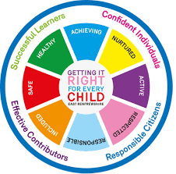
St. Ninian’s High School
PSHE Newsletter
Week beginning 4th March 2019

Focus:

- 5 steps to wellbeing video – Please show all classes

• Lent: For use with your pupils and for personal use.
• S3 Parents’ Evening: see Briefing Sheet from Tony Creighton
• Dance & Gymnastics Show: Wednesday 20th March, 7pm
• Art Exhibition and Fashion Show: Thursday 21st March, 7pm
• No Child Taken Quiz Night, Friday 22nd March, 7-9pm.

- Afternoon Tea for Life: Saturday 23rd March, 1pm-4pm.

- Reminder to all pupils

  - The school is a nut free zone as we have pupils within who have allergies to this food type. Please be considerate with your food choices.

Daily Prayers

HWB – Mental Strength
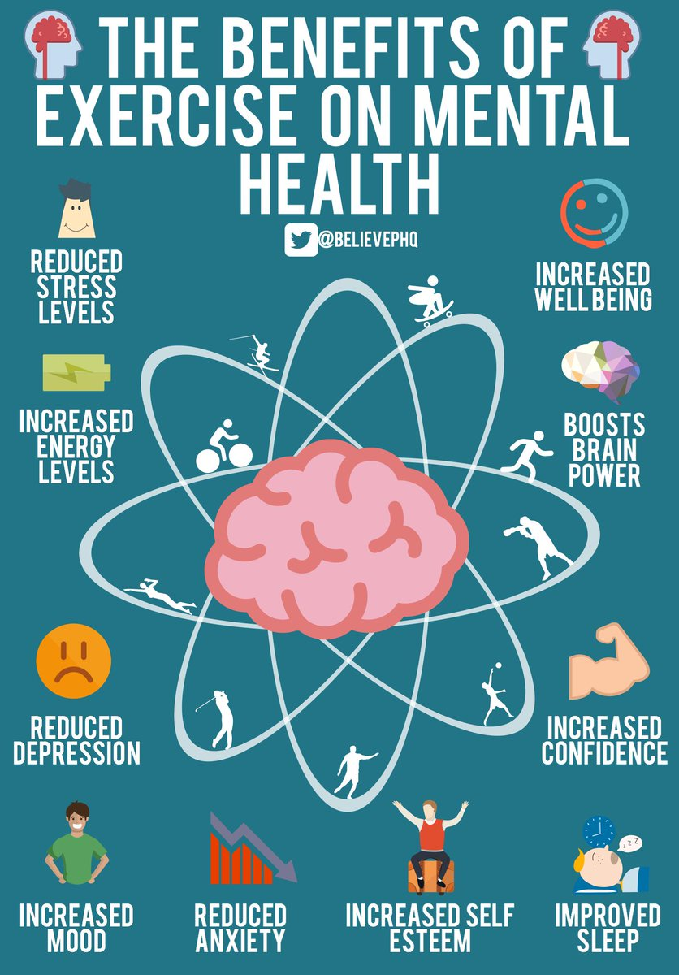

S1
Subject Choices for S1 pupils

Planning for Choices

PSHE Evaluation

Complete Inspiring Purpose booklet

Inspiring Purpose Lesson 3

Inspiring Purpose Lesson 2

Inspiring Purpose Lesson 1 – Please collect booklets from Pastoral Base

S2
Online Etiquette

Teenage Cancer Trust Talk – Staff should register pupils in class and escort them to the Forum with their bags and jackets for talk
Thursday 7th March – 2a1 to 2a10 - 10.40am to 11.30am

Mental Health Awareness

PSHE Evaluation

Human Rights

Prejudice and Discrimination

S3
Keeping Myself Safe using Technology: Clickview: Becky’s Story

Tracking Exercise – Please click on link and show pupils the survey that they are to complete at home. The sheet they were given on Friday has the instructions of how this should be completed

Social media use & internet safety

PSHE Evaluation

Transferable Skills

Study Techniques 2 – Follow up on last week’s lesson

Study Techniques – Pupils will learn a variety of methods that can be used when they are studying

S4
Knife Violence & Gang Culture‐ Knife City (Clickview)

PSHE Evaluation

Online Etiquette

Social Media

EMA – Education Maintenance Allowance – Go over with pupils

Stress and Anxiety – Dealing with Exam stress

S5
Click view - Drug Education for Teens – (Pastoral Staff to choose video topic to be shown to class)

Positive Mental Attitudes - Stigma

Work Experience Survey – Please ask pupils to follow the link via the QR code and fill in any work experience they have done

PSHE Evaluation

Anti-Smoking – Clickview – Smoking Our deadliest Habit – Click on link and use glow details to log in

Ensure that PSHE booklets are up to date including:

- Full report reflection for S5
- Career education standards
- Wellbeing web
- SHANARRI task

Internet Use & Social Network Sites - Clickview- Internet Ethics & Young People

EMA – Education Maintenance Allowance

S6
Work Experience Survey – Please ask pupils to follow the link via the QR code and fill in any work experience they have done

PSHE Evaluation

Diploma Completion for S6 pupils – See the below instructions

- Pupils go on to “Pupil Shared Area”
- Click on “PSHE”
- Pupils go on to “Diploma 2019”
- Pupils click on their own respective Alpha
- Click on the “S6 Diploma” and immediately save in the folder using their name.
- Pupils are to complete each section of the Diploma by writing in to the text box at the bottom of each section
- This will be a working document and pupils should save their work as they go
- It is important that when pupils are writing information in to the text box that they do not hit the return key as this will not work with the software when transferring on to the Diploma

Link to examples of previous diplomas

Link to Lesson for “Responsible Citizen”
Link to Lesson for “Confident Individual”
Link to Lesson for “Successful Learner”
Link to Lesson for “Effective Contributor”

Interview Preparation - 10 step guide on how to prepare for an interview

EMA – Education Maintenance Allowance

Interview Techniques – Watch the clip on “Interview Techniques” and discuss with class

T. Low

