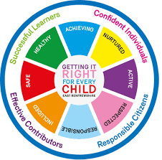
St. Ninian’s High School
PSHE Newsletter
Week beginning 4th February 2019

Focus:
- Mental Health Time to talk day – 7th February – All staff and pupils are welcome to R.E. Room 1 for Tea, biscuits and juice at both break and lunch time. This is an opportunity for staff and pupils to chat and socialise over FREE refreshments. The S6 HWB Group will be organising this event. Please feel free to come along and show your support

- S5/6 Prelims: Timetable issued / Departmental Advice to students

- Modern Slavery & Human Trafficking

- 5 steps to wellbeing video – Please show all classes

- Digital Learning Week 4th to 8th February – Follow this link for a range of activities that you can do with your classes

- Reminder to all pupils

  - The school is a nut free zone as we have pupils within who have allergies to this food type. Please be considerate with your food choices.

Daily Prayers
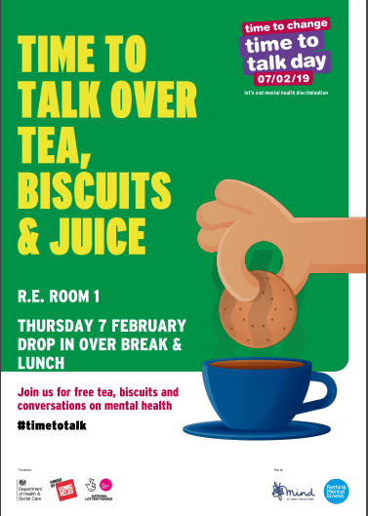
HWB Mental Strength

S1
Safer Internet Day

Inspiring Purpose Lesson 3

Inspiring Purpose Lesson 2

Inspiring Purpose Lesson 1 – Please collect booklets from Pastoral Base

S2
Safer Internet Day

Prejudice and Discrimination

YPI Final – Wednesday 20th February at 7pm. Please support your fellow pupils and attend this excellent event

Complete PSHE booklet – Specifically look at achievements pages. Pupils should complete this – examples are e.g. pupil of the month award etc.

Mindfulness & Breathing Space

S3
Safer Internet Day

Transferable Skills

Study Techniques 2 – Follow up on last week’s lesson

Study Techniques – Pupils will learn a variety of methods that can be used when they are studying
S4

RAMH Talk for 4a10 – Please collect speaker from school office

Online Etiquette

Social Media

Self-Harm - On Edge

EMA – Education Maintenance Allowance – Go over with pupils

Stress and Anxiety – Dealing with Exam stress

S5

Anti-Smoking – Clickview – Smoking Our deadliest Habit – Click on link and use glow details to log in

Ensure that PSHE booklets are up to date including:

- Full report reflection for S5
- Career education standards
- Wellbeing web
- SHANARRI task

Internet Use & Social Network Sites - Clickview- Internet Ethics & Young People

Keeping myself safe – Please watch the video about Scott and engage in class discussion with the questions at the end of the PowerPoint

EMA – Education Maintenance Allowance

S6

Scottish Fire Service – Cut it Out (Driving talk) Could staff teaching 6a4, 6a5 & 6a6 please register in class and take pupils to the lecture theatre and stay for the talk

Could all pupils who are carrying out an S6 Service placement please register in class and go to ICT 8 to complete their Volunteering award

Diploma Completion for S6 pupils – See the below instructions

- Pupils go on to “Pupil Shared Area”
- Click on “PSHE”
- Pupils go on to “Diploma 2019”
- Pupils click on their own respective Alpha
- Click on the “S6 Diploma” and immediately save in the folder using their name.
- Pupils are to complete each section of the Diploma by writing in to the text box at the bottom of each section
- This will be a working document and pupils should save their work as they go
- It is important that when pupils are writing information in to the text box that they do not hit the return key as this will not work with the software when transferring on to the Diploma

Link to examples of previous diplomas

Link to Lesson for “Responsible Citizen”
Link to Lesson for “Confident Individual”
Link to Lesson for “Successful Learner”
Link to Lesson for “Effective Contributor”

Interview Preparation - 10 step guide on how to prepare for an interview

EMA – Education Maintenance Allowance

Interview Techniques – Watch the clip on “Interview Techniques” and discuss with class

T. Low

