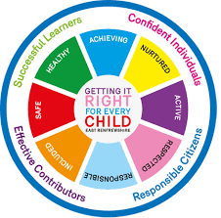
St Ninian’s High School
PSHE Newsletter
Thursday 4th and Friday 5th January 2018

Focus:

Welcome back and Happy New Year to all Staff and Pupils

EMA Meals and Clothing Grant – Must be promoted to all pupils
Daily Prayers

S1

Young Carers

S2

Factors Affecting Food Choice

Pupil PSHE Booklet completion – Complete profile on skills and attributes

S4

Creating a study plan

Complete Questionnaire on Work IT.
Work Experience booklets are to be completed and signed off ASAP.

S6

Assembly for Blood Collection Drive which will be on Thursday 11th January. Pupils who wish to give blood must be 17 years of age and over. Pupils are to be registered in class and taken to the Forum.

T. Low

