St Ninian’s High School
PSHE Newsletter
Week Beginning 2nd December 2019

Focus:

Daily Prayers

• Focus on Advent Week 1: Holy Mass each morning

- Advent: Morning Mass each day at 8.25am. Please encourage our young people to spend time each morning, preparing in the best way for the Nativity of the Lord. I have attached a resource sheet for use with classes

- Christmas Jumper Day 2019

- Emergency Evacuation Procedure

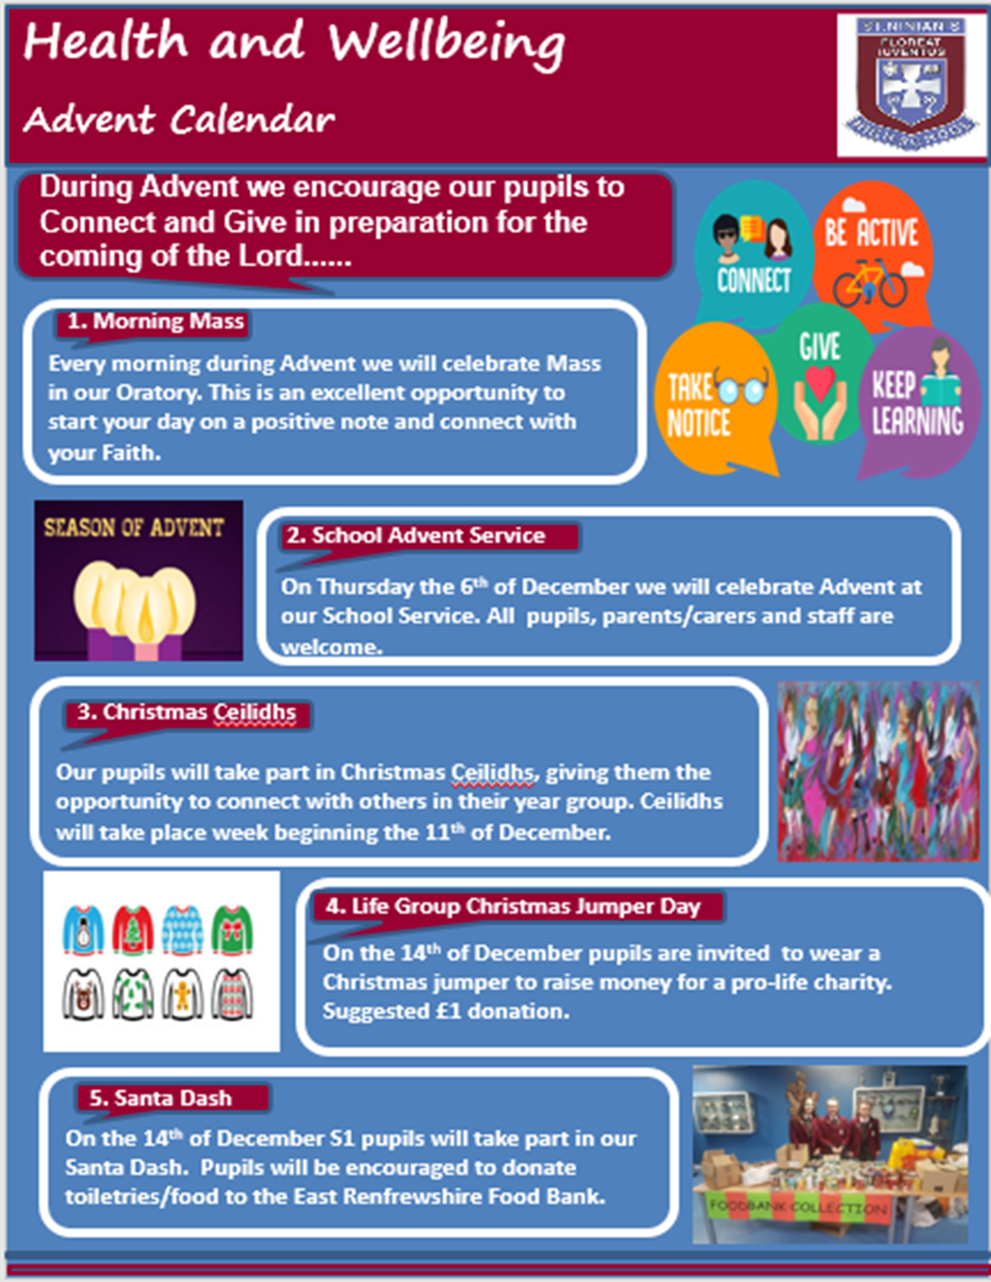

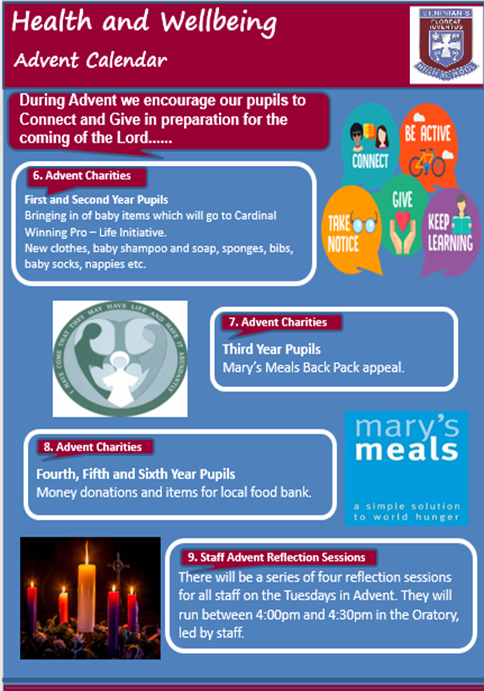

S1

S1 First aid visits
1a9 – Wednesday 4th December – Pleaes collect speaker from school office

S1 Road Safety Talks
1a10 – Wednesday 4th December
Please collect speaker from the school office

Keeping Active – Watch the clip on the benefits of exercise and discuss ideas of how you can keep active over winter. Make notes of this in you PSHE booklet

S1 Santa Dash – S6 pupils will come to class and promote this event

Eating for Success

Talented Athletes – Please highlight to pupils and ask those that meet the criteria to speak with Miss Briggs in P.E.

Ski Trip – Pleaes promote to S1 pupils

S1 Pupil Council Minutes – Please cover with class

S2

YPI Lessons for S2 PSHE – Please complete with class – Class Presentations will begin WB 09/12/18

Online activity and consequences

Food and Health

Anti – Bullying Week 11th to 15th November
Teachers Notes

Children Focussed video on rise of Nazis and how it affects a Jewish family – Please watch video with all classes
S3

My WOW Ambassadors are to meet with Miss Kennedy Period 3 on Wednesday 4th December in the lecture theatre.

STUC Talks
Tuesday 3rd December at 1.50pm to 2.40pm – Classes 3a4 and 3a5
Please register pupils and take them to the lecture theatre. The speaker will also need to be collected from the school office

Anti Smoking – Watch the video on Tobacco: How it Kills. Get in to groups and discuss how you could make an advert to highlight the dangers of smoking to teenagers. You can make a poster in you PSHE booklet or list ways of how you would do this in your groups

Drugs Lesson 1

Anti Social Behaviour

S3 pupil forum minutes – please cover with all classes

Anti – Bullying Week 11th to 15th November
Teachers Notes

Strathclyde’s Engineering the Future for Girls – Please advertise to girls in S3 classes

Children Focussed video on rise of Nazis and how it affects a Jewish family – Please watch video with all classes

S4

RAMH Talks
Wednesday 4th December – 4a9
Friday 6th December – 4a5
Please collect speaker from school office

Study Period – Use this time to revise for any upcoming Prelims

Drugs Lesson

Tracking Extercise to be completd in class

Road Safety Week 18 – 24 November

Prelim Study
All S4 pupils will receive study packs throughout this week. If you are absent when they are issued, please see Mrs Miller
Make the most of all the resources, along with accessing the helpful webpages to help you with studying for your prelims

Children Focussed video on rise of Nazis and how it affects a Jewish family – Please watch video with all classes

Work Experience Recap lesson – Please cover the attached lesson via the hyperlink on pupils work experience placement and complete their booklets

Study Timetable Template – Please Highlight to pupils and print off if pupils would like a copy.

Focus group minutes for S4 – Please go over minutes with classes in PSHE

S5

Road Safety Click View: Staff will need to use there Glow login’s to access videos
- Donnie’s Story
- Driving with Grace

Organ Donation

S5 Tutorials

RAMH Talks
5a5 – Monday 9th December
5a7 – Please collect speaker from the school office

My WOW – Please ensure that pupils are registered

Anti – Bullying week – Slides and link to discussion – Please ensure that all classes provide a return on the Microsoft Forms using the QR Code reader or via the school website

Interim Report – Please complete Page 71 in PSHE Booklets – Pupils are to complete full page along with identifying Targets that they wish to achieve and how they will achieve this

Every Action has consequences Lessson 1

Study Timetable Template – Please Highlight to pupils and print off if pupils would like a copy.

Wider Involvemnent – complete pages 36 – 40 in PSHE booklets

Prepare a Study Plan – What do top students do?
Watch the video and look to see how you can create an effective study plan for yourself

S6

Stewart Ivory Money Talks visit Thursday 5th December – 6a6 and 6a9 – Pleaese register classes and go to Lecture Theatre for talk.

Healthy Eating on a budget for 6a10– Register classes and go to Home Economics

Blood Collection Quiz – pupils should use their phones to complete the quiz on whether or not they are ellligble to give blood. The S6 Head team will be collecting names and providing slots of when pupils will be able to give blood on 9th January 2020 in the small gym. If there are any medical or travel enquiries pupils can call 0345 90 90 999. Only If pupils pass the quiz should they give their name to the S6 Head Team for the collection day.

S6 Tracking QR Code – Pleaes ask S6 pupils to complete in class

Please cover hyperlink slides from Mr McArthur with class:
UCAS – All pupils who are looking at applying through the UCAS process are to log on and fill in basic details including:

1. Personal Details
2. Additional information
3. Student Finance
4. Choices (If Pupils are aware of what Course they are applying for).
5. Education
6. Employment

Pupils should also be looking to complete drafts of Personal Statements for feedback from Pastoral Teacher. Highlight the links below which are on the school website.

6a9 Stewart Ivory Financial education talk. Please collect speaker from the school office

Application evening for S6 pupils

Pupils should log on to the school websit to see the advice available on how to complete their Personal Statement – See Below Hyperlinks

Link to school website and advice on completing Personal Statement

Link 1 – Advice on completing Personal Statement

Link 2 – How to structure Personal Statement

Caritas Award

GIRFEC Booklet – Work through SHANARRI Indicators and complete with class

All about me – Complete with class

T. Low

