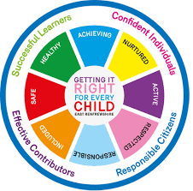
St Ninian’s High School
PSHE Newsletter
Week Beginning 2nd September 2019

Focus:

Daily Prayers

- Pupil Notices – Please cover with S1 to S6

- Volunteering opportunity for those aged 14 and above – Please advertise to pupils

- 1 September: “World Day of Prayer for the Care of Creation”

- Silverburn Teenage Market – Please advertise to pupils

Extra-Curricular programme booklet

Mental Health Awareness

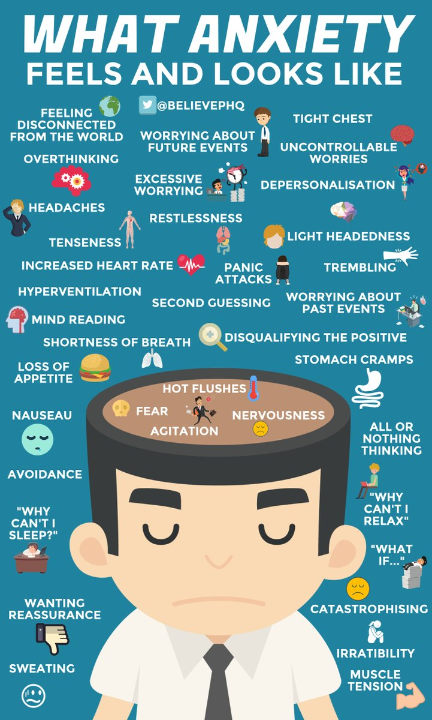

Mental Health Awareness

Strategies to help with Anxiety:

Research has shown that children who experience problematic anxiety can be successfully taught how to cope better with it. Research indicates that the most effective treatment for anxiety disorders is Cognitive Behavioural Therapy (CBT). CBT aims to teach children how to face their anxieties and how to think about situations in a different way so they are able to better manage their anxiety. Cognitive Behaviour Therapy consists of: Learning about anxiety and what causes it (psycho education) Learning relaxation skills Realistic thinking (cognitive exposure) Problem solving Gradually facing the fear/anxiety (graded exposure) Child anxiety management strategies (taught to parents)

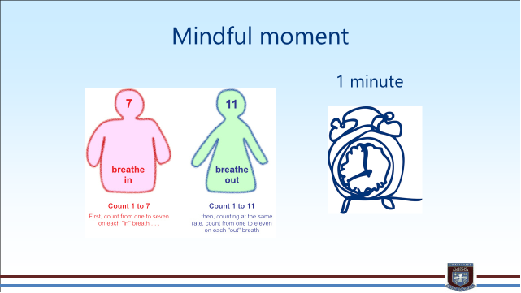
S1

Fun Run Sponsored Event – Please advertise to S1 pupils

GIRFEC Booklet – Work through SHANARRI Indicators and complete with class

PSHE First Aid Visits – Please collect visitor from the school office prior to lesson beginning:
1a7 – 4th September
1a2 – 6th September

Body Image

My first week in St.Ninian’s

Induction Slides

Pupil Council Nominations to be completed ASAP. Please forward names to year head.

S2

Fun Run Sponsored Event – Please advertise to S2 pupils

GIRFEC Booklet – Work through SHANARRI Indicators and complete with class

Body Image

Study Skills for year ahead

Body Image

Induction Slides

Pupil Council Nominations to be completed ASAP. Please forward names to year head.
S3

GIRFEC Booklet – Work through SHANARRI Indicators and complete with class

My WoW Ambassador Programme

Balanced Diet

Exercise Health and Fitness

Pupil Council Nominations to be completed ASAP. Please forward names to year head.

S4

GIRFEC Booklet – Work through SHANARRI Indicators and complete with class

Study Tips – Inside the mind of a Procrastinator

PSHE Booklet – Health and Wellbeing Pages 10, 11, 12 & 13.
Complete Term 1 Sections

Study Skills for S4 – Study Skills Video

Work Experience – Please go over with your respective classes

Pupil Council Nominations to be completed ASAP. Please forward names to year head.

S5

GIRFEC Booklet – Work through SHANARRI Indicators and complete with class

Study Skills – in booklets, highlight the different types of approach to studying. Use ‘Notes’ page for this activity

Study Tips – Inside the mind of a Procrastinator

Pupil Council Nominations to be completed ASAP. Please forward names to year head.

S6

GIRFEC Booklet – Work through SHANARRI Indicators and complete with class

Stuart Ivory "Money Talks" sessions 6a2 – Thursday 5th September 1.00pm - Please collect guest from the reception prior to the start of the lesson

Study Tips – Inside the mind of a Procrastinator

Pupils are to leave class at 1.45pm to avoid corridor congestion

All about me – Complete with class

S6 Service Slides

Heriot Watt University Open Days – Edinburgh Campus
Saturday 14 September
Saturday 26 October

Pupil Council Nominations to be completed ASAP. Please forward names to year head.

Diploma Completion for S6 pupils – See the below instructions

- Pupils go on to “Pupil Shared Area”
- Click on “PSHE”
- Pupils go on to “Diploma 2020”
- Pupils click on their own respective Alpha
- Click on the “S6 Diploma” and immediately save in the folder using their name.
- Pupils are to complete each section of the Diploma by writing in to the text box at the bottom of each section
- This will be a working document and pupils should save their work as they go
- It is important that when pupils are writing information in to the text box that they do not hit the return key as this will not work with the software when transferring on to the Diploma

Link to examples of previous diplomas

Link to Lesson for “Responsible Citizen”
Link to Lesson for “Confident Individual”
Link to Lesson for “Successful Learner”

My World of Work

S6 Service – encourage pupils to sign up to volunteering opportunities that are on offer throughout the year

T. Low

