St Ninian’s High School
PSHE Newsletter
Week Beginning 1st October 2018

Focus:

Daily Prayers

- Building Character: Periodic Table of Character Strengths

Use the hyperlink above to help pupils identify their strengths and where they would like to improve during your discussions with pupils regarding their recent reports.

- Pupils in S1-3 are NOT allowed to go to shops/toll. They should remain on the school grounds. S3 pupils are allowed to go to Eastwood Café during lunchtime only.

- Show Racism the Red Card – Please cover with all classes

- The Dangers of mobile phone/tablet use for young people – “Dear Student” film. Please show to all classes

- Optomistic October Calendar – Please promote to all pupils

Mental Health Awareness

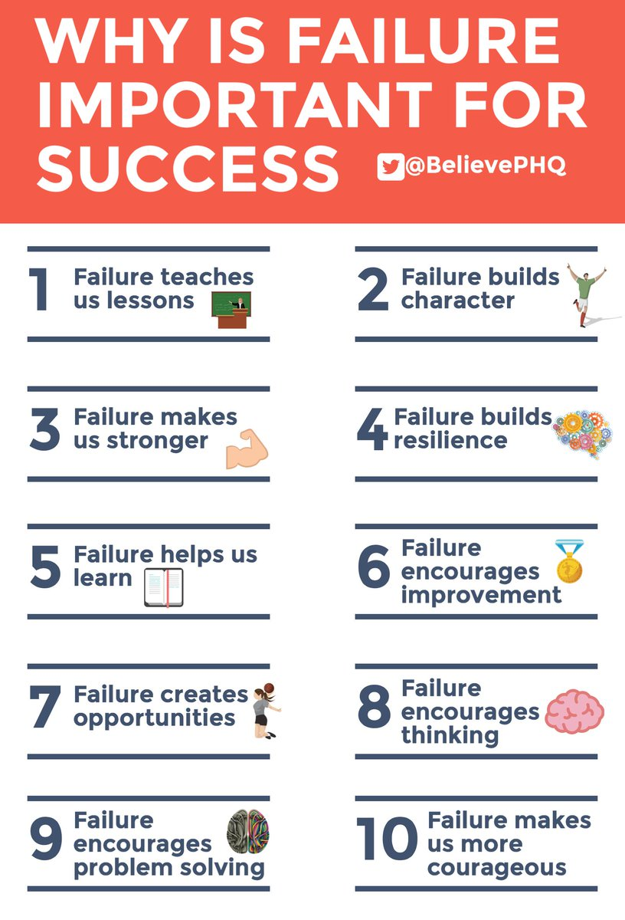
S1

Rugby Club will be on Wednesday’s after school on the grass pitch at the back of the Hockey pitch. Pupils must bring their P.E. Kit, boots and mouthguard. Pleaes see Mr Low for further information.

S1 First aid visits
1a10 – Wednesday
1a2 – Friday

Peer Pressure and Bullying

What is Bullying

Internet Safety
Pupils must use their notes page to answer the questions on this document here

Watch the following clips:
- Chat Rooms
- Downloading files
- Instatnt Messaging
- Online Gaming
- Social Networking

Now answer the questions in your PSHE Booklet Notes section

Healthy Eating

Film Club

GIRFEC Booklet – Work through SHANARRI Indicators and complete with class

Body Image

Pupil Council Nominations to be completed ASAP. Please forward names to year head.

S2

Hunting the Cyber Bullies - Clickview -Panorama February 2012. Watch video and use Powerpoint with class

The Impact of Bullying

Child Protection

Internet Safety

GIRFEC Booklet – Work through SHANARRI Indicators and complete with class

Study Skills for year ahead

Pupil Council Nominations to be completed ASAP. Please forward names to year head.

S3

My World of Work

S3 Tracking exercise to be completed

PSHE Booklet Page 39 – CV Writing. Please complete Personal statement and Skills section with pupils. The hyperlink will also provide some usefule information for CV Writing.

Body Image

Sound Sleep

Mental Health and Wellbeing
The attached slides cover how pupils, parents and staff can access support for a range of Mental Health issues. The information here can also be accessed on the main school website.

Study Skills

S4

RAMH Visit
4A8 Wednesday 9th October
4a2 Friday 11th October
Please collect speaker from the school office

Anti Smoking – Clickview - Introducing Tobacco

CV Writing

Work Experience Check – pupils who have yet to hand in a green form should log on to WorkIT and request placements. Usernames and Passwords can be obtained from Mrs Kennedy

Mental Health and Wellbeing
The attached slides cover how pupils, parents and staff can access support for a range of Mental Health issues. The information here can also be accessed on the main school website.

Pupil Council Nominations to be completed ASAP. Please forward names to year head.

S5

RAMH Visit for 5a10 Tuesday 1st October – Please collet the speaker from the school office

Crime and the Law

Sound Sleep

Prepare a Study Plan – What do top students do?
Watch the video and look to see how you can create an effective study plan for yourself

Complete S5 achievements profile on Pages 36, 37, 38 and 39. Also complete Academic transferable skills and Attributes Page 40.

Mental Health and Wellbeing
The attached slides cover how pupils, parents and staff can access support for a range of Mental Health issues. The information here can also be accessed on the main school website.

Importance of Sleep

GIRFEC Booklet – Work through SHANARRI Indicators and complete with class

Study Skills – in booklets, highlight the different types of approach to studying. Use ‘Notes’ page for this activity

Study Tips – Inside the mind of a Procrastinator

Pupil Council Nominations to be completed ASAP. Please forward names to year head.

S6

6a6 Stewart Ivory Financial education talk. Please collect speaker from the school office

Healthy Eating on a budget for 6a1 – Register classes and go to Home Economics

Volunteers required for S1 information evening. Please give your name to your Pastoral Teacher if you wish to help on the evening (3 October).

Arnold Clark Apprenticeship experience – if any pupils are interested please pass their names to Mrs Kennedy

Pupils should log on to the school websit to see the advice available on how to complete their Personal Statement – See Below Hyperlinks

Link to school website and advice on completing Personal Statement

Link 1 – Advice on completing Personal Statement

Link 2 – How to structure Personal Statement

Fast Track applicants should hand first draft of personal statement to teacher for feedback. Also, log on to UCAS using phones or computers to ensure all information is up to date.

Mental Health and Wellbeing
The attached slides cover how pupils, parents and staff can access support for a range of Mental Health issues. The information here can also be accessed on the main school website.

Caritas Award

GIRFEC Booklet – Work through SHANARRI Indicators and complete with class

Study Tips – Inside the mind of a Procrastinator

All about me – Complete with class

Induction Slides

Pupil Council Nominations to be completed ASAP. Please forward names to year head.

T. Low

