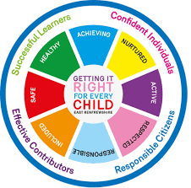
St. Ninian’s High School
PSHE Newsletter
Week beginning 28th May 2019

Focus:

- 5 steps to wellbeing video – Please show all classes

- Health and Wellbeing Committee Needs You!!!

- Sports & Family Fun Day: Wednesday 5th June, 3pm

- S6 Mass of Thanksgiving and Graduation, 7pm, 7th June

- School Show: 18-21st June. Tickets available at the school office

Daily Prayers

Mental Strength and Wellbeing

S1

PSHE Evaluation – Please ask pupils to complete using there GLOW username and password

Please complete the Full Report Section in PSHE booklets with all pupils. Pupils should set targets in relation to discussion from parent’s night

Substance Misuse 2

Substance Misuse 1

Alcohol Part 2

Alcohol Part 1

S2
All Pupils attending Ardeche trip 2019:
EHIC cards, Passports and Pocket Money is due ASAP.

Achieving a Healthy Lifestyle

Drugs Scenario

Drugs Introduction

Friends and Friendship

Stressed Out

S3

Eating Disorders

Healthy Eating/Unbalanced Diets

Understanding Prejudice

Alcohol lessons Click view- ‘Kick it, Binge Drinking’

Alcohol lesson

PSHE Evaluation

T. Low

