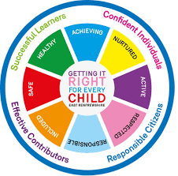
St. Ninian’s High School
PSHE Newsletter
Week beginning 25th February 2019

Focus:

- 5 steps to wellbeing video – Please show all classes

- S3 Wider Achievement: reflection / discussion with pastoral teacher.
- S5/6 Prelims - Final Week.
- S1 Choices Evening, Thursday 28th February, 7pm.
- Life Afternoon Tea, Saturday 23rd March, 1pm.

- Reminder to all pupils

  - The school is a nut free zone as we have pupils within who have allergies to this food type. Please be considerate with your food choices.

Daily Prayers

HWB – Mental Strength
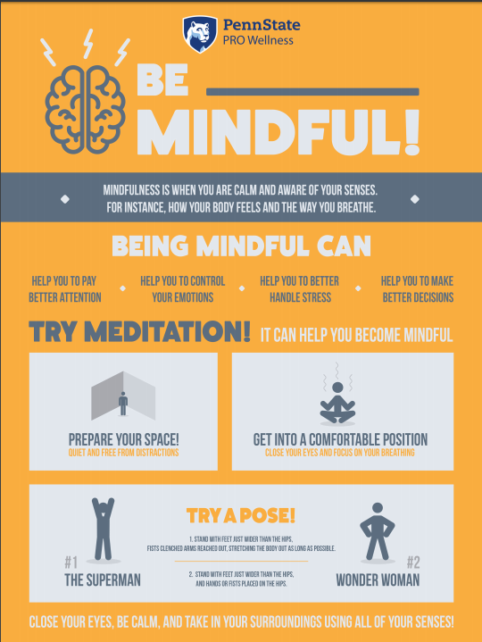

S1
Planning for Choices

PSHE Evaluation

Complete Inspiring Purpose booklet

Inspiring Purpose Lesson 3

Inspiring Purpose Lesson 2

Inspiring Purpose Lesson 1 – Please collect booklets from Pastoral Base

S2
Mental Health Awareness

PSHE Evaluation

Human Rights

Prejudice and Discrimination

S3
Scottish SPCA Talks
Monday 25th February – 3a8
Tuesday 26th February – 3a3 & 3a4
Please collect speaker from the school office

Tracking Exercise – Please click on link and show pupils the survey that they are to complete at home. The sheet they were given on Friday has the instructions of how this should be completed

Social media use & internet safety

PSHE Evaluation

Transferable Skills

Study Techniques 2 – Follow up on last week’s lesson

Study Techniques – Pupils will learn a variety of methods that can be used when they are studying

S4
Options process – S4 into S5 Options begins – Complete sheets with pupils and hand to Mr Marshall

PSHE Evaluation

Online Etiquette

Social Media

EMA – Education Maintenance Allowance – Go over with pupils

Stress and Anxiety – Dealing with Exam stress

S5
The Sutton Trust Summer School Application process closes on 28 February 2019 - If you have any questions about this pleaes email (schools.access@st-andrews.ac.uk) or call 01334 462346. Also speak to your Pastoral Support teacher for further information

Positive Mental Attitudes - Stigma

Work Experience Survey – Please ask pupils to follow the link via the QR code and fill in any work experience they have done

PSHE Evaluation

Anti-Smoking – Clickview – Smoking Our deadliest Habit – Click on link and use glow details to log in

Ensure that PSHE booklets are up to date including:

- Full report reflection for S5
- Career education standards
- Wellbeing web
- SHANARRI task

Internet Use & Social Network Sites - Clickview- Internet Ethics & Young People

EMA – Education Maintenance Allowance

S6
Could all pupils who are carrying out an S6 Service placement please register in class and go to ICT 8 to complete their Volunteering award

Work Experience Survey – Please ask pupils to follow the link via the QR code and fill in any work experience they have done

PSHE Evaluation

Diploma Completion for S6 pupils – See the below instructions

- Pupils go on to “Pupil Shared Area”
- Click on “PSHE”
- Pupils go on to “Diploma 2019”
- Pupils click on their own respective Alpha
- Click on the “S6 Diploma” and immediately save in the folder using their name.
- Pupils are to complete each section of the Diploma by writing in to the text box at the bottom of each section
- This will be a working document and pupils should save their work as they go
- It is important that when pupils are writing information in to the text box that they do not hit the return key as this will not work with the software when transferring on to the Diploma

Link to examples of previous diplomas

Link to Lesson for “Responsible Citizen”
Link to Lesson for “Confident Individual”
Link to Lesson for “Successful Learner”
Link to Lesson for “Effective Contributor”

Interview Preparation - 10 step guide on how to prepare for an interview

EMA – Education Maintenance Allowance

Interview Techniques – Watch the clip on “Interview Techniques” and discuss with class

T. Low

