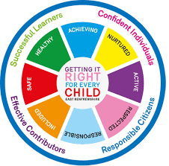
St. Ninian’s High School
PSHE Newsletter
Week beginning 18th February 2019

Focus:

- 5 steps to wellbeing video – Please show all classes

- S5/6 Prelims: 14-28th Feb.: Exam Timetable issued. Teachers to advise their students of times/days and support with their revision programme

- SQA Exam Transport – Please ask pupils who may be affected from the memo sent by Mr Cumming

- Life Mass (7pm) / YPI Final (7pm) / Careers Convention (6pm)
- S1 Choices Evening, Thursday 28th February, 7pm.
- Life Afternoon Tea, Saturday 23rd March, 1pm.

- Reminder to all pupils

  - The school is a nut free zone as we have pupils within who have allergies to this food type. Please be considerate with your food choices.

Daily Prayers

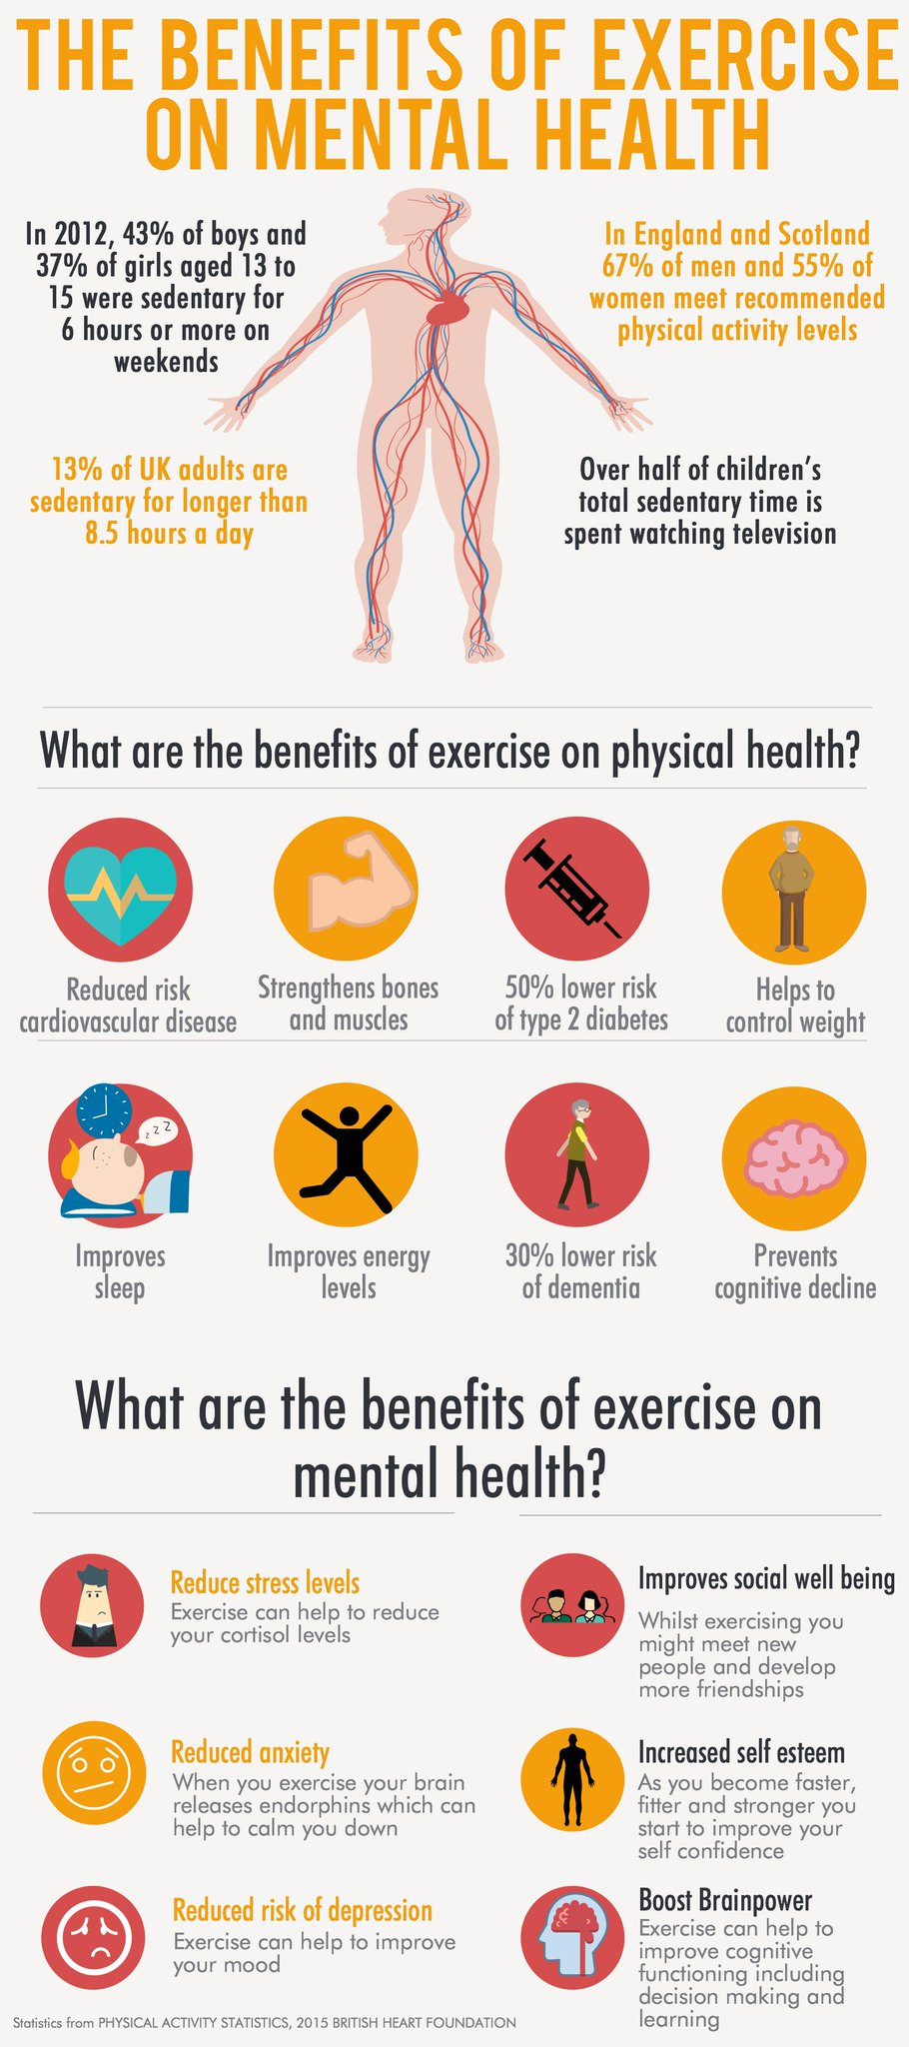

S1
PSHE Evaluation

Complete Inspiring Purpose booklet

Inspiring Purpose Lesson 3

Inspiring Purpose Lesson 2

Inspiring Purpose Lesson 1 – Please collect booklets from Pastoral Base

S2
Scottish Youth Parliament Talks Thursday 21st February
10.40am – 2a6 & 2a7
2.40pm – 2a1 & 2a2
Please collect speakers from the school office

PSHE Evaluation

Human Rights

Prejudice and Discrimination

YPI Final – Wednesday 20th February at 7pm. Please support your fellow pupils and attend this excellent event

S3
Scottish SPCA Talks
Monday 18th February – 3a6 & 3a7
Tuesday 19th February – 3a1 & 3a2
Please collect speaker from the school office

PSHE Evaluation

Transferable Skills

Study Techniques 2 – Follow up on last week’s lesson

Study Techniques – Pupils will learn a variety of methods that can be used when they are studying

S4
PSHE Evaluation

Options process for S4 pupils – Ask pupils to highlight in their booklets what their best 5 subjects are – This will then be the basis of the conversation between pupils and their Pastoral Support teacher

Online Etiquette

Social Media

Self-Harm - On Edge

EMA – Education Maintenance Allowance – Go over with pupils

Stress and Anxiety – Dealing with Exam stress

S5
Work Experience Survey – Please ask pupils to follow the link via the QR code and fill in any work experience they have done

PSHE Evaluation

Anti-Smoking – Clickview – Smoking Our deadliest Habit – Click on link and use glow details to log in

Ensure that PSHE booklets are up to date including:

- Full report reflection for S5
- Career education standards
- Wellbeing web
- SHANARRI task

Internet Use & Social Network Sites - Clickview- Internet Ethics & Young People

EMA – Education Maintenance Allowance

S6
Work Experience Survey – Please ask pupils to follow the link via the QR code and fill in any work experience they have done

PSHE Evaluation

Could all pupils who are carrying out an S6 Service placement please register in class and go to ICT 8 to complete their Volunteering award

Diploma Completion for S6 pupils – See the below instructions

- Pupils go on to “Pupil Shared Area”
- Click on “PSHE”
- Pupils go on to “Diploma 2019”
- Pupils click on their own respective Alpha
- Click on the “S6 Diploma” and immediately save in the folder using their name.
- Pupils are to complete each section of the Diploma by writing in to the text box at the bottom of each section
- This will be a working document and pupils should save their work as they go
- It is important that when pupils are writing information in to the text box that they do not hit the return key as this will not work with the software when transferring on to the Diploma

Link to examples of previous diplomas

Link to Lesson for “Responsible Citizen”
Link to Lesson for “Confident Individual”
Link to Lesson for “Successful Learner”
Link to Lesson for “Effective Contributor”

Interview Preparation - 10 step guide on how to prepare for an interview

EMA – Education Maintenance Allowance

Interview Techniques – Watch the clip on “Interview Techniques” and discuss with class

T. Low

