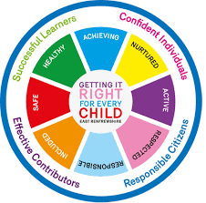
St. Ninian’s High School
PSHE Newsletter
Week beginning 13th February 2019

Focus:

- 5 steps to wellbeing video – Please show all classes

- S5/6 Prelims: 14-28th Feb.: Exam Timetable issued. Teachers to advise their students of times/days and support with their revision programme

- The monthly intention that Pope Francis shares with us all through his personal Prayer Network, reflects the challenges that face humanity and the mission of the Church. He asks, this month, that we pray, with him

- SQA Exam Transport – Please ask pupils who may be affected from the memo sent by Mr Cumming

- Reminder to all pupils

  - The school is a nut free zone as we have pupils within who have allergies to this food type. Please be considerate with your food choices.

Daily Prayers

HWB Mental Strength
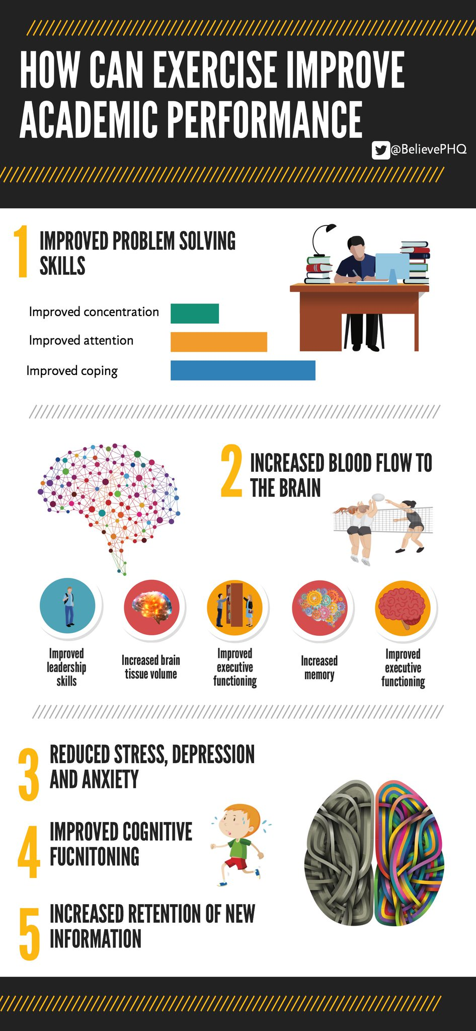

S1
Complete Inspiring Purpose booklet

Inspiring Purpose Lesson 3

Inspiring Purpose Lesson 2

Inspiring Purpose Lesson 1 – Please collect booklets from Pastoral Base

S2
Human Rights

Prejudice and Discrimination

YPI Final – Wednesday 20th February at 7pm. Please support your fellow pupils and attend this excellent event

Complete PSHE booklet – Specifically look at achievements pages. Pupils should complete this – examples are e.g. pupil of the month award etc.

Mindfulness & Breathing Space

S4
Options process for S4 pupils – Ask pupils to highlight in their booklets what their best 5 subjects are – This will then be the basis of the conversation between pupils and their Pastoral Support teacher

Online Etiquette

Social Media

Self-Harm - On Edge

EMA – Education Maintenance Allowance – Go over with pupils

Stress and Anxiety – Dealing with Exam stress

S6

Scottish Fire Service – Cut it Out (Driving talk) Could staff teaching 6a4, 6a5, 6a6, 6a7 & 6a10 please register in class and take pupils to the lecture theatre and stay for the talk

Could all pupils who are carrying out an S6 Service placement please register in class and go to ICT 8 to complete their Volunteering award

Diploma Completion for S6 pupils – See the below instructions

- Pupils go on to “Pupil Shared Area”
- Click on “PSHE”
- Pupils go on to “Diploma 2019”
- Pupils click on their own respective Alpha
- Click on the “S6 Diploma” and immediately save in the folder using their name.
- Pupils are to complete each section of the Diploma by writing in to the text box at the bottom of each section
- This will be a working document and pupils should save their work as they go
- It is important that when pupils are writing information in to the text box that they do not hit the return key as this will not work with the software when transferring on to the Diploma

Link to examples of previous diplomas

Link to Lesson for “Responsible Citizen”
Link to Lesson for “Confident Individual”
Link to Lesson for “Successful Learner”
Link to Lesson for “Effective Contributor”

Interview Preparation - 10 step guide on how to prepare for an interview

EMA – Education Maintenance Allowance

Interview Techniques – Watch the clip on “Interview Techniques” and discuss with class

T. Low

