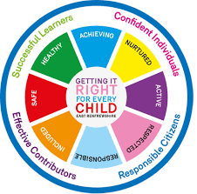
St. Ninian’s High School
PSHE Newsletter
Week beginning 21st January 2019

Focus:

- S4 prelims 14th January-25th January. Timetable / Revision

- Advice

- Virtues for Living and Learning: Eloquence.

- Tracking data for S5/6 issued. Preparation for the S5/6 Parents’ Evening. Please discuss with your pupils their Report in advance of the Parents’ Evening, outlining their strengths & required points for action.

- 5 steps to wellbeing video – Please show all classes

Daily Prayers

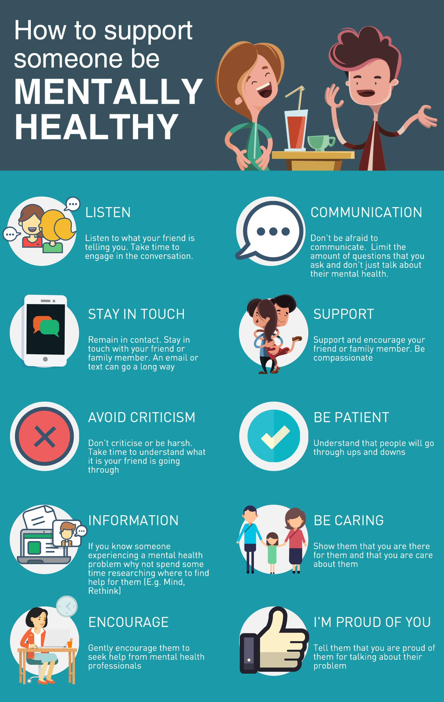
HWB Mental Strength

S1

Inspiring Purpose Lesson 1 – Please collect booklets from Pastoral Base

Young Carers

S2

Mindfulness & Breathing Space

Factors Affecting Food Choice

Pupil PSHE Booklet completion – Complete profile on skills and attributes

S3

Study Techniques 2 – Follow up on last week’s lesson

Study Techniques – Pupils will learn a variety of methods that can be used when they are studying

S4

Self-Harm - On Edge

EMA – Education Maintenance Allowance – Go over with pupils

Stress and Anxiety – Dealing with Exam stress

Creating a study plan

S5

Keeping myself safe – Please watch the video about Scott and engage in class discussion with the questions at the end of the PowerPoint

EMA – Education Maintenance Allowance

Young Carers

S6

Interview Preparation - 10 step guide on how to prepare for an interview

EMA – Education Maintenance Allowance

Interview Techniques – Watch the clip on “Interview Techniques” and discuss with class

- Pupils go on to “Pupil Shared Area”
- Click on “PSHE”
- Pupils go on to “Diploma 2019”
- Pupils click on their own respective Alpha
- Click on the “S6 Diploma” and immediately save in the folder using their name.
- Pupils are to complete each section of the Diploma by writing in to the text box at the bottom of each section
- This will be a working document and pupils should save their work as they go
- It is important that when pupils are writing information in to the text box that they do not hit the return key as this will not work with the software when transferring on to the Diploma

Link to examples of previous diplomas

Link to Lesson for “Responsible Citizen”
Link to Lesson for “Confident Individual”
Link to Lesson for “Successful Learner”
Link to Lesson for “Effective Contributor”

Link to school website to be added for Diploma
T. Low

