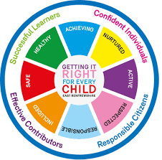

St Ninian’s High School
PSHE Newsletter
Week Beginning 17th December 2018

Focus:

Daily Prayers

- Focus on Advent Week 3: Holy Mass each morning

- Advent: Morning Mass each day at 8.25am. Please encourage our young people to spend time each morning, preparing in the best way for the Nativity of the Lord. I have attached a resource sheet for use with classes

- A Holy and Peaceful Christmas and a safe and restful holiday

- Thank you to pupils and staff for your support through 2018

- HGIOURS Groups oppostunity for all Pupils – Please promote to all year groups

Extra-Curricular programme booklet

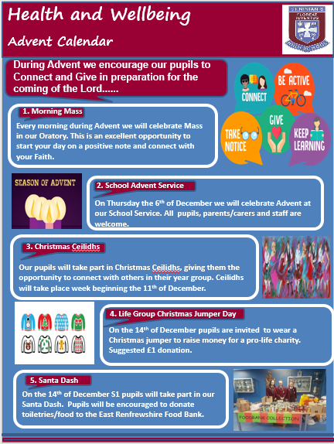
HWB Physical and Mental Strength

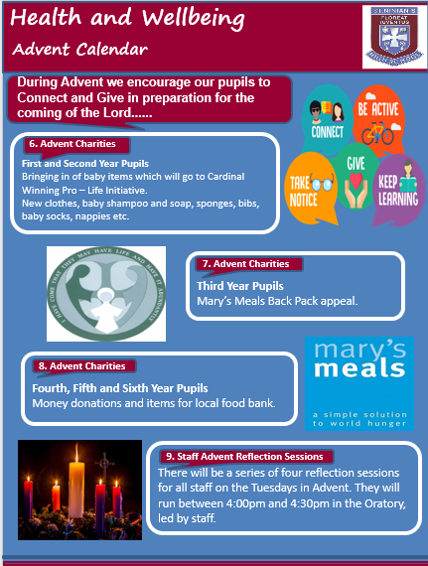

S1

- HWB – Pupils supporting each other – Please complete in PSHE Booklets after a class discussion

- Please ask a class reperesentative to type up the class comments as whole on the attached document

Anti Sectarianism Poster Competition – Please complete this poster competition with your classes. Pupils should work in Groups of 3 or 4 to create their poster

Eating for Success

S1 Road Safety Lesson for 1a10 Wednesday 5th December – Please collect speaker from school office Transport Options

First Aid Talk for 1a4 and 1a5 7th December in the Lecture Theatre – Please register pupils and take classes to the lecture theatre for talk. Collect speaker from school office

GIRFEC Booklet – Work through SHANARRI Indicators and complete with class

S2

- HWB – Pupils supporting each other – Please complete in PSHE Booklets after a class discussion

- Please ask a class reperesentative to type up the class comments as whole on the attached document

YPI Class Presentations

Food and Health

Road Safety Week 19 – 25 November

Tracking for S2 – Please complete with class. Chromebooks are in R.E. corridor during P3 and P7. Candidate numbers can be found HERE

S3

- HWB – Pupils supporting each other – Please complete in PSHE Booklets after a class discussion

- Please ask a class reperesentative to type up the class comments as whole on the attached document

PSHE booklet completition – Pupils are to complete GIRFEC section pages 13 to 17 for term 1.

Drugs Lesson 1

Anti Social Behaviour

PSHE Booklet Page 39 – CV Writing. Please complete Personal statement and Skills section with pupils. The hyperlink will also provide some usefule information for CV Writing.

S4

Work Experience lesson for PSHE booklets – Please aks pupils to bring in their Work Experience booklets and complete as soon as possible

Inspire Stem Opportunity for all pupils

What to remember at Christmas

STUC Presentation Wednesday 12th December 4a6, 4a7 and 4a8 – Please register classes and take them to the lecture theatre – Click here for Presentation for STUC speaker

RAMH Talk - Wednesday 19th December, 4a6 & 4a7 Period 3. Please register classes and take them to the lecture theatre with their bags

S4 Photograph Consents – Please ask pupils to complete the GDPR forms in class

Target Setting following Parents Night – Complete Targets in PSHE booklets. – click on link for “7 things to remember about feedback”.

Drugs Lesson

S5

S5 PSHE Evaluation

Study Plan – Please speak to pupils about creating a study plan over Christmas and New Year

Space School Opportunity – Pleaes promote to all S5 pupils

Self-Harm – Watch Claire’s story Positive Mental Attitudes on Clickview. Staff will need to use their Glow account details to log in

Road Safety Click View: Staff will need to use there Glow login’s to access videos
- Donnie’s Story
- Driving with Grace

Organ Donation

Road Safety Week 19 – 25 November

Every Action has consequences Lessson 1

Alcohol Lesson

Keeping myself safe – Safety at parties and nights out – Staff should log in to Clickview through ‘Glow’ and show video of Jo’s Story

Study Timetable Template – Please Highlight to pupils and print off if pupils would like a copy.

S6

Substance abuse – Just say No!

Anti – Bullying week – Slides and link to discussion – Please ensure that all classes provide a return on the Microsoft Forms using the QR Code reader or via the school website

Award in Volunteering Skills SCQF Level 3 – Please promote to pupils

UCAS – All pupils who are looking at applying through the UCAS process are to log on and fill in basic details including:

1. Personal Details
2. Additional information
3. Student Finance
4. Choices (If Pupils are aware of what Course they are applying for).
5. Education
6. Employment

Pupils should also be looking to complete drafts of Personal Statements for feedback from Pastoral Teacher. Highlight the links below which are on the school website.

Pupils should log on to the school website to see the advice available on how to complete their Personal Statement – See Below Hyperlinks

Link to school website and advice on completing Personal Statement

Link 1 – Advice on completing Personal Statement

Link 2 – How to structure Personal Statement

GIRFEC Booklet – Work through SHANARRI Indicators and complete with class

T. Low

