St Ninian’s High School
PSHE Newsletter
Week Beginning 26th November 2018

Focus:

Daily Prayers

- S4 November Update Parents’ Evening / Pupil Wider Achievement discussion

- School Advent Retreat

- Advent (Holy Mass each morning) / Staff Advent Reflections.

- Christmas Market Friday 30th November. Money raised will go towards supporting school activities. Your support is much appreciated.

- Family Ceilidh: 1st December, 7-10pm, Atrium. Tickets avail. at office.

- Movember

Extra-Curricular programme booklet

HWB Physical and Mental Strength
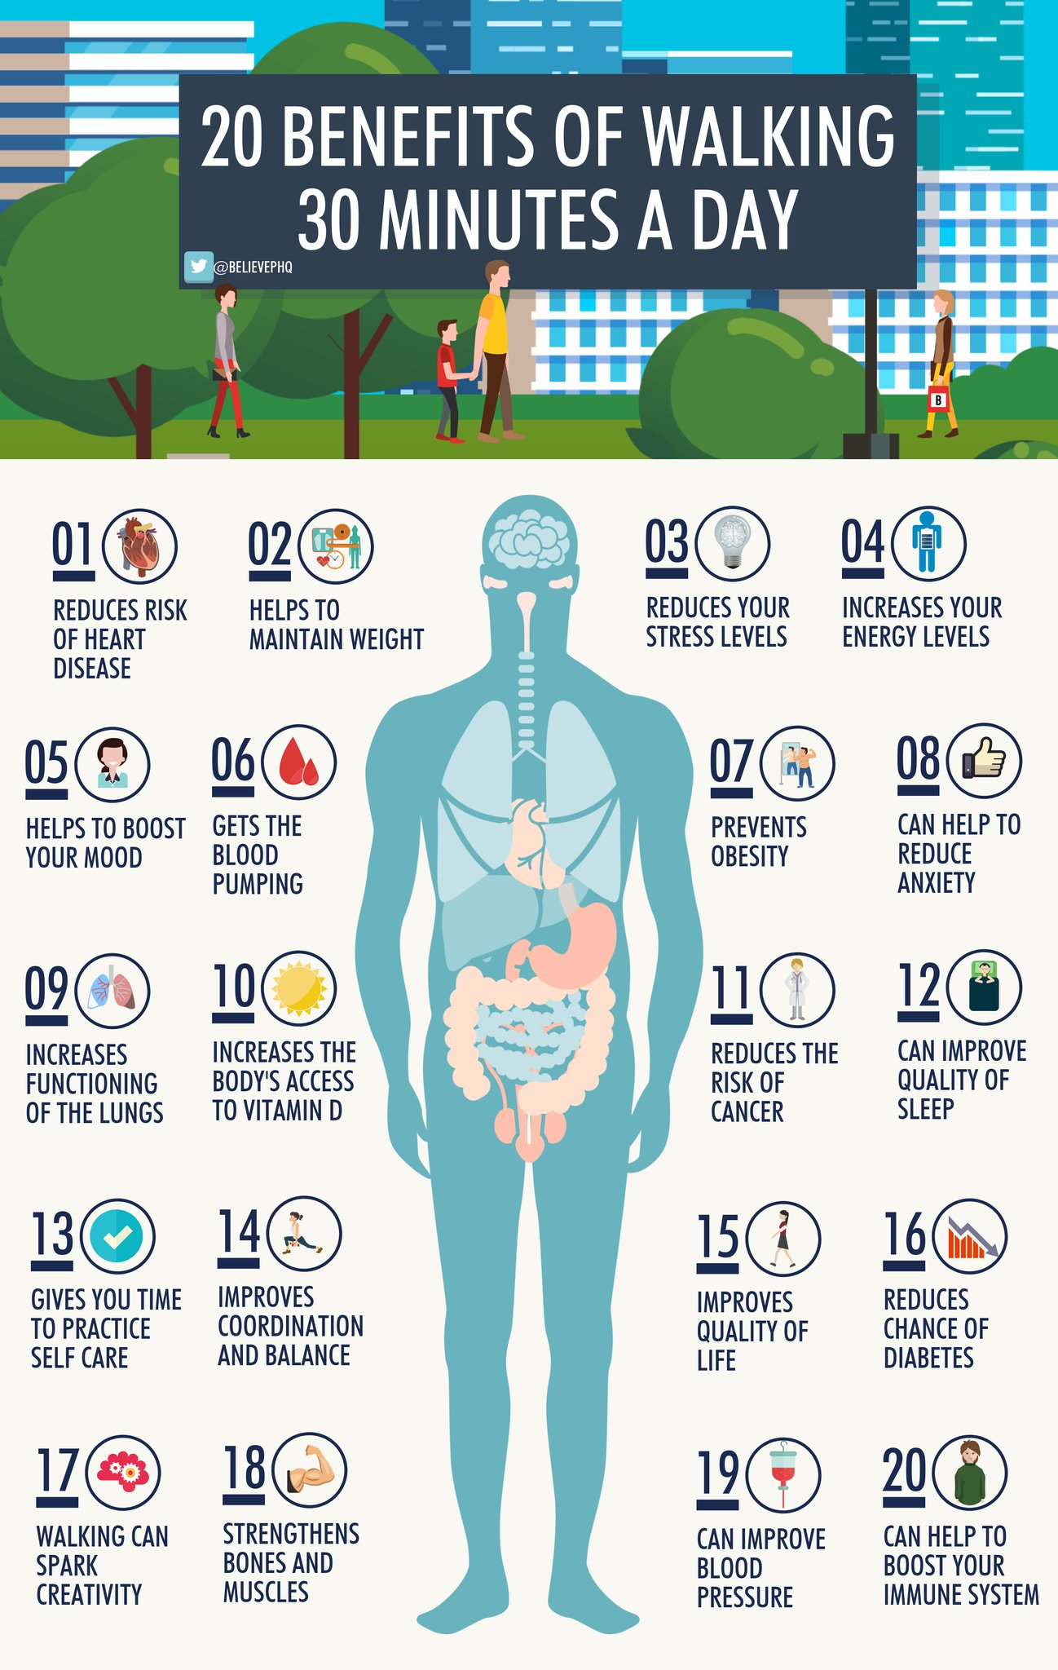

S1

Anti Sectarianism Poster Competition – Please complete this poster competition with your classes. Pupils should work in Groups of 3 or 4 to create their poster

Eating for Success

Road Safety Week 19 – 25 November

Anti – Bullying Week 12th to 17th November – Pupils are to complete poster in groups of 3. What does Respect mean?

S1 Road Safety Lesson for 1a9 Wednesday 28th November – Please collect speaker from school office

First Aid Talk for 1a2 and 1a3 23rd November – Please register pupils and take classes to the lecture theatre for talk. Collect speaker from school office

Transport Options

GIRFEC Booklet – Work through SHANARRI Indicators and complete with class

S2

Food and Health

Road Safety Week 19 – 25 November

YPI Lessons for S2 PSHE – Please complete with class – Class Presentations will begin WB 03/12/18

Tracking for S2 – Please complete with class. Chromebooks are in R.E. corridor during P3 and P7. Candidate numbers can be found HERE

S3

Drugs Lesson 1

Road Safety Week 19 – 25 November

Anti Social Behaviour

STUC Presentation Tuessday 27th November 3a4 and 3a5 – Please register classes and take them to the lecture theatre – Click here for Presentation for STUC speaker

PSHE Booklet Page 39 – CV Writing. Please complete Personal statement and Skills section with pupils. The hyperlink will also provide some usefule information for CV Writing.

S4

Generation Tech opportunity for Girls interested in Engingeering – Please advertise to classes

Drugs Lesson

Road Safety Week 19 – 25 November

Wednesday 28th November – SDS Talks - Robert and Katrina period 3: 4a6, 4a7 and 4a8 – Speakers will come to each respective classroom for the talk on “Routes and Pathways”.

Friday 30th November period 5: 4a4 and 4a5 – Speakers will come to each respective classroom for the talk on “Routes and Pathways”.

Work Experience Prep – Please distribute to class and cover the attached lesson via the hyperlink

S5

Organ Donation

Road Safety Week 19 – 25 November

Every Action has consequences Lessson 1

Alcohol Lesson

Keeping myself safe – Safety at parties and nights out – Staff should log in to Clickview through ‘Glow’ and show video of Jo’s Story

Study Timetable Template – Please Highlight to pupils and print off if pupils would like a copy.

S6

Yearbook quote and hoody order form to be completed on Year book face book

Road Safety Week 19 – 25 November

Anti – Bullying week – Slides and link to discussion – Please ensure that all classes provide a return on the Microsoft Forms using the QR Code reader or via the school website

Award in Volunteering Skills SCQF Level 3 – Please promote to pupils

Healthy Eating on a budget for 6a1 and 6a10 – Register classes and go to Home Economics

First Aid Talk for 6a1, 6a5 and 6a9 TBC

UCAS – All pupils who are looking at applying through the UCAS process are to log on and fill in basic details including:

1. Personal Details
2. Additional information
3. Student Finance
4. Choices (If Pupils are aware of what Course they are applying for).
5. Education
6. Employment

Pupils should also be looking to complete drafts of Personal Statements for feedback from Pastoral Teacher. Highlight the links below which are on the school website.

Pupils should log on to the school website to see the advice available on how to complete their Personal Statement – See Below Hyperlinks

Link to school website and advice on completing Personal Statement

Link 1 – Advice on completing Personal Statement

Link 2 – How to structure Personal Statement

GIRFEC Booklet – Work through SHANARRI Indicators and complete with class

T. Low

