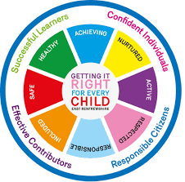

St Ninian’s High School
PSHE Newsletter
Week Beginning 19th November 2018

Focus:

Daily Prayers

- Wellbeing: Getting It Right for Every Child

- World Day of the Poor: 18th November. Compassion & Love for All.

- Catholic Education Sunday, 18th: St Joseph’s Parish, Clarkston. The Caritas Award senior students will speak at all of the Sunday Masses.

- Friends of St. Ninian’s Poster

- Christmas Market Friday 30th November

- Family Ceilidh: 1st December, 7-10pm, Atrium. Tickets avail. at office.

- Movember

- Ring Binders for use – Please promote to all pupils

Extra-Curricular programme booklet

HWB Mental Strength
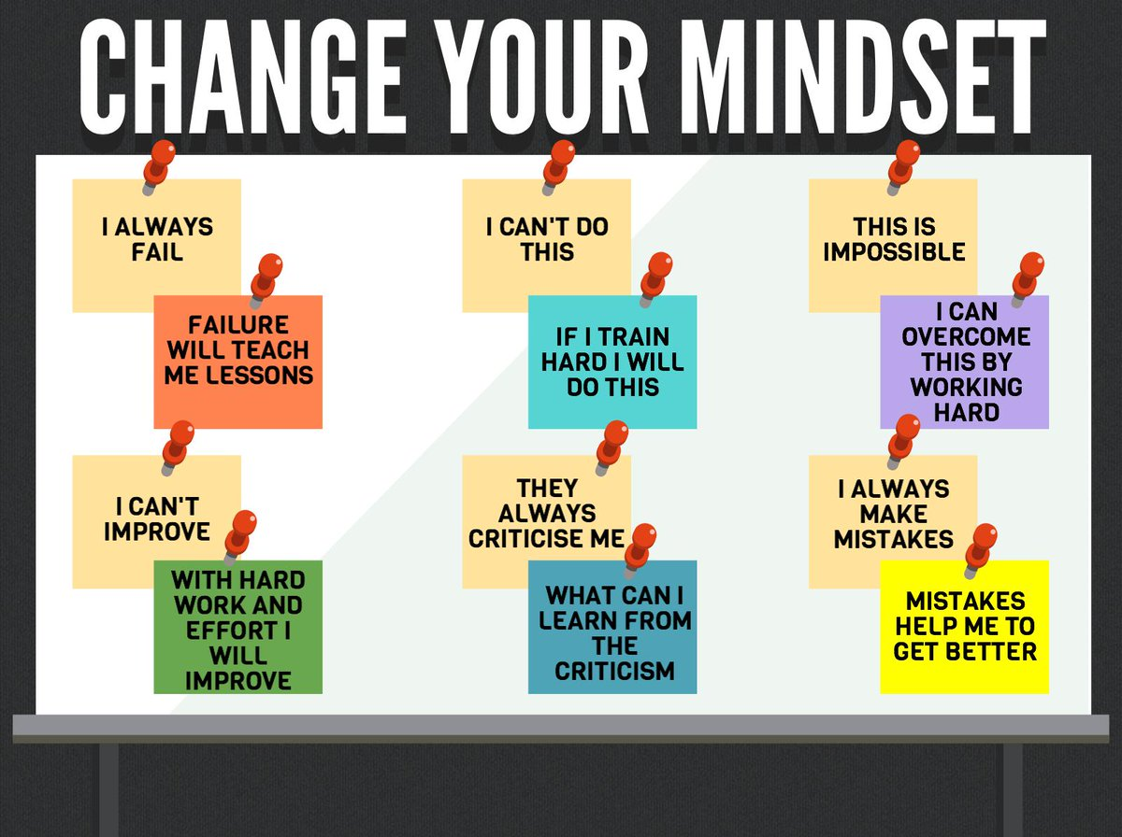

S1

Road Safety Week 19 – 25 November

Anti – Bullying Week 12th to 17th November – Pupils are to complete poster in groups of 3. What does Respect mean?

S1 Road Safety lesson

S1 Road Safety Lesson for 1a8 Wednesday 21st November and 1a5 Friday 23rd November – Please collect speaker from school office

First Aid Talk for 1a2 and 1a3 23rd November – Please register pupils and take classes to the lecture theatre for talk. Collect speaker from school office

Transport Options

GIRFEC Booklet – Work through SHANARRI Indicators and complete with class

S2

Road Safety Week 19 – 25 November

YPI Lessons for S2 PSHE – Please complete with class – Class Presentations will begin WB 03/12/18

Anti – Bullying Week 12th to 17th November – Pupils are to complete poster in groups of 3. What does Respect mean?

S2 Pupil Focus Group Minutes – Please go over with class.

Tracking for S2 – Please complete with class. Chromebooks are in R.E. corridor during P3 and P7. Candidate numbers can be found HERE

S3

Road Safety Week 19 – 25 November

Anti Social Behaviour

Anti – Bullying Week 12th to 17th November – Pupils are to complete poster in groups of 3. What does Respect mean?

Anti Byllying lesson 2

Anti Bullying – Please cover with class

STUC Presentation Tuessday 13th November 3a1, 3a2 and 3a3 – Please register classes and take them to the lecture – Click here for Presentation for STUC speaker

PSHE Booklet Page 39 – CV Writing. Please complete Personal statement and Skills section with pupils. The hyperlink will also provide some usefule information for CV Writing.

S4

Road Safety Week 19 – 25 November

Wednesday 21st November - SDS Talks - Robert and Katrina 4a9 and 4a10 - Speakers will come to each respective classroom for the talk on “Routes and Pathways”.

Friday the 23rd November period 5: 4a4 and 4a5 STUC – Classes should be registered and then go to the lecture theatre with their bags.

Friday the 23rd November - SDS Talks - Robert and Katrina, 4a1, 4a2. 4a3 - Speakers will come to each respective classroom for the talk on “Routes and Pathways”.

Work Experience Prep – Please distribute to class and cover the attached lesson via the hyperlink

S5

Road Safety Week 19 – 25 November

Anti – Bullying week – Slides and link to discussion – Please ensure that all classes provide a return on the Microsoft Forms using the QR Code reader or via the school website

Every Action has consequences Lessson 1

Alcohol Lesson

Keeping myself safe – Safety at parties and nights out – Staff should log in to Clickview through ‘Glow’ and show video of Jo’s Story

Study Timetable Template – Please Highlight to pupils and print off if pupils would like a copy.

S6

Yearbook quote and hoody order form to be completed on Year book face book

Road Safety Week 19 – 25 November

Anti – Bullying week – Slides and link to discussion – Please ensure that all classes provide a return on the Microsoft Forms using the QR Code reader or via the school website

Award in Volunteering Skills SCQF Level 3 – Please promote to pupils

Healthy Eating on a budget for 6a1 and 6a10 – Register classes and go to Home Economics

First Aid Talk for 6a1, 6a5 and 6a9 TBC

UCAS – All pupils who are looking at applying through the UCAS process are to log on and fill in basic details including:

1. Personal Details
2. Additional information
3. Student Finance
4. Choices (If Pupils are aware of what Course they are applying for).
5. Education
6. Employment

Pupils should also be looking to complete drafts of Personal Statements for feedback from Pastoral Teacher. Highlight the links below which are on the school website.

Pupils should log on to the school website to see the advice available on how to complete their Personal Statement – See Below Hyperlinks

Link to school website and advice on completing Personal Statement

Link 1 – Advice on completing Personal Statement

Link 2 – How to structure Personal Statement

GIRFEC Booklet – Work through SHANARRI Indicators and complete with class

T. Low

