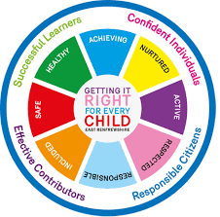

St Ninian’s High School
PSHE Newsletter
Week Beginning 8th Ocotober 2018

Focus:

Daily Prayers

• Peer Tutoring; If pupils feel they could benefit from the help on an S6 Tutor, please take their names and pass on to Mrs McCrea0.

• A safe & restful holiday to pupils and staff. Thank you for your great support and hard work this term.

For S4, S5 & S6 – Please promote this Empoyabiltiy Event to pupils

P.E. Reminder
Pupils are reminded that pupils are not allowed to use Aerosol/Spray deodorants in the changing rooms. If pupils are found to have these types of deodarants they will be confiscated by staff.

Extra-Curricular programme booklet

Mental Health Awareness

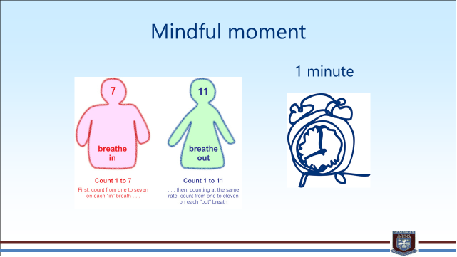
S1

World Mental Health Day 8th October

Homework Diary Check – Pleaese check and sign pupils Diaries

Dyslexia Poster Competition – Pleaes pick up materials from Pastoral base e.g. Paper, colouring pens etc

What is Bullying

Internet Safety
Pupils must use their notes page to answer the questions on this document here

Watch the following clips:
- Chat Rooms
- Downloading files
- Instatnt Messaging
- Online Gaming
- Social Networking

Now answer the questions in your PSHE Booklet Notes section

Healthy Eating

Film Club

GIRFEC Booklet – Work through SHANARRI Indicators and complete with class

Body Image

Pupil Council Nominations to be completed ASAP. Please forward names to year head.

S2

World Mental Health Day 8th October

Homework Diary Check – Pleaese check and sign pupils Diaries

Tracking for S2 – Please complete with class. Chromebooks are in R.E. corridor during P3 and P7. Candidate numbers can be found HERE

Dyslexia Poster Competition – Pleaes pick up materials from Pastoral base e.g. Paper, colouring pens etc

Hunting the Cyber Bullies - Clickview -Panorama February 2012. Watch video and use Powerpoint with class

The Impact of Bullying

Child Protection

Internet Safety

GIRFEC Booklet – Work through SHANARRI Indicators and complete with class

Study Skills for year ahead

Pupil Council Nominations to be completed ASAP. Please forward names to year head.

S3

World Mental Health Day 8th October

Homework Diary Check – Pleaese check and sign pupils Diaries

PSHE Booklet Page 39 – CV Writing. Please complete Personal statement and Skills section with pupils. The hyperlink will also provide some usefule information for CV Writing.

Body Image

Arnold Clark Apprenticeship experience – if any pupils are interested please pass their names to Mrs Kennedy

Sound Sleep

Mental Health and Wellbeing
The attached slides cover how pupils, parents and staff can access support for a range of Mental Health issues. The information here can also be accessed on the main school website.

Study Skills

GIRFEC Booklet – Work through SHANARRI Indicators and complete with class

Balanced Diet

Exercise Health and Fitness

S4

World Mental Health Day 8th October

Homework Diary Check – Pleaese check and sign pupils Diaries

Study Timetable Template – Please Highlight to pupils and print off if pupils would like a copy.

Anti Smoking – Clickview - Introducing Tobacco

Focus group minutes for S4 – Please go over minutes with classes in PSHE

CV Writing

Arnold Clark Apprenticeship experience – if any pupils are interested please pass their names to Mrs Kennedy

Work Experience Check – pupils who have yet to hand in a green form should log on to WorkIT and request placements. Usernames and Passwords can be obtained from Mrs Kennedy

Mental Health and Wellbeing
The attached slides cover how pupils, parents and staff can access support for a range of Mental Health issues. The information here can also be accessed on the main school website.

PSHE Booklet – complete skills learned in each subject

GIRFEC Booklet – Work through SHANARRI Indicators and complete with class

PSHE Booklet – Health and Wellbeing Pages 10, 11, 12 & 13.
Complete Term 1 Sections

Work Experience – Please go over with your respective classes

Pupil Council Nominations to be completed ASAP. Please forward names to year head.

S5

World Mental Health Day 8th October

Homework Diary Check – Pleaese check and sign pupils Diaries

Study Timetable Template – Please Highlight to pupils and print off if pupils would like a copy.

Wider Involvemnent – complete pages 36 – 40 in PSHE booklets

Sound Sleep

Arnold Clark Apprenticeship experience – if any pupils are interested please pass their names to Mrs Kennedy

Prepare a Study Plan – What do top students do?
Watch the video and look to see how you can create an effective study plan for yourself

Complete S5 achievements profile on Pages 36, 37, 38 and 39. Also complete Academic transferable skills and Attributes Page 40.

Mental Health and Wellbeing
The attached slides cover how pupils, parents and staff can access support for a range of Mental Health issues. The information here can also be accessed on the main school website.

Importance of Sleep

GIRFEC Booklet – Work through SHANARRI Indicators and complete with class

Study Skills – in booklets, highlight the different types of approach to studying. Use ‘Notes’ page for this activity

Induction Slides

Pupil Council Nominations to be completed ASAP. Please forward names to year head.
S6

World Mental Health Day 8th October

Homework Diary Check – Pleaese check and sign pupils Diaries

Study Timetable Template – Please Highlight to pupils and print off if pupils would like a copy.

Healthy Eating on a budget for 6a1 and ½ 6a2 – Register classes and go to Home Economics

Pupil Focus Group meeting for S6

Volunteers required for S1 information evening. Please give your name to your Pastoral Teacher if you wish to help on the evening (4 October).

Arnold Clark Apprenticeship experience – if any pupils are interested please pass their names to Mrs Kennedy

Pupils should log on to the school websit to see the advice available on how to complete their Personal Statement – See Below Hyperlinks

Link to school website and advice on completing Personal Statement

Link 1 – Advice on completing Personal Statement

Link 2 – How to structure Personal Statement

Fast Track applicants should hand first draft of personal statement to teacher for feedback. Also, log on to UCAS using phones or computers to ensure all information is up to date.

Mental Health and Wellbeing
The attached slides cover how pupils, parents and staff can access support for a range of Mental Health issues. The information here can also be accessed on the main school website.

Caritas Award

GIRFEC Booklet – Work through SHANARRI Indicators and complete with class

Link to school website and advice on completing Personal Statement

Link 1 – Advice on completing Personal Statement

Link 2 – How to structure Personal Statement

Fast Track applicants should hand first draft of personal statement to teacher for feedback. Also, log on to UCAS using phones or computers to ensure all information is up to date.

Study Tips – Inside the mind of a Procrastinator

All about me – Complete with class

Induction Slides

Pupil Council Nominations to be completed ASAP. Please forward names to year head.

T. Low

