St Ninian’s High School
PSHE Newsletter
Week Beginning 25th September 2018

Focus:

Daily Prayers

- Feedback, performance and learning : link to presentation by Dylan Wiliam on the recent research on feedback. It provides advice on how to ensure feedback makes a difference to pupil learning and understanding.
- Discussion of Interim report for S2 and S4
Teachers should discuss the Negotiated Target and On Track to Achieve Grades with pupils explaining how the grades have been decided. Pastoral staff and Year Head will review the Reports and discuss the action required by pupils, support required from parents, & areas for action through support

P.E. Reminder
Pupils are reminded that pupils are not allowed to use Aerosol/Spray deodorants in the changing rooms. If pupils are found to have these types of deodarants they will be confiscated by staff.

Extra-Curricular programme booklet

Mental Health Awareness

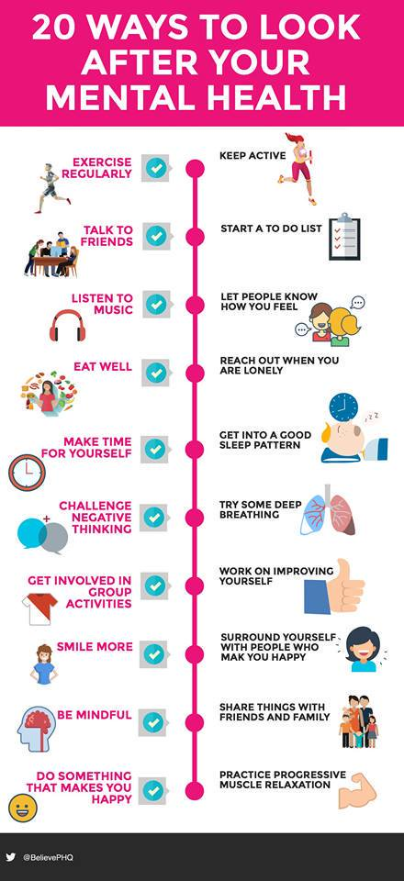

S1

Assembly Wednesday for classes 1a6 – 1a10. Please register pupils and take them to the forum with bags.

Assembly Friday for classes 1a1 – 1a4. Please register pupils and take to the forum with bags.

First Aid Class for 1a9 – Wednesday 19 September 11.30am
Please collect guest from the reception prior to start of the lesson

Internet Safety
Pupils must use their notes page to answer the questions on this document here

Watch the following clips:
- Chat Rooms
- Downloading files
- Instatnt Messaging
- Online Gaming
- Social Networking

Now answer the questions in your PSHE Booklet Notes section

Healthy Eating

Film Club

GIRFEC Booklet – Work through SHANARRI Indicators and complete with class

Body Image

Pupil Council Nominations to be completed ASAP. Please forward names to year head.

S2

The S2 focus group will meet Friday 28 September during P4. Please ensure that pupils involved are aware of this

The Impact of Bullying

Child Protection

Internet Safety

GIRFEC Booklet – Work through SHANARRI Indicators and complete with class

Study Skills for year ahead

Pupil Council Nominations to be completed ASAP. Please forward names to year head.

S3

Body Image

Arnold Clark Apprenticeship experience – if any pupils are interested please pass their names to Mrs Kennedy

Sound Sleep

Mental Health and Wellbeing
The attached slides cover how pupils, parents and staff can access support for a range of Mental Health issues. The information here can also be accessed on the main school website.

Study Skills

GIRFEC Booklet – Work through SHANARRI Indicators and complete with class

Balanced Diet
S4

Focus group minutes for S4 – Please go over minutes with classes in PSHE

CV Writing

Arnold Clark Apprenticeship experience – if any pupils are interested please pass their names to Mrs Kennedy

Work Experience Check – pupils who have yet to hand in a green form should log on to WorkIT and request placements. Usernames and Passwords can be obtained from Mrs Kennedy

Mental Health and Wellbeing
The attached slides cover how pupils, parents and staff can access support for a range of Mental Health issues. The information here can also be accessed on the main school website.

PSHE Booklet – complete skills learned in each subject

GIRFEC Booklet – Work through SHANARRI Indicators and complete with class

PSHE Booklet – Health and Wellbeing Pages 10, 11, 12 & 13.
Complete Term 1 Sections

Work Experience – Please go over with your respective classes

Pupil Council Nominations to be completed ASAP. Please forward names to year head.

S5

Sound Sleep

Arnold Clark Apprenticeship experience – if any pupils are interested please pass their names to Mrs Kennedy

Prepare a Study Plan – What do top students do?
Watch the video and look to see how you can create an effective study plan for yourself

Complete S5 achievements profile on Pages 36, 37, 38 and 39. Also complete Academic transferable skills and Attributes Page 40.

Mental Health and Wellbeing
The attached slides cover how pupils, parents and staff can access support for a range of Mental Health issues. The information here can also be accessed on the main school website.

Importance of Sleep

GIRFEC Booklet – Work through SHANARRI Indicators and complete with class

Study Skills – in booklets, highlight the different types of approach to studying. Use ‘Notes’ page for this activity

Study Tips – Inside the mind of a Procrastinator

Induction Slides

Urdu Class for Nat 5 and Higher begins Friday 25th August. Please make those concerned aware of this.

Pupil Council Nominations to be completed ASAP. Please forward names to year head.

S6

Assembly P5 Thursday for S6a6 – 6a10. Please register and take pupils to the forum.

Volunteers required for S1 information evening. Please give your name to your Pastoral Teacher if you wish to help on the evening (4 October).

Arnold Clark Apprenticeship experience – if any pupils are interested please pass their names to Mrs Kennedy

Pupils should log on to the school websit to see the advice available on how to complete their Personal Statement – See Below Hyperlinks

Link to school website and advice on completing Personal Statement

Link 1 – Advice on completing Personal Statement

Link 2 – How to structure Personal Statement

Fast Track applicants should hand first draft of personal statement to teacher for feedback. Also, log on to UCAS using phones or computers to ensure all information is up to date.

Mental Health and Wellbeing
The attached slides cover how pupils, parents and staff can access support for a range of Mental Health issues. The information here can also be accessed on the main school website.

Caritas Award

GIRFEC Booklet – Work through SHANARRI Indicators and complete with class

Stuart Ivory "Money Talks" sessions 6a8 – Thursday 20 September 1.00pm. Please collect guest from the reception prior to the start of the lesson

First Aid Class for 6a6 – Thursday 20 September 1.00pm
Please collect guest from the reception prior to the start of the lesson

Link to school website and advice on completing Personal Statement

Link 1 – Advice on completing Personal Statement

Link 2 – How to structure Personal Statement

Fast Track applicants should hand first draft of personal statement to teacher for feedback. Also, log on to UCAS using phones or computers to ensure all information is up to date.

Study Tips – Inside the mind of a Procrastinator

All about me – Complete with class

Induction Slides

Pupil Council Nominations to be completed ASAP. Please forward names to year head.

T. Low

