St Ninian’s High School
PSHE Newsletter
Week Beginning 3rd September 2018

Focus:

Daily Prayers

- A Vision of Education for Our Young People

- C19: Permission for Pupils to be Out of Class

- Focus On Corridor Movement, Racism, Bullying

- The first Catholic Leadership Meeting of this School Year will take place at 3.30pm – 4.15pm on Monday 3 September and will be led by Fr Baillie. This is for any pupil involved or who would like to be involved in the faith life of the school including pupils who are part of the Life Group, the SCIAF Group, No Child Taken, those who read at Mass or are involved in any other activity.

Extra-Curricular programme booklet

Mental Health Awareness

Mental Health Awareness

Strategies to help with Anxiety:

Research has shown that children who experience problematic anxiety can be successfully taught how to cope better with it. Research indicates that the most effective treatment for anxiety disorders is Cognitive Behavioural Therapy (CBT). CBT aims to teach children how to face their anxieties and how to think about situations in a different way so they are able to better manage their anxiety. Cognitive Behaviour Therapy consists of: Learning about anxiety and what causes it (psycho education) Learning relaxation skills Realistic thinking (cognitive exposure) Problem solving Gradually facing the fear/anxiety (graded exposure) Child anxiety management strategies (taught to parents)

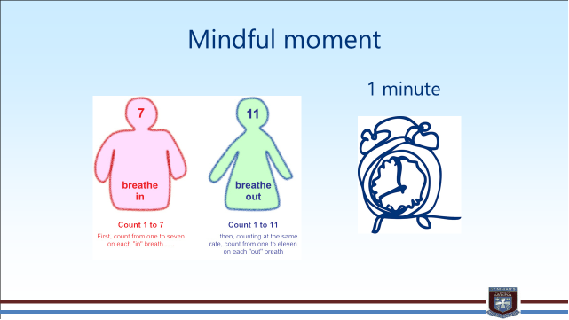
S1

Film Club

GIRFEC Booklet – Work through SHANARRI Indicators and complete with class

First Aid Class for 1a7 – Wednesday 5 September 11.30am
Please collect guest from the reception prior to start of the lesson

Body Image

My first week in St.Ninian’s

Induction Slides

Pupil Council Nominations to be completed ASAP. Please forward names to year head.

S2

Film Club

GIRFEC Booklet – Work through SHANARRI Indicators and complete with class

Sports Council – Nominate two pupils from each alpha to be a part of the St.Ninian’s Sports Council

Body Image

Study Skills for year ahead

Body Image

Induction Slides

Pupil Council Nominations to be completed ASAP. Please forward names to year head.

S3

GIRFEC Booklet – Work through SHANARRI Indicators and complete with class

My WoW Ambassador Programme

Sports Council – Nominate two pupils from each alpha to be a part of the St.Ninian’s Sports Council

Balanced Diet

Exercise Health and Fitness

Induction Slides

Pupil Council Nominations to be completed ASAP. Please forward names to year head.

S4

GIRFEC Booklet – Work through SHANARRI Indicators and complete with class

Sports Council – Nominate two pupils from each alpha to be a part of the St.Ninian’s Sports Council

Study Tips – Inside the mind of a Procrastinator

PSHE Booklet – Health and Wellbeing Pages 10, 11, 12 & 13.
Complete Term 1 Sections

Study Skills for S4 – Study Skills Video

Work Experience – Please go over with your respective classes

Pupil Council Nominations to be completed ASAP. Please forward names to year head.
S5

GIRFEC Booklet – Work through SHANARRI Indicators and complete with class

Study Skills – in booklets, highlight the different types of approach to studying. Use ‘Notes’ page for this activity

Study Tips – Inside the mind of a Procrastinator

Induction Slides

Urdu Class for Nat 5 and Higher begins Friday 25th August. Please make those concerned aware of this.

Pupil Council Nominations to be completed ASAP. Please forward names to year head.

S6

Caritas Award

GIRFEC Booklet – Work through SHANARRI Indicators and complete with class

Stuart Ivory "Money Talks" sessions 6a3 and 6a4 – Thursday 6 September 1.00pm. Please collect guest from the reception prior to the start of the lesson

First Aid Class for 6a2 – Thursday 6 September 1.00pm
Please collect guest from the reception prior to the start of the lesson

Study Tips – Inside the mind of a Procrastinator

Pupils are to leave class at 1.45pm to avoid corridor congestion

All about me – Complete with class

Induction Slides

S6 Service Slides

Heriot Watt University Open Days
Saturday 29 September
Friday 26 October

Those interested in Textiles and Design, there will be a separate open day at the Scottish Borders Campus in Galashiels Friday 12 October and Friday 16 November (10am to 4pm each day).

Pupil Council Nominations to be completed ASAP. Please forward names to year head.

My World of Work

S6 Service – encourage pupils to sign up to volunteering opportunities that are on offer throughout the year

T. Low

