National 4 French/Mandarin
National 4 Modern Languages Courses develop literacy skills by giving pupils opportunities to read, listen, talk and write in a modern language and to reflect on how this relates to English. These courses enable pupils to understand and use a modern language, to apply their knowledge of a modern language, and to develop planning, research and language skills.
Assessment
At National 4 Level, pupils will work on THREE Units.
1. Understanding Language
This is about pupils’ ability to READ AND LISTEN to written and spoken French/Mandarin.
2. Using Language
This is about pupils’ ability to TALK and WRITE in French/Mandarin.
All of the assessments for these Units (Understanding Language and Using Language) will be carried out and marked by the class teacher and they will also be verified by someone from outside the school. The class teacher will build up a bank of EVIDENCE to show that pupils have passed the units. Pupils will sit two assessments per skill area.
3. Added Value Unit
In this assessment, pupils will choose a topic they wish to study with help from their teacher. With their teacher’s guidance they will read at least 2 straightforward texts in French/Mandarin related to this topic. Pupils will have to show their understanding in English of these two texts, by responding to questions asked by the teacher. Afterwards, pupils will select relevant information, give an oral presentation (in French/Mandarin), on the topic they have investigated. Finally, their teacher will ask questions about the chosen topic (in French/Mandarin) to allow pupils to demonstrate that they understand and can respond to straightforward questions.
This assessment will also be marked by teachers in the school and will be verified by someone outside the school.
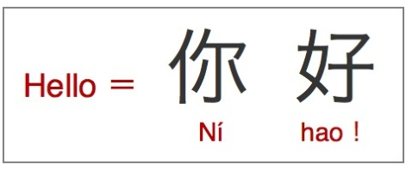
Contexts and Topics
The table below highlights the different Contexts and Topics to be covered in National 4:
Context | Topics | Topic Development
Society | Family and Friends | Saying how you get on with family members/  house rules/housework (gender roles)/  what makes a good friend/importance of friends.
 | Lifestyle | Physical, mental and social wellbeing, eg sport  and relaxation methods.
 | Media | TV, cinema, music,  computers and computer games, TV/viewing  habits.
 | Global Languages | Languages — language use.
 | Citizenship | Roles and responsibilities, being a global citizen.
Learning | Learning in Context | learning in modern languages/in each subject/  record of achievement.
 | Education | Purpose of education/pressures of learning/  the role of the teacher/learner.
Employability | Jobs | Pocket money and managing money,  advantages/disadvantages of different jobs.
 | Work and CVs | Planning for work experience/preparing  CVs/ambitions.
Culture | Planning a Trip | Choice of destination/transport/activity  options/evaluation of trip.
 | Other Countries | Impressions/aspects of other countries.
 | Celebrating a Special Event | Comparison of celebrations/events in another  country.
 | Literature of Another Country | Straightforward fiction, eg. poems, songs, stories.
 | Film and Television | Studying films in the modern language.  Studying television in other countries.
