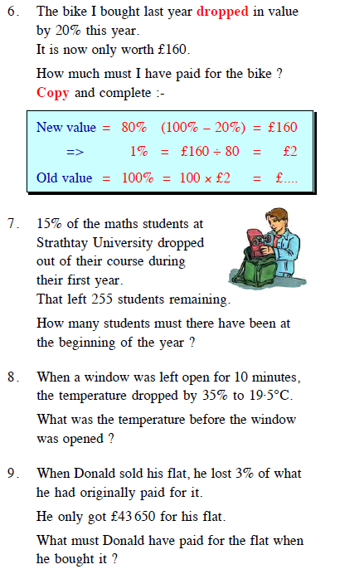
Mrs Gorman – Daily homework

