Growth of Civil Rights Highlighter Heads
For each of the following events, highlight or circle the factor it was tied to AND add a brief explanation in the space at the far right of the table for how this event helped the Civil Rights movement gain support. (Note: some events CAN come under multiple factors, but in the essay you should only discuss the event ONCE)
 | Ongoing Prejudice  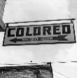 | Black servicemen  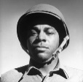 | Civil Rights Organisations | MLK  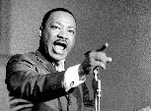 | Other black leaders  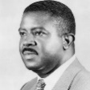 | How this led to growing support
Double V Campaign
Sit Ins
Murder of Emmett Till
March on Washington
Montgomery Bus Boycott
Executive Order 8802
Freedom Rides
Brown v Topeka
Birmingham Protests

