Use this booklet to make notes on the following areas:
- Plot,
- Characterisation,
- Setting
- Theme

- Plot
This is where you outline the basic storyline of the text. You must keep this brief – no more than ten sentences!

Write only about:
- the main character(s)
- the main events
- how things work out in the end.

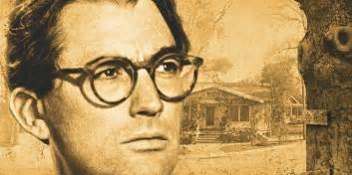

- CHARACTERISATION

Remember that writers are interested in character, and in particular, how characters change or develop. In a short story, you may not observe character development, but you will notice a gradual revelation of different aspects of the character.

- Choose the most important character or two (the ones there is most evidence for and where you see the most change for in the course of the story) and write them down in your jotter (consider this as the basis for your POINT).

- Now think over the story, try to recall which incidents gave you these impressions about the character. You will have to go back to your text and skim through it noting down the key events and interactions which reveal the character. Paraphrase these incidents and this will form the basis of your EVIDENCE.

- Once you have thought about the moments or incidents that gave you the clues as to what the character was like, quote the best example The writer will not often tell you in one sentence what a character is like, so you will have to ‘read between the lines’ and pick an example which ‘exemplifies’ their character.

- You should offer some analysis (in the ANALYSIS column) on how the writer has conveyed their ideas about the character in the section you quoted.

Repeat, using the same process to note the changes in your character. This will form a new and separate paragraph.

ADDITIONAL NOTES

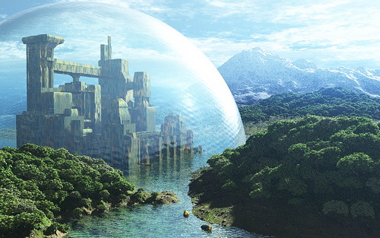

Setting

WHERE

Make a note of the different settings for your story in the different episodes from the beginning through to the end.
Look for the author manipulating setting:
- is the setting sometimes deceptive, i.e. a nice place for horrible or difficult things to happen?

- are the characters’ feelings sometimes reflected by the setting, or by the weather?

- is the setting used to signal how we should feel, i.e. open, lush countryside the sign that things are about to get better?

WHEN

When was the story set?

Present day?………………………………………………………………….
(Remember it may have been “present day” when the author wrote it.)

In the past? (or the future/) If so, when and how does that affect the story?………………………………………………………………………

- How important is the time period of this story (i.e. when it is set)?
- How does the writer try to make the setting, both in time and place, convincing to us, e.g. through accurate detail, dialogue, etc?

- What might be a benefit of reading a story about this time and place in history and how can these events be said to be relevant to today?

- Make a note of any other relevant thoughts and feelings you have on setting.

- THEME
It may help to notice that themes are almost always ABSTRACT NOUNS, things which exist as ideas, not as solid ‘objects’. We all have some understanding of what love, hate, fear, anger, loss, friendship, loyalty, honesty, courage are, and we believe they exist, but they’re not solid. You can’t chop them up or slice them or put them in a bag (as you could with ordinary nouns like tables, bread, chocolate or books).

In your novel study, you want to show your awareness that your text has these deeper meanings. You won’t have to use a quote to support your opinions, just references to the story itself. It is important, however, that you show your understanding of what the themes are and how well the author has explored them.

Write down the theme of the story.

Show that you understand HOW the themes are explored through:

- key events

- setting

- characters

ADDITIONAL NOTES

