Higher Chemistry: Unit 2 – Nature’s Chemistry
Part B – Alcohols, Oxidation and Esters
Lesson 2 – Oxidation of Alcohols

Learning Outcomes
By the end of this lesson you should know:
- What is meant by the terms “oxidation” and “reduction” in carbon chemistry

- The names of two oxidising agents for alcohols

- That when some alcohols oxidise, they can produce aldehydes, ketones and carboxylic acids. Some alcohols do not oxidise.

- How to draw and name carbonyl compounds, aldehydes and ketones.

Success Criteria
You will have been successful in this lesson if you:
- Read and learn the notes given
- Watch the links provided
- Complete revision questions provided
- Complete and submit the homework assigned by your class teacher.
There is also a further reading section to help you gain more depth of understanding for this section.
If you have any questions about the content of this lesson, you should ask your class teacher either through your class zoom or via email. The teams will be monitored through the week and someone will get back to you as soon as they can.
Links to Prior Knowledge
You may wish to revise the following to help you understand this lesson:
- National 5 chemistry – alcohols and carboxylic acids
You may wish to have a copy of the data booklet handy for this lesson. Download or print a copy of the Higher Chemistry Data Booklet from MS Teams or the SQA website - https://www.sqa.org.uk/sqa/files_ccc/ChemistryDataBooklet_NewH_AH-Sep2016.pdf

Notes – Check your class notes – you may have already covered this in class. If so, you do not need to copy this lesson, as it is just a revision of what you covered in school. You may wish to add to your notes with the content below.
If you have not covered this in school, then you should either copy, print or save the notes below.
A full copy of these notes are available on the Higher Chemistry Teams site and you will receive a paper copy when we return to school.

Oxidation of Alcohols

Oxidation and Reduction

In organic (carbon) chemistry oxidation reactions are defined as a reaction which increases the oxygen to hydrogen ratio of a molecule. This is achieved by either adding an oxygen atom to a molecule or removing hydrogen atoms.

For example, the reactions below would be described as oxidation reactions as the oxygen to hydrogen ratio is increasing.

ethanol C₂H₅OH → C₂H₄O ethanal → C₂H₄O₂ ethanoic acid
O : H O : H O : H
1 : 6 1 : 4 2 : 4 (= 1 : 2 )

The reverse reaction is called a reduction reaction. In organic chemistry, reduction is a decrease in the oxygen to hydrogen ratio, by either the adding of hydrogen atoms or the removal of oxygen.

Oxidising Agents and Products of Oxidation

In an experiment, the following oxidising agents can be used to oxidise primary and secondary alcohols. A colour change occurs when the oxidation takes place:

Oxidising Agent | Colour Change
hot copper(II) oxide, CuO | black to red/brown
acidified dichromate, Cr₂O₇²⁻ | orange to green/blue

GENERAL RULE:
- Primary alcohols can be oxidised to aldehydes and further oxidised to carboxylic acids.
- Secondary alcohols can be oxidised to ketones.
- Tertiary alcohols cannot be oxidised.

Using oxidising agents in the laboratory

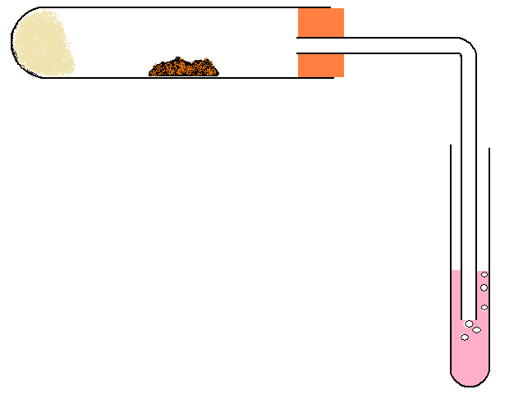
1. Oxidation of ethanol (primary alcohol) using hot copper oxide
copper(II) oxide
colour change from black to red/brown
universal indicator shows an acid is produced
HEAT
This reaction produces ethanal and ethanoic acid.
ceramic wool soaked in ethanol

2. Oxidation of propan-2-ol (secondary alcohol) and 2-methylpropan-2-ol (tertiary alcohol) using acidified potassium dichromate.
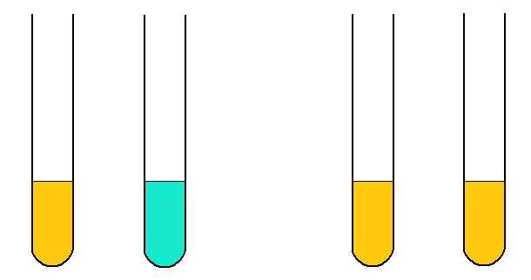
HEAT
HEAT
colour change from orange to green/blue
2-methylpropan-2-ol
in acidified dichromate solution
propan-2-ol
in acidified dichromate solution
no oxidation occurs

In this reaction, the secondary alcohol will oxidise to form propanone.
The tertiary alcohol will not oxidise.

Aldehydes and Ketones (Carbonyl Compounds)

Aldehydes

Aldehydes are a homologous series with the general formula C_{n}H_{2n}O. Aldehydes are identifiable by their carbonyl functional group (-C=O). For aldehydes, the carbonyl group is always positioned on the end of the carbon chain. A selection of aldehydes are shown below:

Name | Molecular formula | Extended structural formula | Shortened structural formula
methanal | CH₂O | 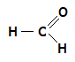 | CH₂O
methylpropanal | C₄H₈O | 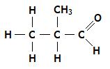 | CH₃CH(CH₃)CHO
3,3-dimethylpentanal | C₇H₁₄O | 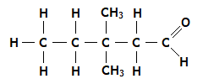 | CH₃CH₂C(CH₃)₂CH₂CHO

Ketones

Ketones are a homologous series with the general formula C_{n}H_{2n}O. Ketones are isomers of aldehydes with the same number of carbons and differ only in the position of the carbonyl group (-C=O). In ketones the carbonyl group is positioned somewhere along the middle part of carbon chain, rather than at the end of the chain. A selection of ketones are shown below:
Name | Molecular formula | Extended structural formula | Shortened structural formula
propanone | C₃H₆O | 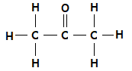 | CH₃COCH₃
pentan-2-one | C₅H₁₀O | 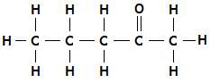 | CH₃CH₂CH₂COCH₃
3-methylbutanone | C₅H₁₀O | 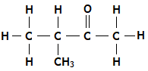 | CH₃CH(CH₃)COCH₃

SUMMARY

- Oxidation increases the oxygen to hydrogen ratio
- Oxidising agents for alcohols include:
- hot copper(II) oxide – changes from black to red/brown
- acidified dichromate solution – changes from orange to green
- Primary alcohols can be oxidised to aldehydes and then to carboxylic acids
- Secondary alcohols can be oxidised to ketones
- Tertiary alcohols cannot be oxidised.
- Aldehydes and Ketones are two homologous series, both with the general formula C_{n}H_{2n}O.
- Aldehydes and Ketones both contain the carbonyl functional group, –C=O.
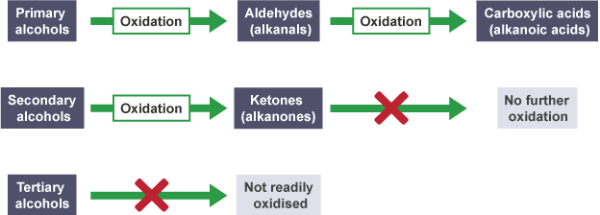
Image from BBC bitesize
Learning Outcomes
You should now know:
- What is meant by the terms “oxidation” and “reduction” in carbon chemistry

- The names of two oxidising agents for alcohols

- That when some alcohols oxidise, they can produce aldehydes, ketones and carboxylic acids. Some alcohols do not oxidise.

- How to draw and name carbonyl compounds, aldehydes and ketones.

Further Reading
To learn more about oxidation of alcohols, try the following online resources:
BBC Bitesize: https://www.bbc.co.uk/bitesize/guides/zyq22hv/revision/2
Scholar: Log in through GLOW
Higher Chemistry Nature’s chemistry Oxidation of food read content 9.1-9.5
Evans2 chem web: https://www.evans2chemweb.co.uk/login/index.php#
Username: snhs password: giffnock
Select any teacher revision material CfE Higher Unit 2: Nature’s Chemistry Oxidation of food

Check your understanding – Answers the questions below in you class jotter
2.3 Oxidation of Alcohols (i)

1. The structure of Butan-2-ol is shown below:

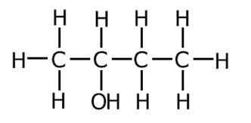

a) Why is butan-2-ol described as a secondary alcohol?
b) Name and draw the full structural formula of the substance that is produced when butan-2-ol is oxidised.
c) Define oxidation, with regards to oxidation of organic compounds.
d) Name two oxidising agents that can be used to oxidise alcohols.

2. Name the ketone or aldehyde(and then carboxylic acid) which would be produced if the following can be oxidised:
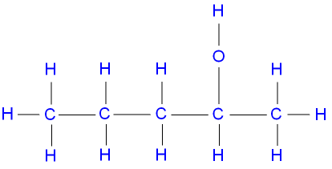
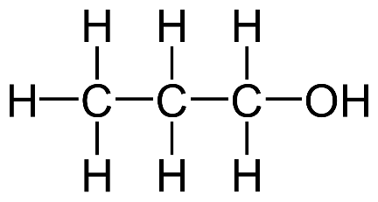

- b)

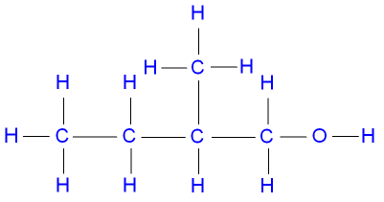
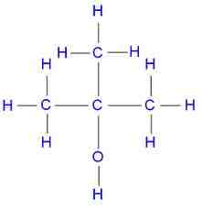

c) d)

e) CH₃OH f) CH3CH(OH)CH(CH₃)CH₃

g) CH₃CH₂CH₂CH₂C(CH₃)(OH)CH₃ h) CH₃C(CH₃)₂CH(OH)CH₃

2.4 Oxidation of Alcohols (ii)

1. Give the full structural formula and name for the aldehyde or ketone formed by oxidation of the following alcohols.

a) ethanol b) propan-2-ol
c) Hexan-1-ol d) 4-methyl pentan-1-ol
e) 3,4-dimethyl pentan-2-ol f) cyclobutanol

2. Alcohol X, was oxidised to produce a neutral compound Y, of molecular mass 58. Compound Y could not be oxidised.

a) Draw the full structural formulae of X, and Y.
b) Give the name of X and Y.
c) What colour change would be observed when X is oxidised using:
i. Hot copper oxide?
ii. Acidified dichromate solution?

3. Draw the full structural formula of the alcohols that were oxidised to
produce the following molecules:
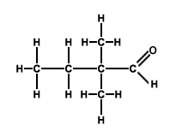

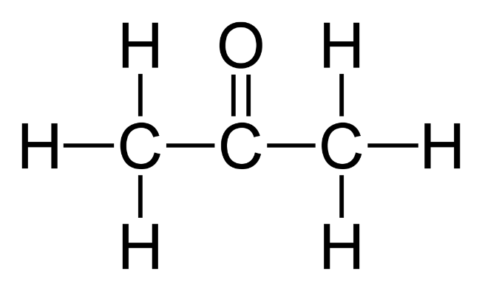
a) b)

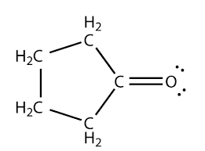
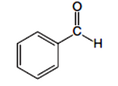
c) d)

EXTENSION WORK
If you have already completed the above exercises in school, you should completed the following blue book questions:
Oxidation of carbon compounds Page 54 Q1-10

ANSWERS TO Ex 2.3, 2.4 AND EXTENSION WORK WILL BE POSTED ON WEDNESDAY

HOMEWORK
You should now complete “Homework 1 – Alcohols & Systematic Carbon Chemistry” in your homework jotter, or the back of your class jotter if you don’t have your homework jotter at home with you.

Take a picture of your homework answers and submitted them to your class teacher, through your class team by 1pm on Friday 15th January.

Your teacher will let you know how to submit this and will give you feedback on this homework.

If you have already completed this homework you should send a picture of the extension work above to your teacher.

A copy of the homework is on the next page.

Homework 1 – Alcohols & Systematic Carbon Chemistry

- What is the systematic name for the compound below?
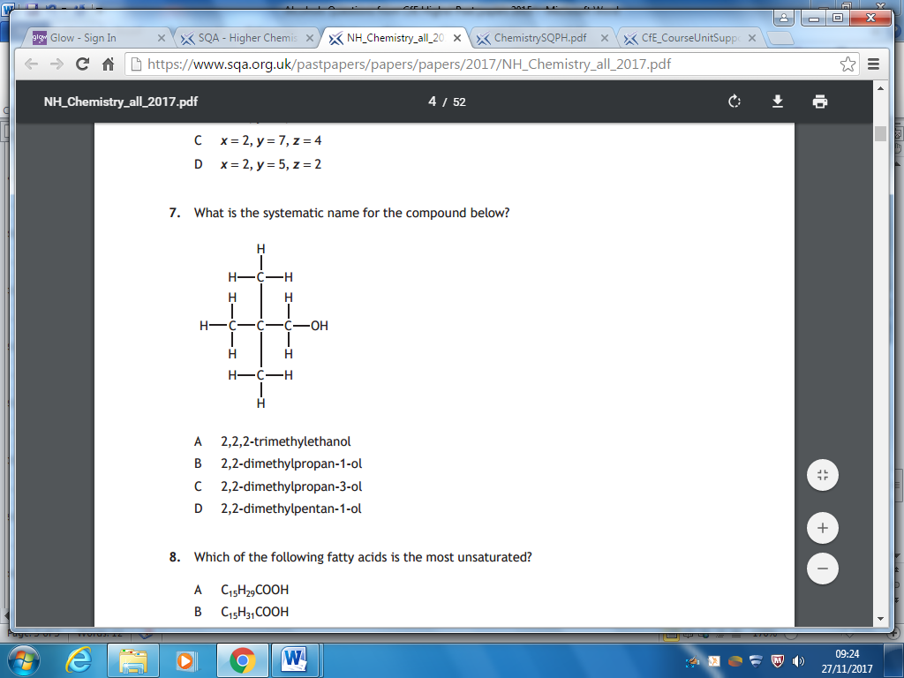
  - 2,2,2-trimethylethanol
  - 2,2-dimethylpropan-1-ol
  - 2,2-dimethylpropan-3-ol
  - 2,2-dimethylpetan-1-ol

- What type of alcohol is the molecule in Question 1?

  - primary
  - secondary
  - tertiary
  - unsaturated

- Which of the following compounds will be the best solvent for the molecule below
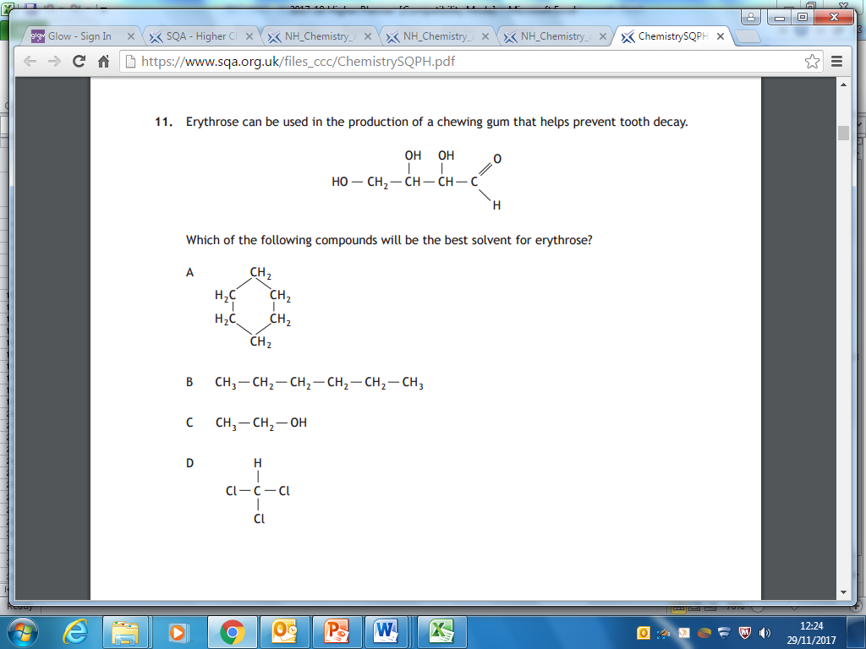

- Which of the following is an isomer of 2,2-dimethylpentan-1-ol

  - CH₃CH₂CH(CH₃)CH₂OH
  - (CH₃)₃CCH(CH₃)CH₂OH
  - CH₃CH₂CH₂CH₂CH₂CH₂CH₂CH₂OH
  - (CH₃)₂CHC(CH₃)₂CH₂CH₂OH

- Which of the following is secondary alcohol

  - CH₃CH₂CH(OH)CH₃
  - (CH₃)₃CC(CH₃)(OH)CH₃
  - CH₃CH₂CH₂CH₂CH₂CH₂OH
  - (CH₃)₂CHC(OH)₂CH₂CH₃

Questions 6 and 7 refer to the structures below
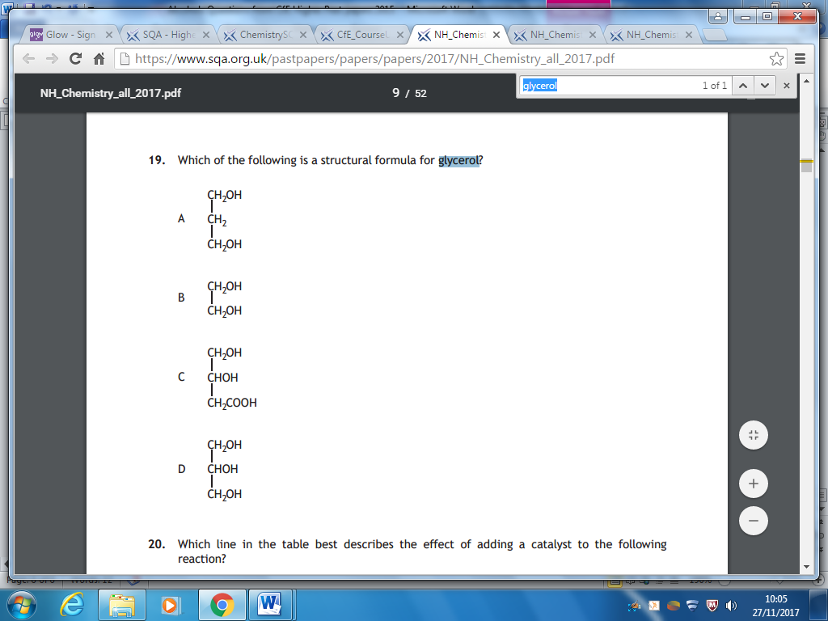

- Which of the compounds is a triol?

- Which molecule is propan1,3-diol?

- Which of the following is responsible for the solubility of alcohols in water?

  - London Dispersion Forces
  - Permanent dipole to dipole interactions
  - Hydrogen bonding
  - Covalent bonding

- For each of the following compounds:

    - Draw the full structural formula
    - Write the shortened structural formula
    - State whether it is a primary, secondary or tertiary alcohol

- 2-methylpentan-1-ol (2)

- 2,3-dimethylbutan-2-ol (2)

- 3,4-dimethylhexan-2-ol (2)

- Name the following compounds

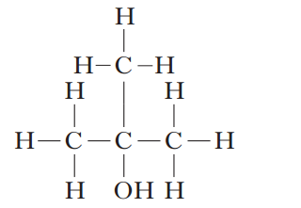 (1)

- CH₃CH(CH₃)C(CH₃)(OH)CH₂CH₃ (1)

- The table below compares properties of butane and propan-1-ol.
These molecules can be compared because they have similar molecular masses.

Property | butane | propan-1-ol
Mass of one mole | 58g | 60g
Boiling Point / ºC | -1 | 97
Solubility in water | insoluble | soluble

- Name the functional group present in propan-1-ol (1)

- Which molecule would you expect to have a higher viscosity (1)

- Explain clearly why propan-1-ol has a much higher boiling point than butane.
You should mention the type of intermolecular force involved and how it arises. (2)

Total = 20

