Higher Human Biology
Distance learning tasks
Week beginning 18th May 2020
Continue with Key area 1.2 DNA and DNA replication.
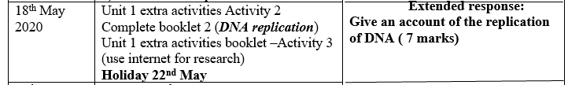
Mark scheme for last week’s “Structure of DNA” extended response will be uploaded into Key area 1.2 folder on Tue 19th May
Compulsory Homework (assignment) 1.2 DNA should be submitted by midnight Tuesday 19th May.
Compulsory Homework (assignment) 1.2 DNA replication will be uploaded Wednesday 20th May.

