Welcome to 2060
It is the year 2060, considering the Earth’s current climate and estimated statistics for the future, we must decide whether to put our Science knowledge to saving Earth or colonising a different planet, such as Mars.
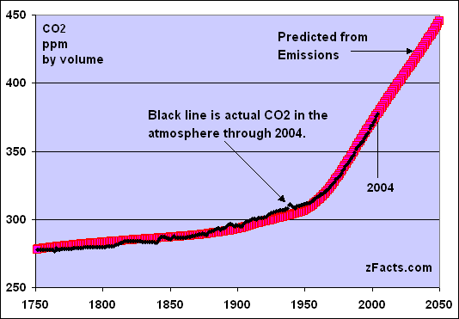

You have been added to a Microsoft Team for your class (1A-R), you will find a folder with your name on it in this Team, here is where you will upload all of your work.
Task 1 – Create a word document with all of your research on these topics and upload it to your folder. (around 2 sides suggested)
Task 2 – Create a PowerPoint project explaining your stance on the argument – Stay on Earth or leave? (around 5 slides suggested)
Follow the slides in the Microsoft Team to explore how each science links to the topic of climate change and help you complete your tasks.

