UNIT 3 NEUROBIOLOGY & Immunology. Key area 3.1 Divisions of the Nervous system& neural pathways

DIVISIONS OF THE NERVOUS SYSTEM
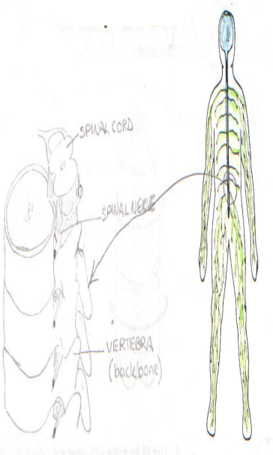
- Define the terms:
  - Central nervous system (CNS)
  - Peripheral nervous system (PNS)
  - Somatic nervous system (SNS)
  - Autonomic nervous system (ANS)

- Describe the structure and function of each system

- With reference to the autonomic nervous .system
describe & explain the antagonistic actions of the sympathetic and parasympathetic systems on heart rate, breathing rate, peristalsis and intestinal secretions.

TYPES OF NEURAL PATHWAYS

- Show in diagramatic form the difference between CONVERGING and DIVERGING neural pathways.

5. Describe the structure and function of a reverberating pathway

6. 6. Give an example of the function of a diverging,converging & reverberating neural
pathway

Diverging pathway Converging pathway

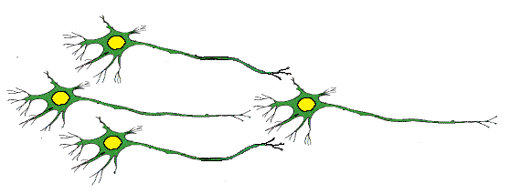
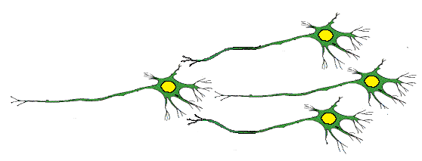

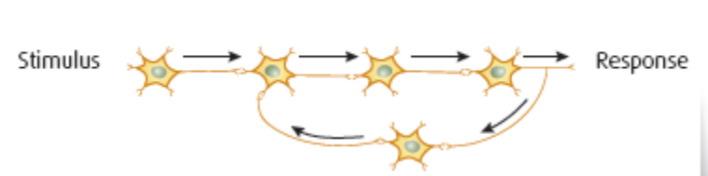
Reverberating pathway

