UNIT 3: life on earth
Key Area 2: Distribution of Organisms

- Provide examples of resources that organisms compete for.
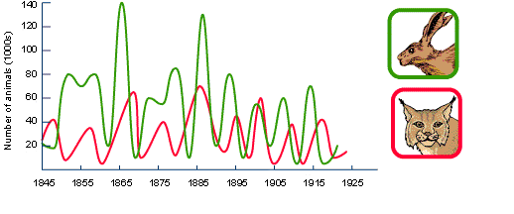

- Interpret predator prey interaction graphs.

- Define the terms abiotic and biotic factors and state examples for each

- Describe and use a variety of techniques for measuring abiotic factors.

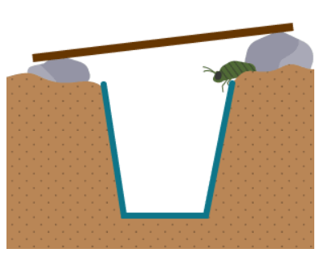
- Identify possible sources of error for sampling techniques and explain how they can be minimised.

- Sample plant and animal populations using qudrats and and pitfall traps.

- Evaluate limitations of these sampling techniques, possible sources of error and how these can be minimised.

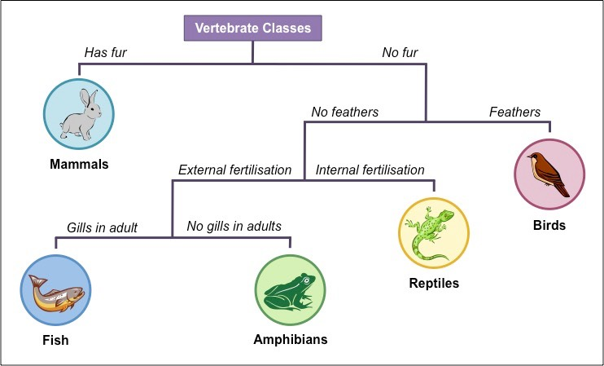
- Construct and use branched and paired statement keys to identify organisms.

- Explain how biotic and abiotic factors can effect the biodiversity and distribution of organisms in an ecosystem.

- Describe the role of indicator species in determining the environmental quality/ levels of pollution in an ecosystem.

