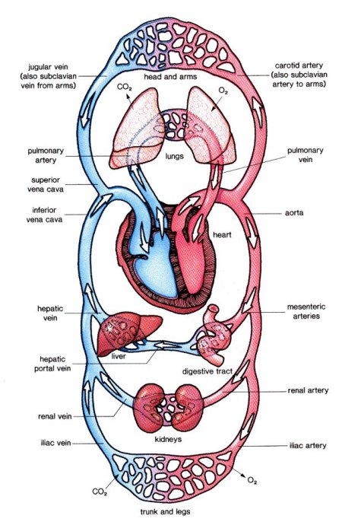
Animal transport systems.

- Name the 3 components of blood

- State that blood transports nutrients, oxygen and carbon dioxide

- Identify the specialised features of a red blood cell that allow if to transport oxygen efficiently.

- Describe the role that white blood play in the body.

- Name and explain the two main types of white blood cells.

- Label a diagram of the heart, valves and associated blood vessels.

- Identify and state the function of the following blood vessels:

- Aorta
- Vena cava
- Pulmonary arteries & veins
- Coronary arteries.

- Describe the path taken by blood as it passes around the body.

- Describe the structure and function of the three main types of blood vessels.



