UNIT 1: CELL biology KEY AREA 6: RESPIRATION

ENERGY

- Name the type of ENERGY stored in FOOD and the units used to measure it.

- Describe a method to measure the energy contained in food.

ATP

- State that ATP (Adenosine TriPhosphate) is a HIGH ENERGY COMPOUND able to release and store ENERGY where and when it is needed in the cell.

- Name the mitochondrion as the site of ATP production.

- State that cells requiring more energy have more mitochondria eg muscle, nerve and sperm cells.

- Explain that energy released from the breakdown of glucose is used to synthesise ATP from ADP and INORGANIC PHOSPHATE (Pi). The ATP can then be used by the cell as an energy source.
Pi
Pi
Pi
Adenosine
Pi
Pi
Pi
+
Energy
Enzymes
Adenosine

RESPIRATION
- Define the term RESPIRATION. The chemical energy stored in glucose must be released by all cells through a series of enzyme-controlled reactions called respiration.

- Understand the difference between AEROBIC RESPIRATION and FERMENTATION (anaerobic respiration).

- Understand that some energy from respiration is released as HEAT from cells but most is used for cellular activities such as muscle cell contraction, cell division, synthesis of proteins and transmission of nerve impulses.
FIRST STAGE OF RESPIRATION
- Explain that the FIRST STAGE of respiration is called GLYCOLYSIS and is common to AEROBIC RESPIRATION and FERMENTATION.

- Understand that GLYCOLYSIS involves the breakdown of GLUCOSE into PYRUVATE, with the release of 2 molecules of ATP.

AEROBIC RESPIRATION
- State that AEROBIC RESPIRATION occurs when OXYGEN is present.
In the SECOND STAGE, Oxygen is added to Pyruvate to produce CARBON DIOXIDE and WATER and 36ATPs.

- Explain that during AEROBIC RESPIRATION in animal and plants, the USEFUL PRODUCT is ATP ( A TOTAL OF 38 molecules of ATP are produced per ONE molecule of GLUCOSE oxidised).

- State that the TWO WASTE PRODUCTS of aerobic respiration are WATER and CARBON DIOXIDE.

FERMENTATION
- State that FERMENTATION occurs when NO OXYGEN is present.
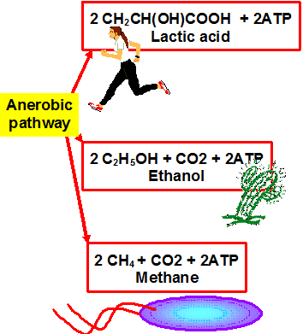
- Explain that during FERMENTATION in animal and plants, the USEFUL PRODUCT is ATP (2 molecules of ATP are produced per ONE GLUCOSE molecule oxidised).

- Explain that in the absence of oxygen, ANIMAL CELLS convert the PYRUVATE made in GLYCOLYSIS into the waste product LACTATE.

- State that a build up of LACTATE causes muscles to feel sore and fatigue.

- LACTATE build up (oxygen debt) is reversed when OXYGEN is available.

- Explain that in the absence of oxygen, PLANT and YEAST CELLS irreversibly convert the PYRUVATE made in GLYCOLYSIS into ETHANOL and CARBON DIOXIDE as waste end products. This is called FERMENTATION.

- State that Respiration begins in the CYTOPLASM. The process of fermentation is completed in the cytoplasm whereas aerobic respiration is completed in the MITOCHONDRIA.

