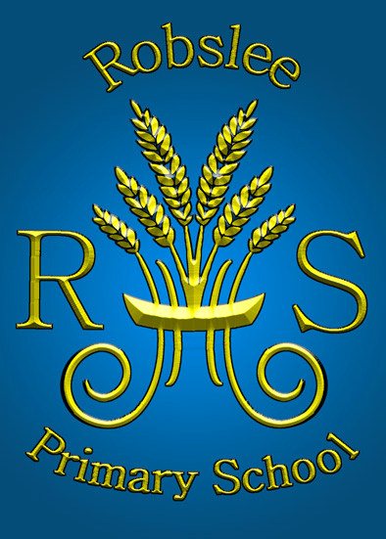
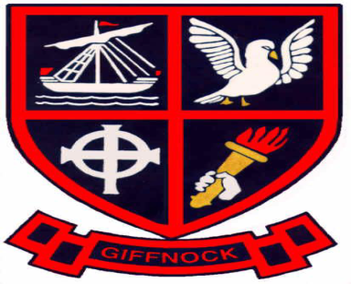
TRANSITION NEWSLETTER

March 2014
Dear Parent

Transition Plan

The latest report detailing our further progress was submitted to the Education Minister by the authority in January 2014.

A copy of the updated plan and the report can be found on the school website.

Transition Steering Group

The group last met on Thursday 23rd January 2014 and are scheduled to meet again on Thursday 8th May 2014.

Building Improvements
The new ‘Big screen’, projector and speakers installed in blue gym hall will enhance future presentations and assemblies.

Work is almost complete on the additional storage space and the ramp from the fire exit so we should soon be ‘back to normal’!

.

Playground

With additional funding received from ERC we have been able to purchase several playground furniture items and develop a number of the children’s playground ‘zones’. Work has already begun on these areas.

We are grateful to the parents and associates who have kindly given of their time, advice and expertise.

Joint Activities for Pupils

Primary 6 and 7 enjoyed traditional Burns’ celebrations complete with bagpipes!
'The topic has been amazing and maybe now we will be the next Richard Bransons." Ross

For P6 the main project has been the Virgin Money 'Make £5 Grow'. All P6 pupils across both campuses have taken part. Pupils formed their own businesses to make the £5 grow into as large a profit as possible. Great profits have been made from various businesses such as cake baking, car washing, card and jewellery making, You are welcome to find out more at the 'show-case' on 28th March from 1:30 -3:00pm.

Primary 5 and 6 are continuing to work on the playground project.
Kitty: "The quiz was great as we got to know the other children better. It was a fun way to make friends."

"This is awesome!" Sean

The Primary 5 classes from both campuses attended a theatre workshop named "Bannockbunkum", a Wars of Independence play and also took part in a quiz based on the
I really enjoyed myself, it gave us lots of information while making the re-enactment fun"

Scottish wars of Independence.

Sana said," it was awesome when the Instructor burst the balloon and 2 gases reacted, we had to cover our ears as the bursting noise was so loud."

A joint day at Glasgow Science Centre allowed the children to take part in a 'Water, water everywhere' workshop.
Across campuses, the pupils have been dying materials to see how people made use of plants in the times of Wars of Independence. They designed their own t-shirts by making a spiral, coloured design.

All primary 7 pupils will participate in the Cluster Transition Sporting Event at Linwood later this month.

Dressing for Excellence Survey
Thank you to all who took time to complete and comment in the recent survey. Views have been collated and the findings will be shared at the next Parent Council meeting.

Parent Council News

A recent social ‘Film Night’ held for pupils in primary 5 and 6, was very well attended.
Spring Discos are also planned on Thursday 3rd April.
Next meeting Thursday 1st May 2014 @ 7pm.

Opportunities for Parents

May I remind parents that a weekly drop in service with the Senior Management Team takes place on the following days/times:

Robslee Primary Thursday mornings – 9.00 a.m. – 9.30 a.m.

Giffnock Primary Friday mornings – 9.00 a.m. – 9.30 a.m.

Yours sincerely
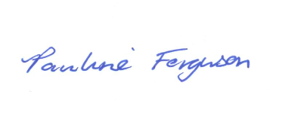

Pauline Ferguson

Head Teacher

