Primary 6/7 & 7a are learning all about Famous Scots. They are looking at Scots who have produced famous novels, created mind breaking inventions and made history. They will also take part in Body Builders as part of their interactive Science visit. This will take place on 22nd February.
Primary 7 are learning all about World War II. They are studying famous dates and significant events. They will be looking at the Home Front and how we survived the war. The children will also be learning more about Electricity and take part in Body Builders on 22nd February.
Patients Direct Family Health Medical Study
A group of Doctors from a company called Patients Direct have embarked on a medical research study to gather evidence about what happens when winter illness hits a family. The authority has given permission for schools to include the web link for all families to complete the survey. You can find the survey at www.myfamilyflu.co.uk. If you would prefer to complete with a nurse over the telephone there is a freephone number – 0800 731 2647. There is no obligation to participate in this survey but if you do it is highly confidential.
School Log Book
This month we look back to 1959.
- Miss Craig attending Jury duty. Sheriff Court Paisley – one day leave without salary.
- Mrs. A Brown began today in charge of the February intake of infants.
- Mrs. E MacFarlane began today to teach Music to the primary classes.

Holidays & Inservice Days

February break: Mon 11 & Tue. 12 Feb 2013
Easter: Fri 29 Mar to Fri 12 April 2013
May Weekend (1): Mon 6 May 2013
May Weekend (2): Fri. 24 & Mon 27 May 2013
Summer Holiday: School closes 26 June 2013
Inservice Days: Fri 8 February 2013
Tue 28 May 2013

Please remember if you have any concerns, queries or compliments please do not hesitate in contacting me at the school or coming along to one of our management team drop ins - 9 – 9.30 a.m. every Thursday (Robslee) and Friday (Giffnock).

Yours truly
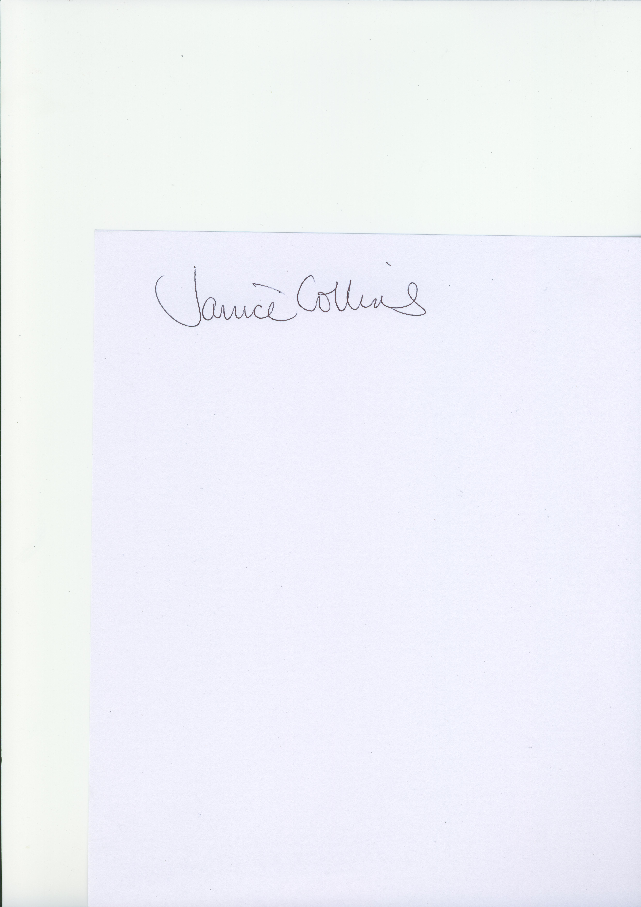

Janice Collins
Head Teacher

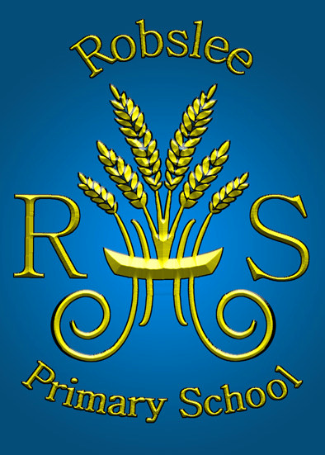
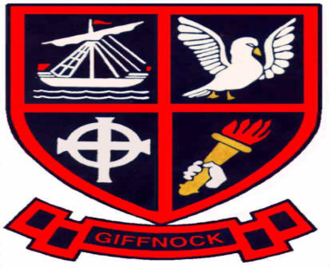
Newsletter



February 2013

Dear Parents

I can’t quite believe we are now in February. The time is passing so quickly. February is a very busy month in school, we have our standardised tests, inservice day and a holiday thrown in too.
I would like to take this opportunity to point out that in Giffnock/Robslee we only have 1 inservice day this month – Friday 8th February. Woodfarm High, along with the other secondary schools will be working on the new National Qualifications and will have 2 inservice days – Thursday 7th February and Friday 8th February.

School Improvement Plan
The school is currently developing its Science programme. The inservice day will be dedicated to improving staff knowledge and skills for teaching this subject. All cluster primary schools (Braidbar, Giffnock, Robslee and Thornliebank) staff, along with the Science department from Woodfarm High School will spend the day together with specialist tutors. In addition, a large percentage of the school budget has been allocated to provide interactive Science workshops for each class. Dates for workshops may change.

Standardised Tests
The testing programme will take place from Monday 4th February to Thursday 7th February. Mrs. Ferguson will administer the Primary 7 papers, Miss Rawley the Primary 5 papers and I will carry out the Primary 3 testing. The children will be tested in Reading and Mathematics. I would ask that you try to ensure, illness permitting, that your children are not off on these days. The results will be available in term 4.

News from around the classes
Nursery – the nursery children have been learning all about patterns of day and night. They have been investigating the jobs people do during the day and at night, also animals that sleep during the day and hunt at night. I think the most fun they have had is visiting space in the role play corner! The children will deepen their learning by visiting the Science centre on Wednesday 20th February.

Primary 1a, b, c & d – also have budding scientists! They are investigating materials. They will focus on the properties e.g. strength, resistance to water, etc. Their Science workshop is planned for 25th February. Please ask your child about what they learned on this day.

Primary 2a & 2b – have been learning all about ‘When Granny was Young’ and the olden days! They have shared tales on life before electric irons, automatic washing machines, computers and iPads. The children will also have a visit from ZOOLAB as part of their Science studies. This visit will take place on 13th February.

Primary 3a & 3b – the children will be learning all about Future Earth as part of their Science workshop. In addition Primary 3a will visit The Tall Ship in Glasgow on Tuesday 19th February. Primary 3b have been learning all about The Chinese New Year and will share with parents at their assembly on Friday 15th February.

Primary 4, 4a & 4b – performed to parents their fantastic version of Tam O’Shanter. This is a difficult poem, but the children brought humour and laughter to their rendition. This was part of their Rabbie Burns’ study. The children loved learning Scots and we loved learning from them. The children will either have ZOOLAB or Body Builders providing their Science workshops on 13th February or 22nd February.

There is something fishy going on in Primary 5 as they learn all about the River Clyde. ‘Clyde in the Classroom’ has taken over their room as the children learn about river life. Power from the People will be visiting on 28th February.

The Wars of Independence are being relived in Primary 5a, the children have been showing off their knowledge by writing poems to describe some of the events. We are trying hard to ensure they don’t mistake Mel Gibson for William Wallace! They too will be participating in Power from the People as part of their Science workshop on Friday 1st March.

The Primary 5/6 children have been learning all about the Scottish Parliament. They have been learning about the various political parties and hope to form their own! The Primary 5 part of the class will join Primary 5a for their Science workshop, and Primary 6 children joining Primary 6a.

Primary 6 can share some of their knowledge as they have just completed their own in-house elections. Robslee Political Party fought a great campaign and was elected by their peers. The children are now learning all about Friction of a different kind, as part of their Science studies. They will participate in a workshop titled Make a Move on 5th February.

Having just returned from a trip to Kelvingrove Art Gallery I must congratulate
Primary 6a on their behaviour and conduct. Five separate individuals approached the class teacher to highlight how well behaved and respectful the children were – well done! The children were visiting the Gallery to find out more about the Highland Clearances. They will also be taking part in Make a Move on 5th February.

