Uniform
We have noticed that a few children are not quite as smartly dressed as they were at the beginning of the year, opting to wear sport’s tops, trainers, different coloured cardigans etc. I would like to ask for your support to ensure that all children continue to dress appropriately and wear, where possible, their shirt and tie and/or their school polo-shirt or sweatshirt.
Dates for your Diary
- Primary 1 Induction visits – 6th & 10th June.
- Nursery Induction – 12th June
- Sports Day – 7th June: Robslee and 14th June: Giffnock
- School report cards and nursery summative reports issued - 14th June.
- The Primary 7 Induction visits to Woodfarm High School - 20th & 21st June.
- Giffnock Primary 7 leaver’s Ceilidh & Robslee Primary 7 end of term day out – 19th June
- Meet your Class – 21st June
- Summer Service – afternoon of 25th June (Robslee) & morning of 26th June (Giffnock)
School Log Book
This month we look back to 1972:
- 18th February – school closed at 11 a.m. – no heating – office advised. Parents advised by circular to expect further closures on high risk days.
- 22nd September – Photographs were taken in groups. Each class was taken and one of staff. Mr. Rendell, in-service department lecturer from Jordanhill, came to talk to the staff about different methods of approaching project work.

Holidays & In-service Days
May Weekend (1): Mon 6 May 2013
May Weekend (2): Fri. 24 & Mon 27 May 2013
Summer Holiday: School closes 26 June 2013 at 1 p.m.
Inservice Days: Tue 28 May 2013

Please remember if you have any concerns, queries or compliments please do not hesitate in contacting me at the school or coming along to one of our management team drop ins - 9 – 9.30 a.m. every Thursday (Robslee) and Friday (Giffnock).

Yours truly
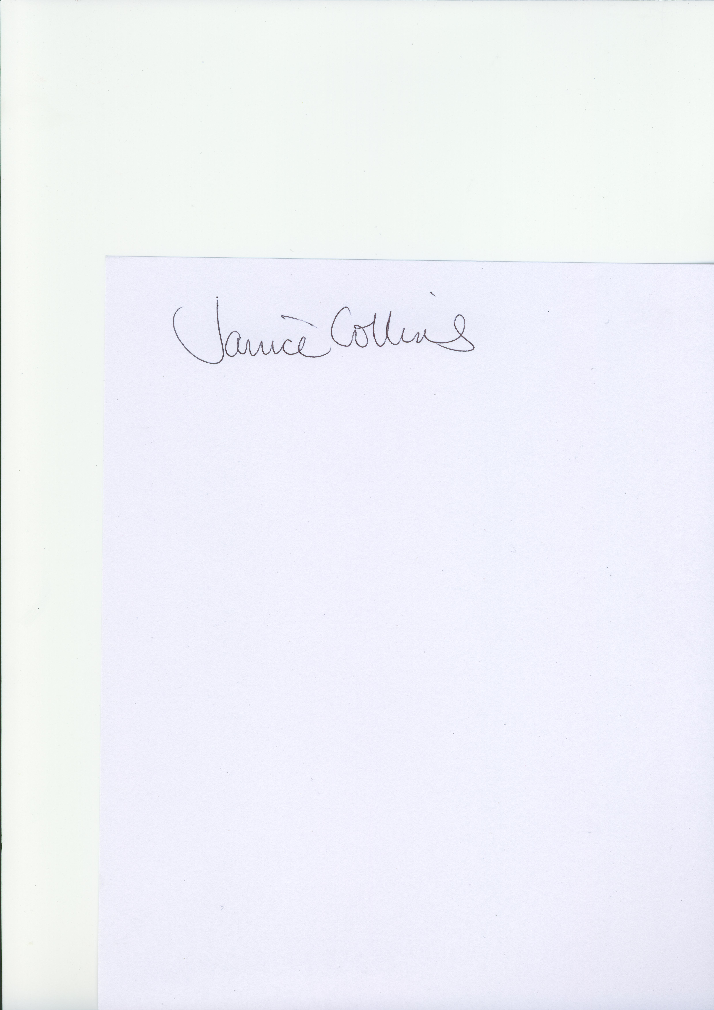

Janice Collins
Head Teacher
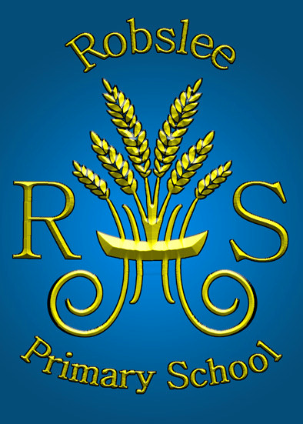


Newsletter


April 2013

Dear Parents

Welcome to the final term of this session. At the time of writing we have 10 weeks until the summer break. During this time we have the small matter of a school show, Castle Toward visit, nursery graduation and sports day, to fit in. A busy time ahead!

Standardised Testing
The school standardised test scores are now available. Individual scores will be reported on children’s report cards; however, if parents wish to find out scores before, then they should contact Miss Rawley (for Primary 3 scores), Mrs. Frew (for Primary 5) and Mrs. Ferguson (for Primary 7).
School Show
Rehearsals are now underway for our Primary 4-7 performance of Cinderella – a summer pantomime. Primary 5 form most of the advertising committee and will be issuing details regarding tickets etc in the very near future.
Cluster News
A Health information evening will take place at Woodfarm High School on Wednesday 8th May from 7 p.m. The evening will focus on the current Health and Wellbeing curriculum. A variety of workshops and presentations will be on offer, with a key note presentation from Robina Simpson, NHS Health Improvement Practitioner – Parents and Sexual Health. We hope you can come along to find out some key aspects of your child's health education.
Woodfarm High school staff have been spending more time working with our Primary 7 children, getting to know them and finding out about how they can support their move to first year after the holidays.
United School
The Transition Steering Group is due to meet in the next week or so. The agenda will focus on progress with our school playground project and new homework guidelines. Minutes of all steering group meetings can be found alongside other transition information on the school website under the United School section. Please let us know if you have any items you wish to add to the agenda.
News from around the classes
Nursery – the Nursery Family Day out will take place on Monday 24th June. This year we are off to Dean Castle Country Park. The Nursery Graduation will take place the following morning (Tuesday 25th June). Please note that there will be one ceremony for both morning and afternoon children.
Primary 1 has been very busy since their return from holiday. Last week they visited the Wee G bus to hear about safety on the railways and had fun trying out a variety of games. Their week went from one exciting event to another as they had an author's visit on Friday from Ross Collins. Primary 1 have also been bringing in a selection of photos of themselves and looking at how they've changed. Even the teachers have joined in...and how they've changed!!
They have set up a "nursery" in the role-play area and the children are having the opportunity to feed, change, clothe and look after the babies.
A real baby is visiting next week – baby Isabel, Mrs Gilhespie's new granddaughter.
Primary 2a – are learning about their bodies. They have thought up lots of questions and discussed how they can find the answers. They are also enjoying a book called Aaaarrgghh Spider and now have a web full of spiders on their wall! They have written super stories about having a spider as a pet and created great spider acrostic poems.
Primary 2b - are growing potatoes. They are looking at how the potatoes grow, the parts of the plant, the different ways we eat potatoes and they have incorporated numeracy! The class are learning about metres and centimetres, and using metre sticks and rulers, so measuring the growing plants has been excellent practice for them.
Primary 3a & 3b - have begun to look at things that live around about us. They are looking forward to welcoming some creepy crawlies into the class and learning more about metamorphism.
Primary 4 – is full of reading detectives, finding out all about cause and effect. They have also been studying the water cycle and are moving on to look at life-cycles of various creatures.
Primary 4a - have been enjoying looking at maps and locating some physical features of Scotland. They are also learning about time.
Primary 4b - have been learning about the human body, creating their own model filled with vital organs and soon to be covered with their skeleton and muscles.
Primary 5 - thoroughly enjoyed their trip to Stirling Castle last term. They 'met' Sir William Oliphant and walked around the castle listening to him share facts about living there during the time of The Scottish Wars of Independence. They were fascinated by the weaponry and defensive features of the castle. They are currently learning about classifying vertebrates as part of their Living Things topic.
Primary 5a - have entered the Greenbank Garden Centre wheelbarrow competition. They will be submitting an entry under the category 'A Scottish garden'. Fingers crossed. The children took part in an excursion to Stirling Castle in March which they thoroughly enjoyed. This was in connection with their topic, The Wars of Independence.
Primary 5/6 - are using the skills learned through Poetry last term (similes, metaphors and personification) to make their stories more interesting. They have also been creating their own version of Cinderella, with a Scottish twist.
Primary 6 children led our Tartan celebrations across both buildings, sharing all that is wonderful about our nation. They designed and made items of clothing for their celebration, using Charles Rennie Mackintosh, Scottish scenery, famous landmarks and natural Scotland as their inspiration. All children participated in the fashion show and chose appropriate Scottish music to set the scene.
Primary 7 participated in their own ‘Woodfarm Cluster’ Olympic games. These games were held at Kelvinhall sport’s arena in Glasgow. The children took part in an opening and closing ceremony as well as participating in traditional Olympic events. This was a great occasion and provided the children with an insight into the real thing which will be happening very soon. In addition Primary 6 & 7 are about to start their Bikeability training.

