East Renfrewshire Early Years Intervention Group (EYIG)
Referral Guidance

EYIG is a multi-agency group which is led by East Renfrewshire Education Department to discuss and allocate additional educational support to children aged 0-5 years. EYIG meets monthly during term time. Referrals to EYIG are accepted from professionals who work closely with a family and have identified a need for additional support following the GIRFEC principles, SHANARRI indicators and National Practice Model (see below). Referrals should demonstrate a holistic, in depth analysis of need to support a comprehensive discussion at EYIG.
This guidance accompanies the information leaflet
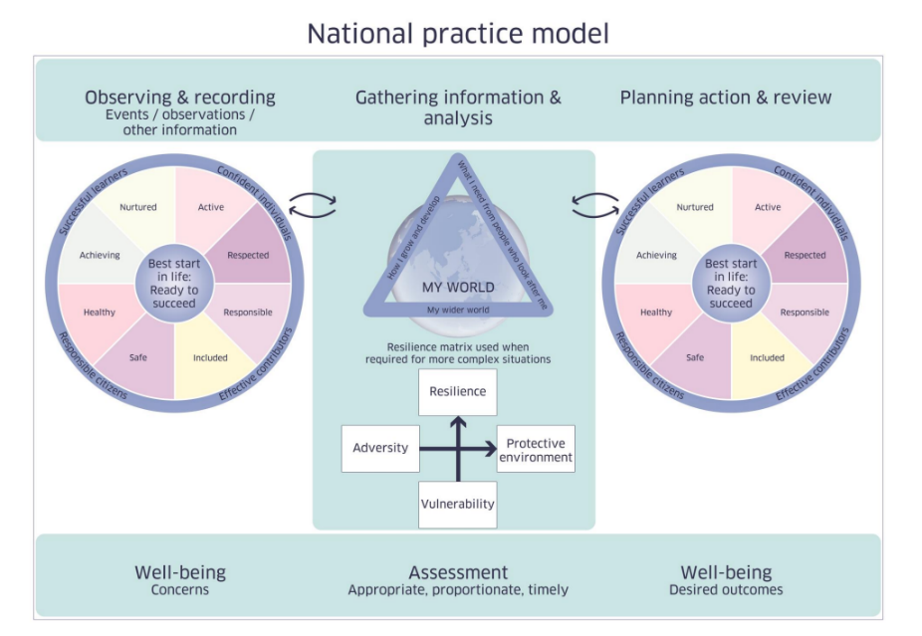
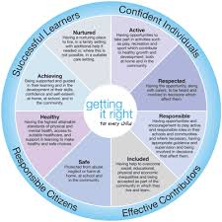
For more information please refer to the Scottish Government website:
https://www.gov.scot/publications/shanarri/documents/
Funded 2 Year Old Places
If the child you are referring is 2 years old, please consider an entitled 2 application. If you think the child may be entitled you should ask the parent to submit an application to the education department instead of an EYIG referral.
For information related to which families may qualify for a funded 2 year old place please visit the ERC website:
https://www.eastrenfrewshire.gov.uk/nursery-places-2
What happens to the information you provide?
The information you supply will be used by East Renfrewshire Council to administer the EYIG. We will use your information to verify your identity where required, contact you by post, email or telephone and to maintain our records. The council will use this information to perform a task carried out in the public interest. The information will be shared with our colleagues in NHS Greater Glasgow and Clyde to provide this service and to protect public funds by preventing fraud. If you do not provide us with the information we have asked for them we will not be able to provide this service to you. We also need to process more sensitive personal information about you for reasons of substantial public interest asset out in the Data Protection Act 2018. It is necessary for us to process it to carry out key functions as outlined by law. If you have provided anyone else’s details on this form please make sure you have told them that you have given their information to East Renfrewshire Council. We only use this information to assess your entitlement to this service. You can find out more about how we handle this information and your rights in respect of it by going to www.eastrenfrewshire.gov.uk/privacy. If you do not have access to a computer and wish a paper copy please ask the person making your referral to give you a copy.
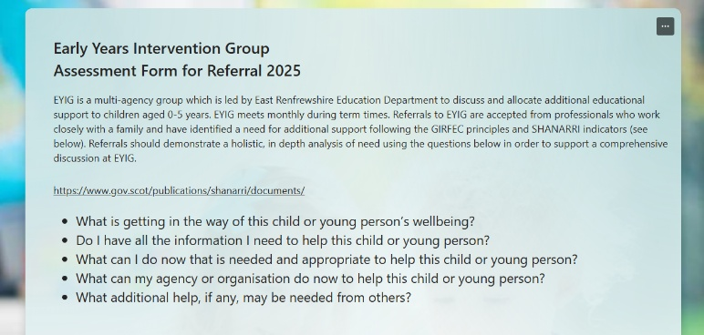
The Referral Form
Please click on the link below to access the online referral form.
Early Years Intervention Group Assessment Form for Referral 2025 – Fill in form
Please ensure you have all the information you require prior to completing the form as it not currently possible to save and return to the form.
Section 1 - Your Details as Referrer
It is vital that the child’s parent or carer has given consent to the referral, to their information being shared and that they are aware of which agencies are represented at EYIG.
Agencies represented at EYIG:
Education (Early Years Development Officer)
Educational Psychology Service
Health Visiting
Speech and Language Therapy
Headteachers from Early learning and Childcare settings and Early Years ASN provisions
Family First
Early Years Admissions Team Administrative Support

Please also provide your details as the referrer.
Section 2 – Child’s Details
Please provide the child’s details including SIMD decile
Section 3 – Wellbeing Concern and Evidence of Staged Intervention
The information provided in this section of the referral informs the discussion at EYIG about what supports are most appropriate for the child and family. It is vital, therefore, that you provide as full and comprehensive assessment as possible. Referrals should demonstrate a holistic, in-depth analysis of need relevant to the SHANARRI indicators (Safe, Healthy, Active, Nurtured, Achieving, Respected, Responsible, Included). The questions below can help to inform your assessment:
- What is getting in the way of this child or young person’s or family’s wellbeing?
- Do I have all the information I need to help this child, young person or family?
- What can I do now that is needed and appropriate to help this child, young person or family?
- What can my agency or organisation do now to help this child, young person or family?
- What additional help, if any, may be needed from others?

15. What is getting in the way of this child’s wellbeing?
Example response

Safe – Holly’s mum (Sally) is the victim of domestic abuse and is now the sole carer for Holly and her older child Andrew (9 years). Sally and Holly are in temporary homeless accommodation while they await local authority housing. They have very little space inside for Holly and Andrew to play and no garden space. Sally is supported by a CPN to support her mental health needs. Sally has struggled with depression since her separation from her partner 6 months ago. This is impacting her ability to respond to Holly’s needs and take her out and about.

Healthy – Holly is a healthy 2 year old. Her recent 27-30 month review highlighted delays in speech and language development. Holly is currently using no spoken language but she will use gesture and physically lead her mum to make her needs known.

Nurtured – Sally is a very loving mum and has a close attachment with both children. This was evident at the home visit when Holly kept her mum close by and in her sight at all times, regularly seeking cuddles and comfort.

Achieving – Holly is achieving age appropriate milestones in her gross/fine motor skills and problem solving. She is an active, inquisitive girl who has good balance and coordination. She is demonstrating some delays in her communication and personal-social development. She uses no verbal language, minimal eye contact and is reluctant to let others join her play. Sally is struggling to manage some of Holly’s behaviours. She can become very distressed if she doesn’t get her own way and takes a long time to settle when she’s upset. Sally has been working with Family First on improving her confidence with managing Holly’s behaviour and is making some progress.

Included - Sally has tried taking Holly to toddler groups but she becomes so upset and disruptive to the session that she has stopped attending. Sally is experiencing a particularly bad period in terms of her mental health, is struggling to leave the house and feels overwhelmed by her situation. Sally is engaging well with Women’s Aid, Family First and her CPN but struggles to juggle appointments while looking after the children. She has no wider family support.

16. What has your agency or other agencies already done to help this child and their family and what has been the impact of this support?
Please provide the impact of any support that has been offered:
- To what extent has the family engaged with the support?
- What evidence do you have that the support has been successful or unsuccessful
Example Response

Support from Community Nursery Nurse – mum engaged well with 6 week block. Mum has successfully tried new play ideas and toys and has reported feeling more confident about how to play with Julia in the house. She is still struggling with transitions when out and about.

Speech and Language Therapy – strategies for encouraging communication were discussed with mum. She is finding it challenging to use these consistently. SLT continuing to offer advice through the helpline.

Family First – mum has engaged well with discussions about finances, daily routines to support transitions. Support continuing.

17. What is your request and how will this request contribute positively to the child's development at this time?
If your request is for early learning and childcare placement or additional hours, please state detail of which early learning and childcare setting and how you think this resource will contribute positively to the child's development at this time. This should be support that is appropriate and timely and based on your assessment of the child's current needs.
If the referral is for a child with an additional support need, a funded nursery place may, on some occasions, be appropriate if there are additional pressures on a family, for example, housing concerns, physical or mental health needs. However, in most cases, the home environment is considered the best place for a child to develop their skills with support from community based services.
Section 4 – Additional Information
Please let us know more information about the child including if the child is care experienced and their health visitor if this information is known.
Section 5 – Parent or Carer Details
Please provide us with information for at least one parent or carer
Section 6 – Agencies Involved
Please let us know which, if any, agencies are involved with the family and the nature of this involvement.
Section 7 – Additional Information about your Referral
Please select yes or no to the questions in this section. Please note that requests for Sensory Support Service are for children with visual or hearing impairment only.
Section 8 – Child and Family Risk Factors
Please select as many risk factors as are relevant for this child and family.
If your request is for an Early Learning and Childcare Centre please note the age range for each setting before selecting.
Thank you for your referral to EYIG
Please send any supporting documentation to ps@eastrenfrewshire.gov.uk

