Children can access their Google Classroom in two different ways.
Through GLOW
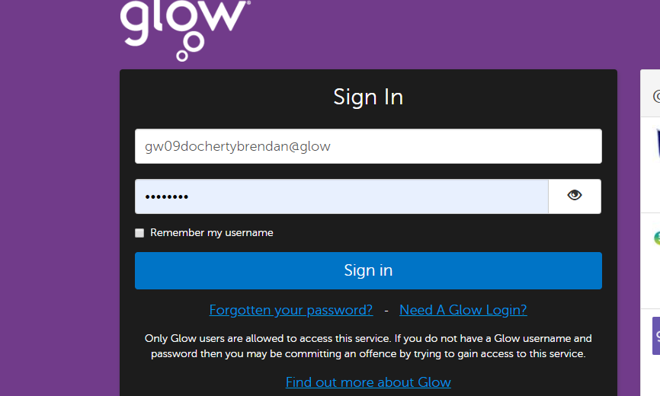
Log in to glow using you username and password. Your username starts with ‘GW’.
If you can’t find the webpage, use a search engine such as google to find ‘Glow sign in RM’

On your launch pad look for the Google Classroom tile.
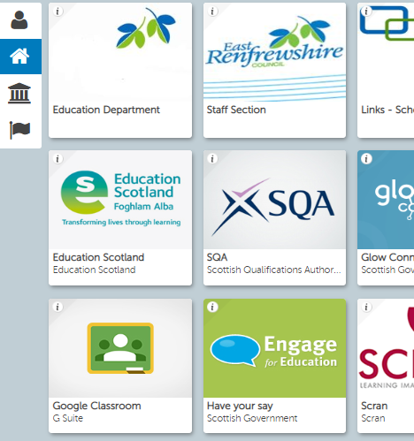
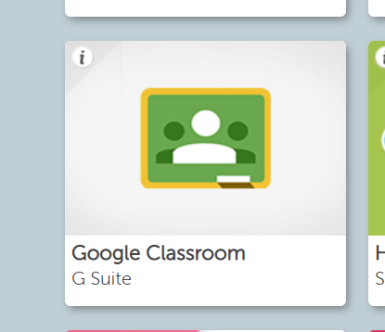
When you click on this, it will take you to a page where the classes you are a member of will be showing.
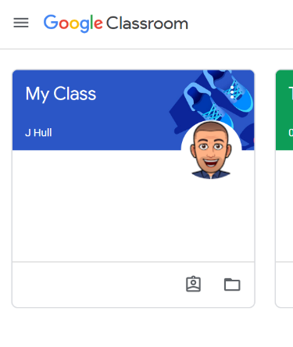
Click on the class
When you click in to the class, you will see a page that looks something like this.
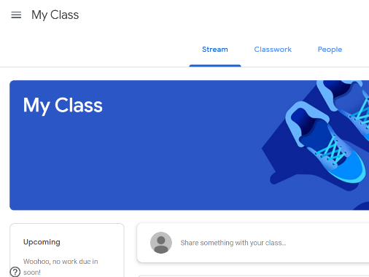
Click on ‘view your work’ 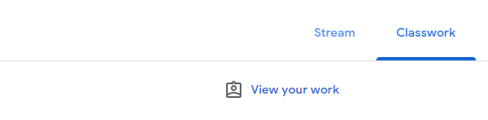

The work that your teacher has set for you will be showing. Select the piece of work that you are going to complete.
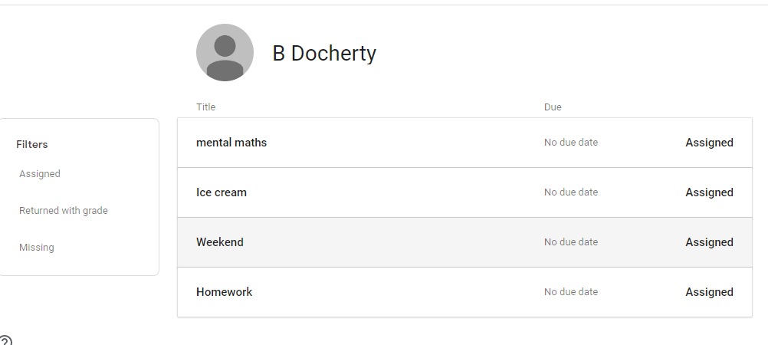

When you select the piece of work you want to work on, it will open.
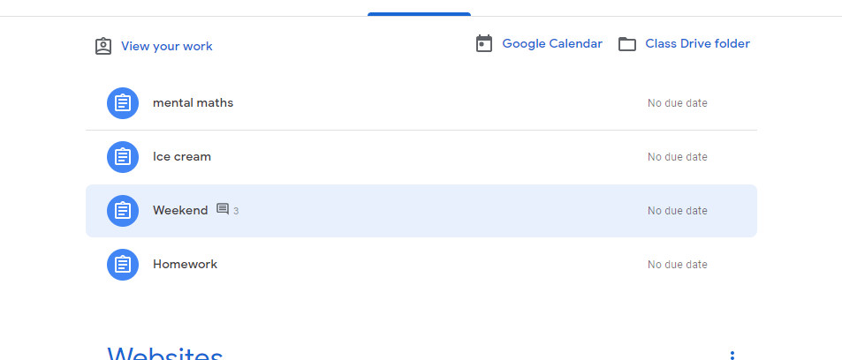
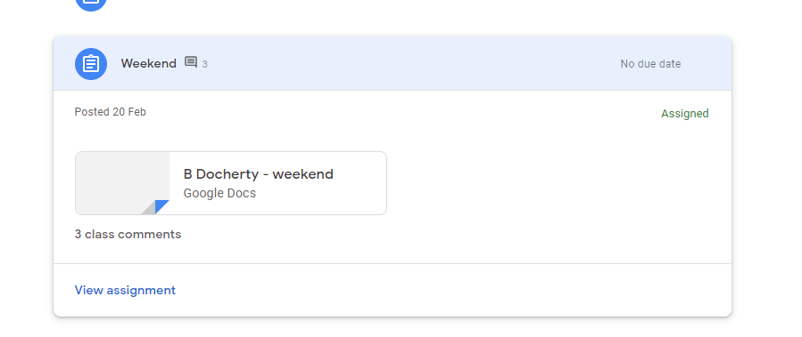
Then click on the piece of work and the document will open. Documents will save
automatically. Your teacher will know that this is your work.

Through the App
Download the Google Classroom app through Apple store or Google Play store
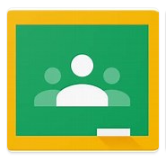
Once downloaded, you will be asked to login. Your login details will be your glow
username with the ending @er.glow.scot (e.g. gw15smithjohn@er.glow.scot)
Once you are logged in, you will be able to access your class page.

