How to save files on Glow.
All pupils have access to online storage facilities through Glow. These are Google Drive and Microsoft OneDrive. This allows documents to be accessed and edited in school and at home.

Log in to Glow via https://glow.rmunify.com/
Click on the arrow beside ‘My Files’ on the Launch Pad
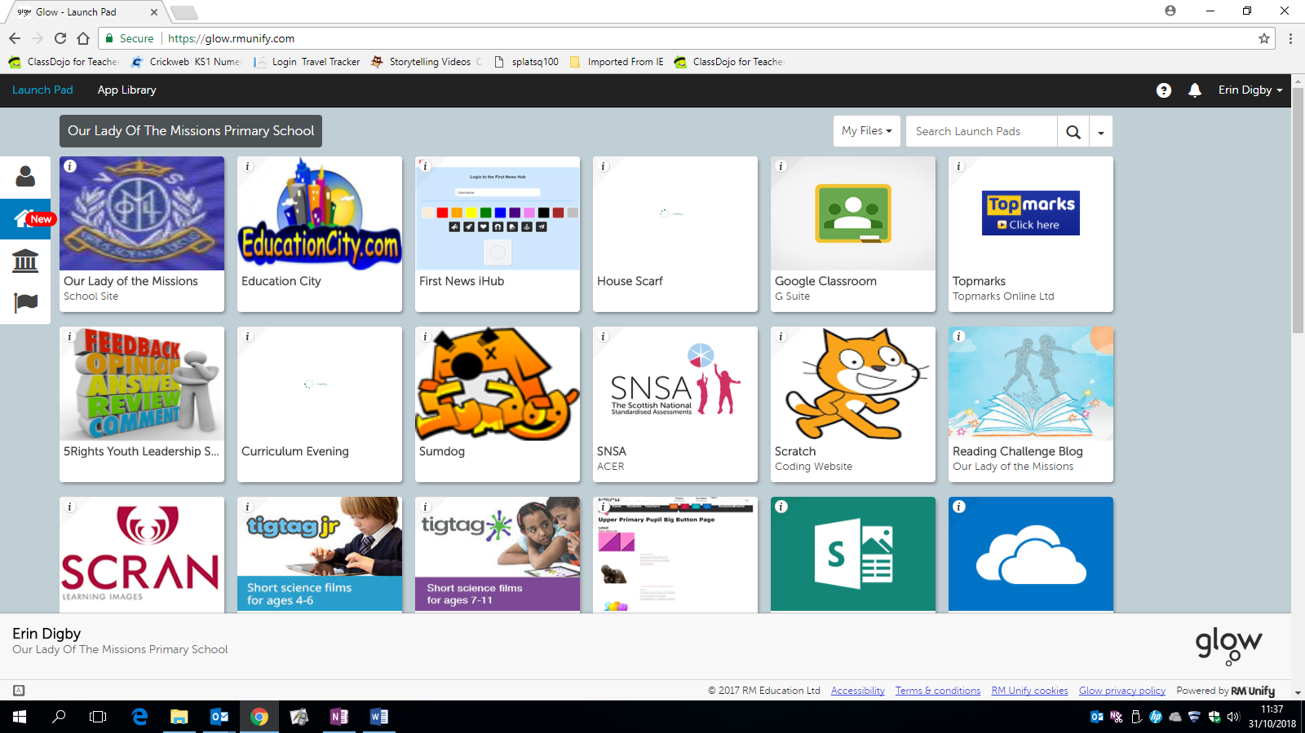
Select your preferred storage option.

For Google Drive, click on the plus sign to add or create files. All Google files automatically save to the drive.
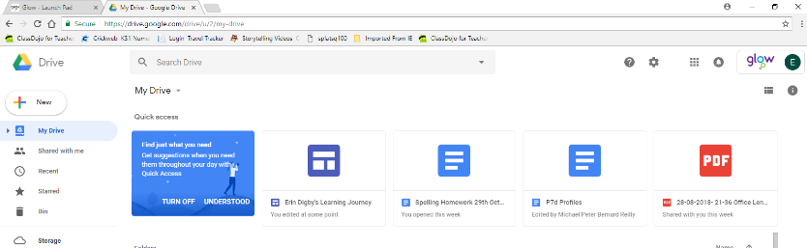
For Microsoft OneDrive, click on ‘upload’ or drag the document from your hard drive into the files page.
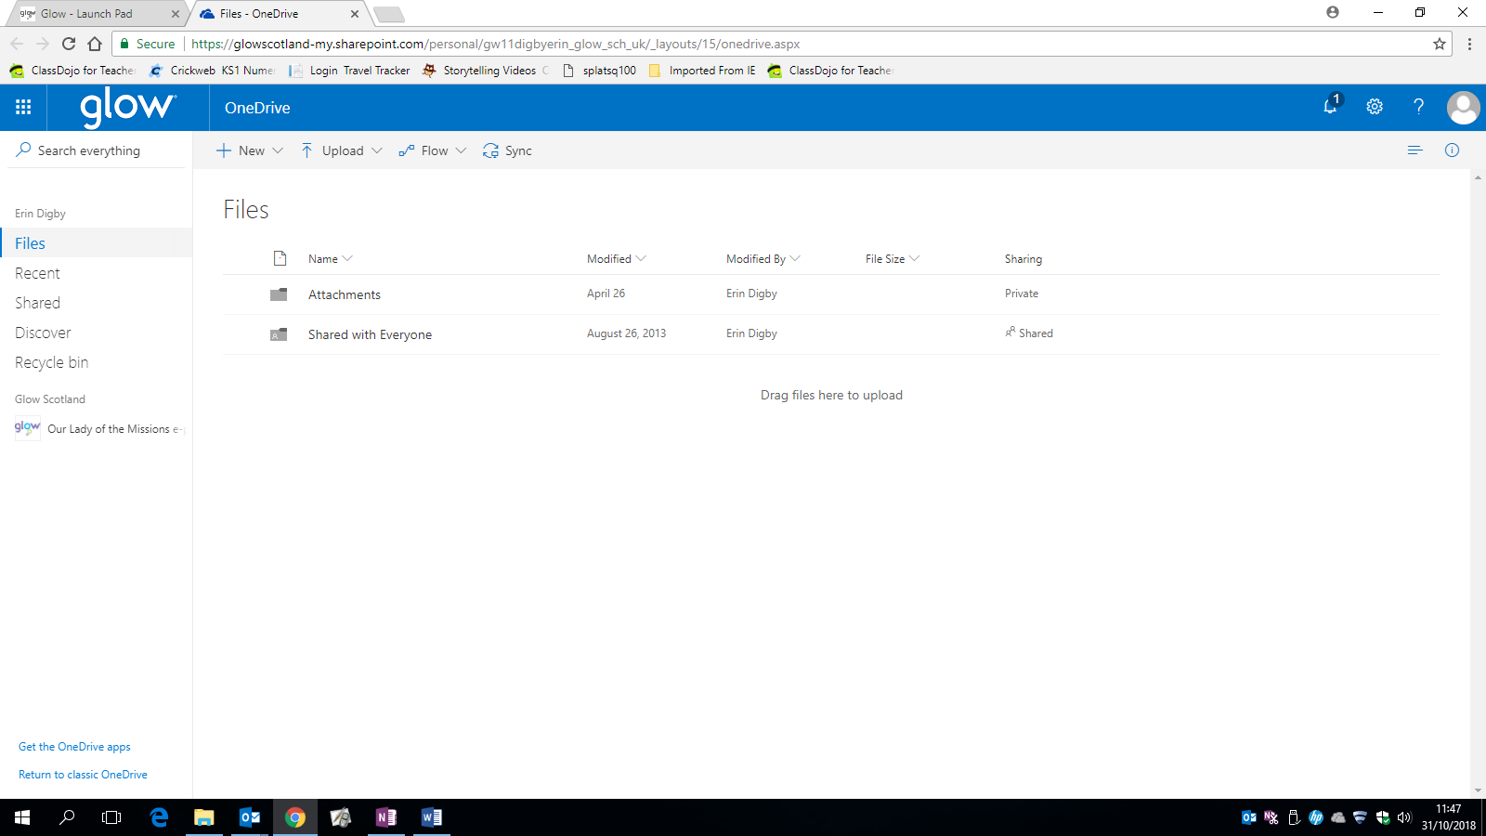

If you click on + New then files created will be automatically saved in the drive.
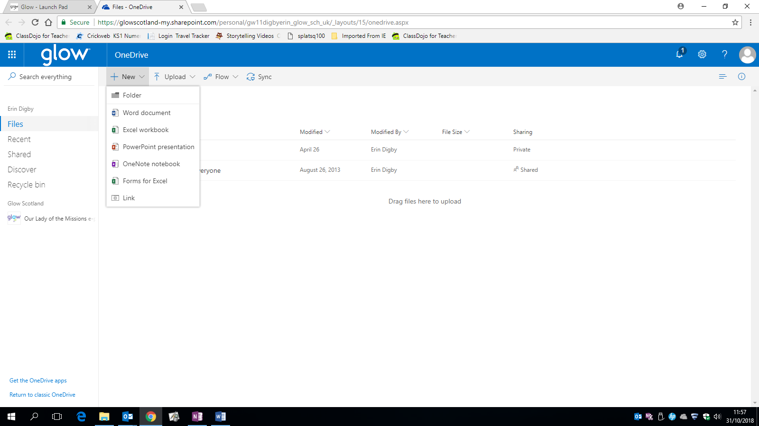

Google and Microsoft applications can be accessed via the internet or mobile apps. Pupils will be required to enter their Glow details to use them. Both accounts require a suffix after the username.
For Google, enter: glowusername@er.glow.scot
For Microsoft, enter: glowusername@glow.sch.uk

